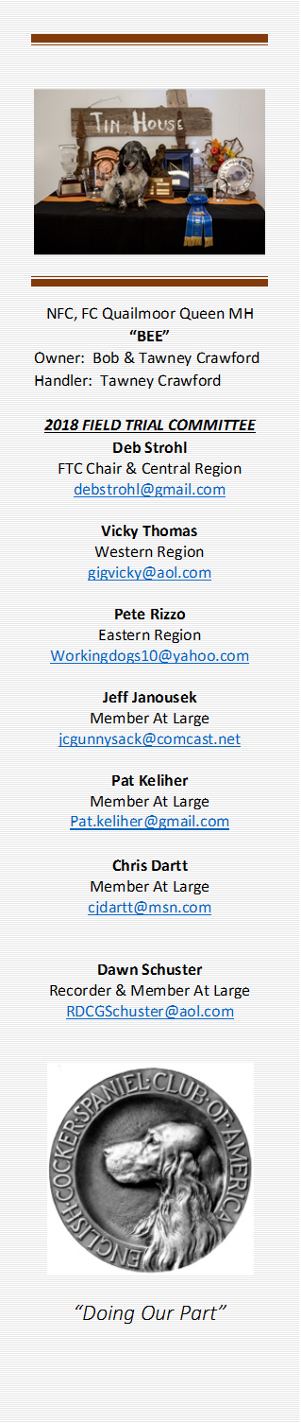
July 10, 2018
The meeting was called to order at 7:02 PM Central time. Present were Chair, Deb Strohl, members, Pete Rizzo, Dawn Schuster, Chris Dartt, Pat Keliher, Vicky Thomas and Jeff Janousek .
The minutes for June were read. A motion was made to approve the minutes via Email and submit them to fieldcockers for publishing before the start of the next month’s meeting.
The motion to approve the agenda was made by Vicky Thomas and seconded by Pete Rizzo.
Agenda Items:
- 1st A discussion about starting a yahoo group list for the FTC members took place. With a yahoo list, all correspondences between the FTC, including documents would be easily accessible to the members serving. It was decided that we would not pursue as not all members of the FTC follow along on Yahoo group lists or are able to access Yahoo lists.

- 2nd Spring 2019 dates are coming in and the calendar is being set up. Please start thinking about getting your requests in early to secure dates for the 2019 Spring. Holly Boggess has requested permission to post the Cocker trial/event dates on the ESSFT website. All were in favor. If you have an event planned, please forward your information onto Holly at the ESSFT website at support@essft.com .
Likewise, if you have an event, please forward the information to fieldcockers@yahoo.com. Please include links to entry services, premiums, and any other useful information. Many fall trials are not updated yet.

- 3rd There was a review of initial ballots for Nationals. Should the initial ballot ask to select 2 or 4 judge names? Could checking 4 sway the votes for some. It was decided that no changes to the process would happen. 4 names should be selected for the initial ballot.

June 19, 2018 – continued

- 4th No new update for the final financial report was available for the NACC. Deb will contact the chair to get those reports as soon as possible.

- 5th The committee continued discussion on holding the NACC every year vs every other year.
Each member was given an opportunity to report on their regions concerns and comments.
A vote was taken. The FTC will recommend that the NACC should be held every other year in the spring until such time that attendance warrants a yearly event.
The next National Amateur Cocker Championship will be recommended to be held in Spring 2020.
- 6th The Harold S. Bixby award. The committee started submitting names to be nominated for the Harold S Bixby award. Bios will be due by next meeting. If there is a person who you would like to see nominated, please contact any member of the FTC.
  - “The Harold S Bixby Service Award recognizes the individual who has continuously, unselfishly, and distinctly given of themselves to advance the cause of the English Cocker Spaniels’ field work. The winner is selected to exemplify the high standards, set by Harold S. Bixby, whose generosity and unselfish support of the English Cocker Spaniel in the field has contributed enormously to the success in all field events. “
Nominations for the HB will be presented by the field trial committee, voted on, and presented at the 2018 NCC in New York. Should get the word out to trialers to submit their suggestions/bios to FTC Rep for their area.
7th Contracts for National photographers. It was decided that if the selected photographer bills the ECSCA for services, a contract will be required. If the photographer selected has a bill of 0 to the ECSCA, ex.. a private donation or outside funding, no contract is required.
New Business.. No new business
- Next meeting will be held Tues, Aug 14, 2018
- Meeting adjourned at 8:49 PM Central time.
Submitted by Dawn Schuster, Member at Large

