Minutes from the March 13, 2018 Meeting
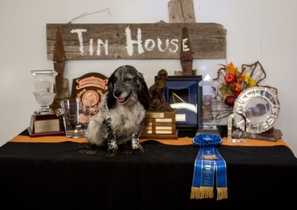
NFC, FC Quailmoor Queen MH “BEE”
Owner: Bob & Tawney Crawford
Handler: Tawney Crawford

2017 FIELD TRIAL COMMITTEE
Deb Strohl
FTC Chair & Central Region
debstrohl@gmail.com

Vicky Thomas
Western Region
gigvicky@aol.com

Pete Rizzo
Eastern Region
Workingdogs10@yahoo.com

Jeff Janousek
Recorder & Member At Large
jcgunnysack@comcast.net

Pat Keliher
Member At Large
Pat.keliher@gmail.com

Chris Dartt
Member At Large
cjdartt@msn.com

Dawn Schuster
Member At Large
RDCGSchuster@aol.com

“Doing Our Part”

Members Present: Deb Strohl, Vicky Thomas, Pete Rizzo, Chris Dartt, Dawn Schuster, Jeff Janousek, Pat Keliher. Guest: Rumi Schroeder
Call to Order: The meeting was called to order at 6:02pm CST.
Approval of Minutes: Vicky moved to approve the prior minutes, seconded by Dawn Schuester. Approved unanimously
Approval of Agenda: Motion to approve by Vicky, seconded by Jeff. Approved unanimously after 2 additions.
Old Business:
- National Amateur – Rumi Schroeder & Dawn Schuster: Update
28 entries to date. Everything is coming together and it looks like we will have a good attendance.
- Jeff – discuss having yearly alternating NACC and NCC events. Rather than both in the same year, alternate them every other year. Basically the discussion ended with the fact that the NCC couldn’t/wouldn’t be held every other year so at this point, we will try to have the Amateur every other year. This might have to be revisited if the attendance/ revenues of either event fall ‘considerably’ in any case.
- Vicky – Creation of the “Amateur Honor Society” for NACC
This is to honor those dogs that ran in amateur stakes without thought that there would ever be an NACC in their lifetime. Approximately 135 +/- dogs in this Society, but the number needs to be verified. Original list supplied by Sue Rose.
This Society would be a finite number of dogs that placed in an amateur stake between 2006 and a cut-off date. This cut-off date would be either - the date AKC announced that the NACC would happen, or 12/31/17 (the last day of the year prior to the first NACC). Discussion revolved around a definitive date and settled upon 12/31/17.
The FTC wanted to be sure that the list is correct and no dog is accidentally excluded. So, it should be double checked to be sure we’ve done our best. Any handler with a dog that was missed – totally by accident mind you – could challenge the list and provide proof of placement in an amateur stake and have the dog’s name added to the Society’s list.
This list will also be included in all future NACC catalogs.

New Business:
- The next FTC meeting is to be April 17 - 6:00 pm CST and it will follow up on the Photography contract to be developed by Jeff as well as extending criteria from 3 trials to 5 trials for the NCC/NACC judges.
- The meeting was adjourned.

