ECSCA Field Trial Committee Meeting Minutes
Wednesday, January 15, 2020
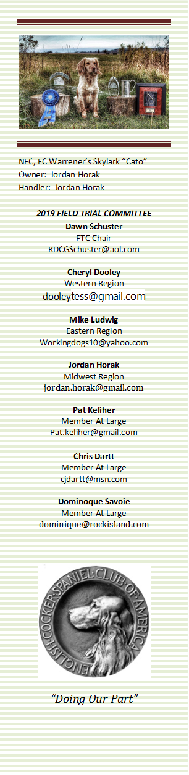
Call to Order - The meeting was called to order by Dawn Schuster at
6:03 PM CST.
Present: Dawn Schuster (Chair), Ron Bullock, Chris Dartt, Cheryl Dooley, Jordan Horak, Pat Keliher, Mike Ludwig, and Dominique Savaii.
Approval of Minutes from November 20, 2019 – Mike made a motion to approve the minutes. Jordan seconded the motion and the motion carried.
Approval of Agenda – Jordan made a motion to approve the Agenda. Chris seconded the motion and the motion carried.

Thank You & Welcome– Dawn acknowledged the efforts of Dominique Savoie over the past year. The FTC appreciates all the hard work and is hoping Dominique will continue to lead the process of re-writing “How to Run an NCC”. Dawn also welcomed Ron Bullock to the FTC. Ron will be an At-Large Member.
Selection of FTC Chair & Recording Secretary– Dawn nominated Cheryl Dooley as the Recording Secretary. Hearing no other nominations, the FTC approved. Mike nominated Dawn Schuster to continue on as the FTC Chair. Hearing no other nominations, the FTC approved.
Update on 2020 NACC– Dawn indicated the NACC for 2020 is going well. She will be traveling to the area this week and will visit the Grounds with the Judges Steward. The plan is to get an assessment of the cover at this point in time. Additionally, she will visit the Hotel with the intent to speak with the Staff and meet with the Emergency Coordinator. Dawn indicated the 1sdt, 2nd and 5th Series now have Sponsor commitments. Chris indicated the need for a photo of Breeze (2018 Champion). The image of Breeze will be needed for the trophies.
NEW BUSINESS:
Amateur Qualified Dog List – Dawn informed the FTC that an updated list of Dogs qualified for the Amateur National is now available. However, there are two issues related to this list. First, some addresses missing from the list. Dawn asked Cheryl to send the list to FTC Members and asking each Member to assist in filling in the missing addresses. Secondly, the FTC is seeking a VOLUNTEER to maintain the list from this time forward. This would involve someone updating the list after the Spring Trials and again after the Fall Trials. The updated list should then be forward to Bethann Wiley for posting on Fieldcockers.com.
Changing status from Pro to Amateur- Dawn informed the FTC of a recent request from a Pro Handler to change their status from Professional to Amateur. A notarized letter has been received from the individual. The ECSCA will need to write an acknowledgement of this request.
Dawn explained to the FTC that currently there is no rule that specifically addresses Field Cockers. She pointed out that there is a rule written for Springers as well as other breeds; including Retrievers and Pointers.
The FTC discussed a number of points regarding the rule and how it should be written. Some of the key points discussed were: 1) do we ask someone to sit out for 1 or 2 years; 2) do we allow someone to only make this transition once; and 3) what dogs might the individual be allowed to handle at the Amateur level. Jordan pointed out that we should allow Folks to switch from Pro to Amateur as this would potentially increase participation in the Sport. Pat indicated that we need to be careful as to how we define the rule concerning how long must a person NOT act as a Pro before they are able to participate as an Amateur. Pat also cautioned the group on the importance of a clear definition of what dogs the ex-Pro might be allowed to handle as an Amateur. Other Breeds have rules indicating the Person is allowed to handle dogs owned by their Immediate Family. The Group discussed a variety of descriptions as to what might constitute an Immediate Family Member; including whether the individual would need to reside in the same household.
The discussion also led to the issue of whether an Amateur should be allowed to run a dog belonging to another Amateur. It was determined that this is indeed allowed as long as the Amateur Handler is not being compensated in any fashion.
Pat agreed to look closely at the rules written for Retrievers, Pointers and Springers and write a rule that would be for Field Cockers. He will include in this rule, definitions of what constitutes a pro and who is defined as ‘Immediate Family’. As soon as Pat writes the proposed rule, he will email the draft to the FTC Members for their comments. The FTC is hoping to settle this issue via email and will alert the Membership as to the Rule once a final draft is agreed upon.
Reminder to Club/Trial Secretaries to submit info to fieldcockers.com - Dawn requested that all Regional Reps on the FTC remind their respective Clubs that their Secretaries need to keep Bethann informed of any information regarding their Trials. Bethann will then post said information on the fieldcocker website.
Pat and Dawn pointed out that it is critical the Calendar have no conflicts between Clubs in the same Region. Dawn asked Chris to create a spreadsheet so we can determine what the issue might be with ‘doubling-up’ in the same Region.
Mike also pointed out that Clubs choosing to skip a year for their normal Field Trial while they plan a NCC should not be penalized and loses their ‘usual’ dates for their regular Trial.
Dawn asked the FTC to table this issue until February while everyone thinks about the best approach for this issue.
New Hampshire Bill regarding Competitive Hunting - Pat informed the FTC an article has been published for New Hampshire to abolish competitive hunting. This would include Field Trials. Pat will keep the FTC posted on any new information. Dawn will alert the ECSCA Board and request them to lobby against any such legislation.
2021 National Amateur Judge Voting – Cheryl mentioned to the FTC that if it is decided to hold a National Amateur Trial yearly, instead of every other year, we will need to have a plan for voting for Judges for the 2021 NACC. This issue will be tabled until the February meeting.
Adjournment Pat made a motion to adjourn the meeting. Mike seconded the motion and the motion carried. The meeting was adjourned at 7:17 PM CST.
The next FTC Meeting will be held at 6:00 PM (CST) on Thursday, February 20, 2020.
Respectfully submitted by Cheryl Dooley.

