ECSCA Field Trial Committee Meeting Minutes
Wednesday, August 28, 2019
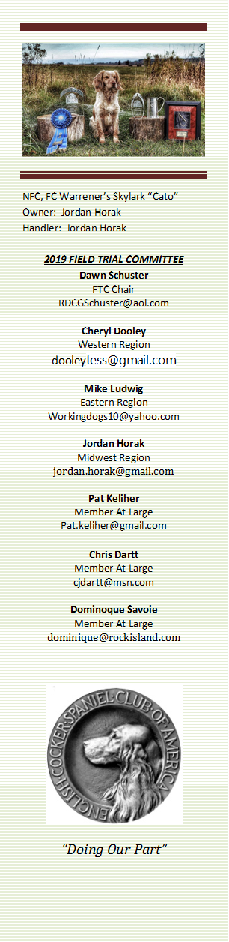
Call to Order- The meeting was called to order by Dawn Schuster at 6:03PM CST
Present: Dawn Schuster (Chair), Chris Dartt, Cheryl Dooley, Mike Ludwig, & Dominique Savoie
Approval of Minutes from July 17, 2019 – Chris made a motion to approve the minutes. Mike seconded the motion and the motion carried.
Approval of Agenda – Mike made a motion to approve the Agenda. Chris seconded the motion and the motion carried.

Harold Bixby Award Nomination – Dawn explained the details of the Bixby Award. In particular, she mentioned the recipient should be someone who meets the high standards set by Harold and unselfishly contributed to the success of the Field Cockers. The FTC discussed possible recipients. It was decided everyone will take the next month to think about the best possible choice and make a final decision at the September FTC Meeting. At that time, the FTC choice will be submitted to the ECSCA Board of Directors.
Bids for NCC 2021 & 2022 – Dawn reported that Pat Keliher reported Maine intended to place a bid for the 2021 NCC, but are working on the grounds they intended to use. The Club has a plan for improving the grounds and the process will take over a year. As such, Maine is expressing interest in submitting a bid for the 2022 NCC instead of the 2021 NCC.
There was discussion around the possibility of either Wisconsin or Montana hosting the 2021 NCC.
2019 Fall Trials – Dawn reported the Liberty and Mid-Atlantic Clubs had intended to hold a Trial in October. However, the Liberty Club has now indicated they can’t participate in the planning. The Mid-Atlantic Club (Ralph Botti & Bill Pierson) has agreed to plan the Trial alone, but will move the trial to the grounds on the Botti Farm in Elmira, NY. The same grounds the NCC 2018 was held. Premiums have been posted on Fieldcockers.com.
Chris reported Minnesota will be holding both Open & Amateur Stakes Saturday and Sunday this Fall.
Dawn reported the Cascade Club has received permission from the AKC to hold a Friday Springer Open, Saturday Springer & Cocker Amateurs, and a Sunday Cocker Open.
Dawn asked the Regional Reps to remind Field Trial Secretaries to be certain to provide Bethann Wiley with Premiums so they can be posted on the Field Cocker calendar on fieldcockers.com.
There was a discussion around also posting on the Calendar who the Judges will be as well as whether the Stakes will be Open, Amateur or both. There was also discussion around a potential new website that might have more ‘current’ software. The FTC will look closer at this as an option to communicate information to the Membership.
“How to Run an NCC” Update – Dominique indicated she continues to work on the document. The plan now is to have a separate page dedicated to each individual facet of an NCC. The facets include: Chair duties, financial obligations, Trophies, Hospitality, Judges Steward, Gun Teams, Marshalls, Patrons, etc. Dominique plans to solicit the help of individuals who have been involved with these various facets and ask them to write up a one page set of guidelines for future NCC Chairs to follow.
NEW BUSINESS:
North Dakota 2020 NCC Bid– Jon Hunke provided the FTC with a Proposal and Preliminary budget for the 2020 NCC. One comment from the FTC was concern over the possibility that one North Dakota Member may not be a member of the ECSCA. A second concern was not having someone assigned to the position of Hospitality Chair. There was also some concern over the possibility that the Wolbaum Property may be SOLD. Cheryl will ask Jon to clarify the above points.
In terms of the preliminary budget the concerns mentioned included: Judge airfare, no income listed from the Patrons, Trophy cost, Not enough birds ordered, food expense (particularly lunches), no mention of a Banquet, the cost of the tent, etc. A list of questions will be submitted to Jon and he will be asked to attend the September FTC so the official announcement for the location of the 2020 NCC can be made at the 2019 Iowa NCC.
Use of Flea and Tick Collars during Trials-. Dawn spoke with Tom Meyer from AKC about allowing Flea &Tick Collars during trials where the collar is allowed to be on the dog until the dog’s run. There was a discussion around the pros and cons of allowing a dog to wear a collar. AKC’s opinion was that they would allow the use of Flea and Tick collars during field trials BUT the parent clubs would need to make amendments to trial rules to allow for them to be worn. After some discussion Dawn asked to for a motion. Mike made a motion to NOT allow a collar of any kind during a Cocker Trial. Chris seconded the motion and the motion carried. No rule change will take place.
Reasoning for NOT allowing flea and tick collars during runs are, they could be construed as a training device and taking a flea and tick collar off should not decrease the protection the dog has from parasites for such short periods of time, if the collar is put back on the dog again.
NCC 2019 Iowa Agenda for the General Meeting: The FTC discussed possible topics to be addressed at the 2019 General Meeting. Two possible topics mentioned were:
Amateur National Trials – should they be held YEARLY? And would it be best to hold them in the Spring or Fall? The FTC has been debating these issues for months and feels it is now time to get input from the General Members.
2- year versus 1- year Open Qualification – The FTC discussed the pros and cons of changing to a one year qualification for NCC. The Pros included – it might increase the entries at Club Trials held throughout the year, the number of dogs currently qualified is over 145 so going to one year would likely lower that number thus making it easier on Judges and the Committee planning the event. It was decided it might be best to wait to see how many dogs enter the 2019 Iowa NCC. And, also, get the General Membership opinion at the General Meeting in Iowa.
FTC elections: There was discussion around the fact that 4- FTC members (Dawn, Pat, Dominique & Chris) have terms expiring this year. The FTC will be seeking nominations for these positions.
Field Trial Approval: There was discussion around the current protocol for Field Trial approval. It was suggestion Clubs first contact their Regional Rep concerning their proposal to hold a Trial. The Regional Rep would then be responsible for determining if the Trial would conflict with other Clubs on the Calendar. This discussion was tabled for future consideration. As of now, all field trial requests should be filled out on the form found on the home page of fieldcockers.com and submitted to the FTC Chair (Dawn Schuster)
Please remember to get your Spring trial requests in early.
Adjournment – Mike made a motion to adjourn the meeting. Chris seconded the motion and the motion carried. The meeting was adjourned at 7:38 PM CST.
The next FTC Meeting will be held September 18, 2019.
Respectfully submitted by Cheryl Dooley.

