ECSCA Field Trial Committee Wednesday, June 5, 2019
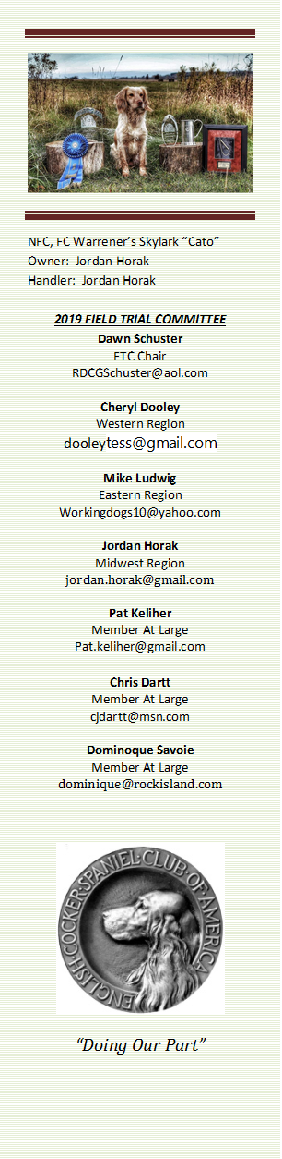
Call to Order- The meeting was called to order by Dawn Schuster at 7:03 PM CST
Present: Chris Dartt, Cheryl Dooley, Pat Keliher, Mike Ludwig, Dominique Savoie & Dawn Schuster
- FTC’s Role in Educating the Field Trial World on Cocker Genetics & DNA Testing-
Dawn explained to the Group that this Special Meeting was called to bring everyone up-to-speed with regard to one confirmed case and one suspected case of AMS (acral mutilation syndrome).
Cheryl reminded the group that there are 4- COMMON recessive inherited conditions: Progressive Retinal Atrophy, Autosomal Recessive Hereditary Nephropathy, Glycogen Storage Disease and Exercise-induced Collapse. It was also pointed out that AMS is a RARE recessive inherited condition. That said, it this is a very devastating condition with no cure. Generally, the condition results in the dog being euthanized.
Cheryl suggested that since the FTC will be mailing a FINAL ballot for the 2020 NCC Open in mid-July it might make sense to prepare an educational document that could be mailed with that ballot. This would allow the FTC to reach out to the Field Cocker world without any addition expense. This document would include a list of recessive inherited conditions as well as a simple explanation on how genetic crossings may lead to those conditions. Additionally, the document would encourage Folks to perform DNA testing on their dog(s).
Dawn indicated she had a conversation with Linda Amick (ECSCA) explaining the intention of the FTC to prep this simple, basic document. Linda gave Dawn the ‘go-ahead’ to proceed with the mailing.
A question arose as to why the FTC would like to work with the Health & Rescue Organization. Dawn suggested that by pooling resources with the H&R Committee, we can quickly get accurate information to ALL who field trial and breed rather than just parent club members. Dawn indicated that Linda Amick expressly indicated to proceed and that the ECSCA Board will meet with the Health & Rescue Committee to learn more details.
Cheryl will proceed prepping a rough draft to be reviewed by the FTC and Addi Pittman from the H&R committee by June 19th.

- Adjournment – Chris made a motion to adjourn the meeting. Dominique seconded the motion and the motion carried. The meeting was adjourned at 7:42PM CST.
The next FTC Meeting will be held June 19, 2019.
Respectfully Submitted – Cheryl Dooley

