ECSCA Field Trial Committee Wednesday, April 17, 2019
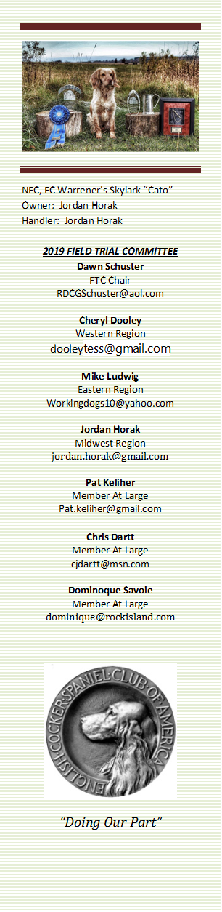
- Call to Order- The meeting was called to order by Dawn Schuster at 6:03 PM CST
Present: Chris Dartt, Cheryl Dooley, Jordan Horak, Pat Keliher, Mike Ludwig, Dominique Savoie & Dawn Schuster
- Approval of Minutes from March 20, 2019 – Pat made a motion to approve the minutes. Chris seconded the motion and the motion carried.

- Approval of Agenda – Pat indicated he wanted to add a couple of items to the agenda. Chris made a motion to approve the Agenda with Pat’s amendments. Pat seconded the motion and the motion carried.

- State Legislature Update – Pat has written a letter to the Parent Club urging them to contact the AKC Lobbyist requesting they campaign against State Bills potentially in opposition with the use of game birds. It was mentioned that both New Jersey and New Mexico are now added to the list of states proposing such bills. While initial writing of these bills was intended for direct opposition to ‘coyote contests’, the wording is nebulous and leaves the door open to include Field Trials using game birds.

- “How to Run an NCC” Update – FTC progress to-date includes a Proposed Budget and Checklist Document. Dominque offered to rewrite the Checklist in bullet format in order to make it easier for Clubs to use when planning a NCC. The new format will clearly list the task that needs to be done, along with a time-line as to when completion is necessary. Dominique indicated she would need 2- months for this project to be completed. After completion, the FTC will view the document for approval.

- National Voting Progress Report – Cheryl indicated the Final Ballot for the 2020 National Amateur Judges was mailed and is due to be postmarked by May 3rd. After that date, Shannon Loritz agreed to count the ballots and contact Dawn with the names of the two highest vote-getters. Any dogs who become new Qualifiers this spring, will be given opportunity to vote as well. Additionally, the 2020 NCC (Open) Judges Survey was mailed on April 15, 2019. Judges are asked to confirm their eligibility to Judge a National Open as well as indicate if they are willing to do so. Those letters are to be returned to Cheryl with a postmark no later than May 31st.
Parent Club Meeting – Dawn recently attended the ECSCA (Parent Club) Board Meeting. During the meeting, Dawn introduced the Members of the FTC to the Parent Club and reported the current focus of the FTC includes focusing on the 2019 Iowa NCC event and editing the “How to Run a NCC” document so it is more user-friendly. Dawn also reported the budget for the 2019 NCC will be posted on fieldcockers.com and this year’s NCC will be held near the scenic covered bridges of Iowa, starting, Tuesday, October 29th, with the Annual FTC Meeting on, Monday, October 28th. She also informed the Parent Club the 2020 NACC is in a planning process. Pete Rizzo is the Chair and they are seeking a location that, right now, will likely be Western Ohio. Additionally, she reported Spring Trials are in-progress, the FTC is working on the 2019 Fall Calendar and the balloting for both the 2020 NCC and 2020 NACC are in-progress. Dawn also took the opportunity to reiterate to the Parent Club the concern the FTC has over current proposed State legislation that, if passed, might eliminate the ability to hold Field Trials.
New Business:
Fall Trials– Dawn provided the FTC with a list of potential 2019 Fall Trials that includes:
Western Region –
Timpanogos – Clarkston UT – ESS/Cocker – 2 opens each Sept 27 &28
Arrowhead – Fallon, NV – Cocker/Springer – 2 Cocker opens- Oct 12 &13
Eastern Region –
Maine – Dresden, ME – 2 opens – Oct 5 &6
Liberty ECS Club – Southport NY – 1 open – Oct 11
Mid-Atlantic – Southport NY – 2 opens, 2 amateurs, 2 pups – Oct 12 &13
Euclid – Jackson MI – 2 opens, 2 amateurs, 1 pup – Oct 19 &20
Central Region –
Cocker Spaniel Hunting Enthusiasts – Arena, WI – 2 opens, 2 amateurs, 2 pups - Sept 20- 22
Fox Valley – Reedsville, Wi – 2 opens, 2 amateurs, 2 pups – Oct 5 &6
North Dakota – Menoken, ND – 1 open, 1 amateur, 1 pup – Sept 14 & 15
Central Minnesota – Princeton MN – 2 opens, 1 amateur
It was suggested Holly Boggess be contacted in order to have all the Cocker Trials listed on the essft.org site.
There was also a reminder that on days when an Open and Amateur take place, the OPEN must take precedence over the Amateur.
Pat indicated that Central Maine is considering offering a third Trial this year. He asked if there were any objections. None were noted.
Pat also indicated Maine is interested in hosting the 2021 or 2022 NCC. There was discussion about the next four years of NCC Trials. There are no bids in to-date for 2020, 2021, or 2022.
Dominique made a motion to accept the Fall Trial requests. Mike seconded the motion and the motion carried.
FTC Expectations or Goals - Dawn asked each FTC Member to state what they feel the FTC goals should be for the upcoming year. Goals mentioned included: A plan to inspire interest by young/novice Handlers, Encouraging Clubs to hold Trial Series work in ‘cocker-type’ cover, and determining how we can better communicate these or other ideas to all Handlers. After a lengthy discussion on these topics it was decided everyone would take the next month to organize their thoughts and the May meeting would be devoted to these topics.
Adjournment – Mike made a motion to adjourn the meeting. Jordan seconded the motion and the motion carried. The meeting was adjourned at 7:57 PM CST.
The next FTC Meeting will be held May 15, 2019.
Respectfully Submitted – Cheryl Dooley

