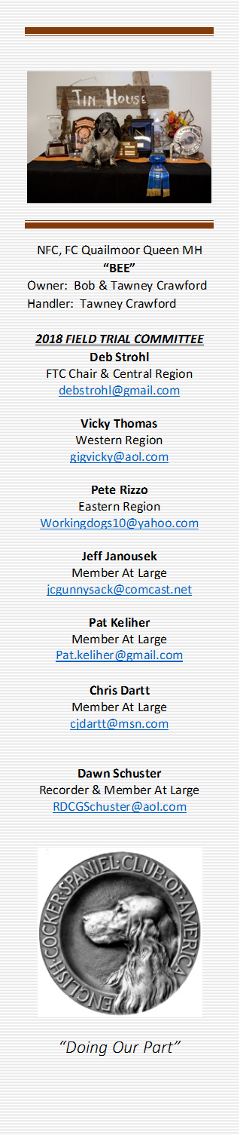
June 19, 2018
The meeting was called to order at 7:02 PM Central time. Present were Chair, Deb Strohl, members, Pete Rizzo, Dawn Schuster, Chris Dartt, Pat Keliher, Guests, Cheryl Dooley and Murray Tate. Not present, Vicky Thomas and Jeff Janousek.
The minutes for May were read. A motion was made to approve the minutes by Chris Dartt and seconded by Pete Rizzo.
The motion to approve the agenda was made by Dawn Schuster and seconded by Pat Keliher. No new additions currently.
Agenda Items:
- 1st Dawn Schuster will be replacing Jeff Janousek as recorder due to a change in Jeff’s work schedule. Jeff agrees to remain on the committee.

- 2nd Guest Cheryl Dooley joined the meeting to give an update on the 2019 NCC judging selection ballots. After the 1st mailing, 119 ballots were sent and a total of 91ballots have been returned so far. As it stands right now, there are 3 separate ties in votes. It was decided that the next mailing of the final ballots would contain the top 7 names. Those ballots will be sent out August 1st and due back to Linda Amick for final tallying by Sept 15th. It had been decided that no biographies would be sent via mail. All bios will be available by link on Fieldcockers.com or can be obtained by emailing Cheryl Dooley. Below are the final nominations for the 2019 NCC Judging panel.
Dave Williams of Nebraska
Dominique Savoie of Montana
Donny Mock of California
Pete Rizzo of New York
Rick Shively of Colorado
Robert Griffin of Montana
Vern Knapp of Maine
Thanks Cheryl!

- 3rd Guest Murray Tate joined the meeting to give an update on the 2018 NCC in New York State.
  - Dates for the National:
    - Wed Oct 24, 2018 through Completion
    - Grounds in Southport, NY
    - HQ Hotel in Elmira, NY

June 19, 2018 – continued
- All 5 series will be held at the Ralph Botti Farm. Series 1 and 2 will be held in open grass fields.
  - Series 3 and 4 will be in broken cover of shrubbery and grass mixes.
  - The 5th series will be held in the woods on the property.
- Planning is going well and on schedule.
- The water series will be off the property between the farm and the host hotel.
- All meetings, gatherings and banquets will be held at the host hotel.
  - The host hotel has a restaurant and pub in house.
  - Other hotels and restaurants are within reasonable distance to the grounds and host hotel.
  - More updates will be forthcoming in the next couple months.
Thanks Murray!
- 4th A preliminary financial report was given by Dawn Schuster on the NACC 2018.
The committee was happy to report that the trial did well. Exact numbers will be given in July meeting. The trial itself did have a small profit and due to an amazing outpouring of support through fundraising, there is now a very nice next egg available for the next NACC. The NACC and the ECSCA wishes to thank everyone who pitched in and helped make the Amateur Nationals a reality this year and for years to come.

- 5th The committee discussed holding the NACC every year vs every other year. Chris questioned the impact of geography on attendance – East coast potentially fewer west coast, etc. Discussion around how many amateur stakes are we having –Pete fewer this fall in the East– not Maine, etc. are we having, growing or shrinking, how it affects the Open. Would it increase the # of AM stakes to have a certain # of points qualify for the Open NCC? Other way around, Open points qualify for the am, quickly decided it would kill the AM😊 Decided to table conversation pending regional reps reaching out to the participants in their areas for input. The discussion will continue next month with input from the cocker trialing community. Discussion on what future qualification time frames to run in the NACC would be was also tabled until that time.

- 6th The Harold S. Bixby award. The chair asked for committee members to start thinking about nominations for the Harold S. Bixby Award. Each nomination must be accompanied by a (short) biography or reason why the person is being nominated – submit these to Deb.
  - “The Harold S Bixby Service Award recognizes the individual who has continuously, unselfishly, and distinctly given of themselves to advance the cause of the English Cocker Spaniels’ field work. The winner is selected to exemplify the high standards, set by Harold S. Bixby, whose generosity and unselfish support of the English Cocker Spaniel in the field has contributed enormously to the success in all field events. “
Nominations for the HB will be presented by the field trial committee, voted on, and presented at the 2018 NCC in New York. Should get the word out to trialers to submit their suggestions/bios to FTC Rep for their area.
New Business
It was brought to the attention of the committee that the regional high point dogs have not been posted on the Field Cockers website. High point dogs for 2017 have not been posted either, and we have just wrapped up the Spring 2018 season. Discussion – Chris stated Robin should have the spreadsheets, which are multi-tabbed and have all the metrics for each category. Presume all that’s needed is to get them from Robin and send to Bethann to post. Same thing for YTD – get what Robin has so far. is needed is to get them from her and have Bethann post on fieldcockers. Deb will investigate this.
- Next meeting will be held Tues, July 10, 2018
- Meeting adjourned at 8:44 PM Central time.
Submitted by Dawn Schuster, Member at Large

