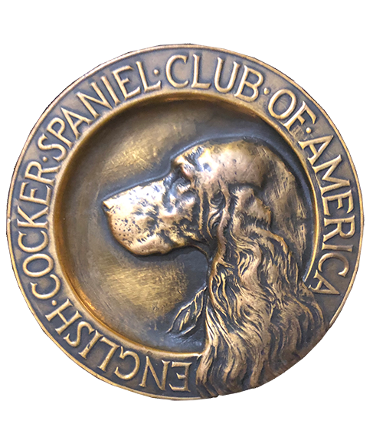
ECSCA
Field Trial Committee
Dawn Schuster – Chair
At-Large Members –
Ron Bollock, Chris Dartt, Pat Keliher
East Region Rep – Mike Ludwig
Midwest Region Rep – Jordan Horak
West Region Rep – Cheryl Dooley

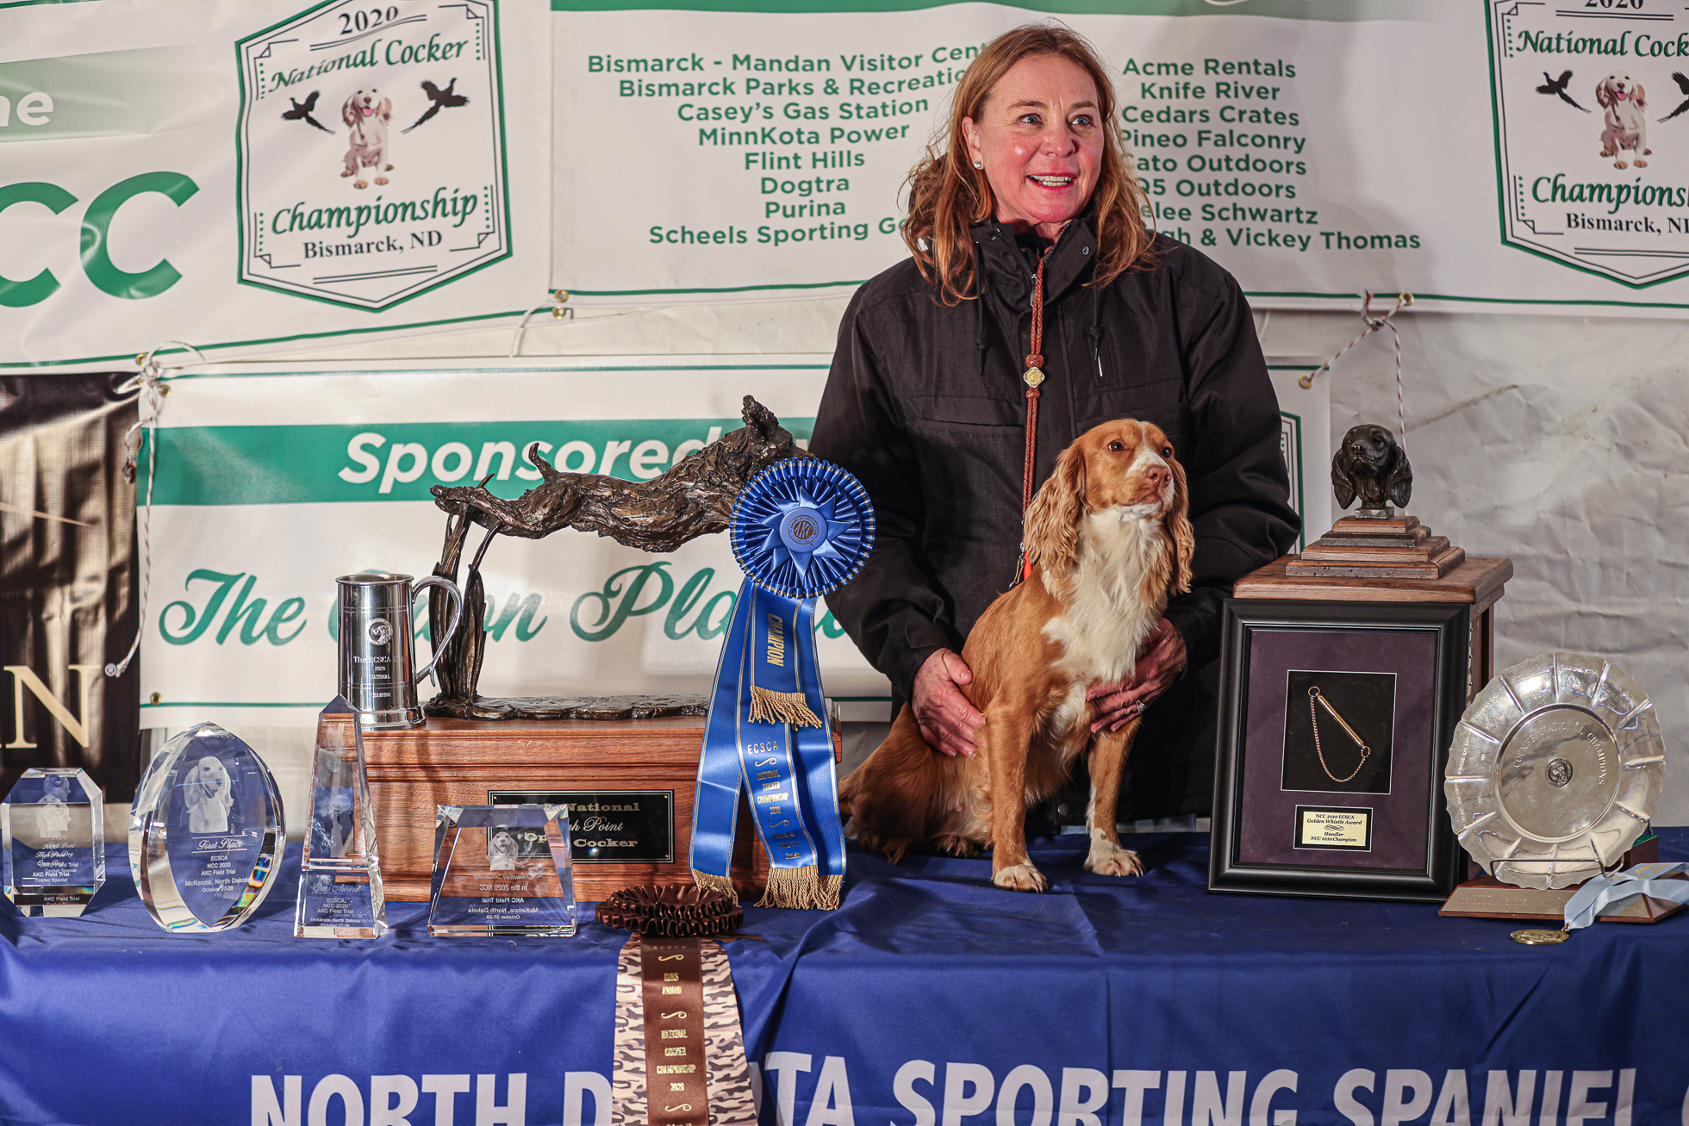
2020 National Champion
Warrener’s Tullinadaly “Tully”

2

ECSCA Field Trial Committee Meeting Minutes
Thursday, December 17, 2020

Call to Order: The meeting was called to order by Dawn Schuster at 6:07 PM CST.

FTC Members Present: Dawn Schuster (Chair), Ron Bollock, Chris Dartt, Jordan Horak, Pat Keliher, Mike Ludwig and Cheryl Dooley.

Approval of November Meeting Minutes: Chris made a motion to approve the November meeting minutes. Ron seconded the motion and the motion carried.

Approval of Agenda: Ron inquired as to whether the FTC is required to compose a Year-End Report. Dawn informed the Committee the FTC Chair writes a Year-End Report for the ECSCA Board. It will be published in the ECSCA Yearbook in January. Pat requested a new addition to the agenda regarding a phone call he received about National Judges. Pat made a motion to approve the agenda as amended. Ron seconded the motion and the motion carried.

OLD BUSINESS:

NACC Wrap-Up: Dawn reported the National Amateur went very well. The Trial ran smoothly with the First and Second Series on Wednesday, the Third and Fourth in the woods on Thursday and the Fifth followed by the Water Test on Friday. Dawn also indicated everyone did well and were very supportive of each other. The Food Booth at the Hotel was a success and there were a number of compliments received. Of the 44 entries, there were three scratches.
The Committee discussed the event and there was comment about the lack of communication regarding the Judge change. Some FTC Members received phone calls with complaints. Dawn indicated the change occurred on the Thursday prior to the event, but approval for the replacement Judge had to be obtained from the AKC. That approval did occur until Monday.
The final consensus was that while unfortunate the change occurred late, it could not be avoided and the lateness was due to a health issue/Doctor orders. The information was reported as soon as possible and, again, the Trial went well.
The FTC is very appreciative to Kim Wiley for stepping up at the last minute to take on the role of replacement Judge.
Dawn read the Placements and the FTC offered Congratulations to all Participants:

First Place – Jesse (Owner/Handler Walt Leytham) (Breeder Walt Leytham)
Second Place – Cruz (Owner/Handler Pete Rizzo)
Third Place – Shandy (Owners Joan & Kevin Gadde) (Handler Kevin Gadde)
Fourth Place – Dakota (Owner Alexandra Roberts) (Handler Scott Mason)

Certificate of Merit
Dutch (Owner/Handler Lori Guile)
Jacks (Owner/Handler Cahir Lynch)
Ripples (Owner/Handler Rumi Schroeder)
Finley (Owners John Kriegl & Mark Schinderle) (Handler John Kriegl)

NCC 2021: Dawn reported that Richie Whelan submitted his application for ECSCA Membership. The application is now in the 30-day review period and will be decided January 10th. At that time, the 2021 Flint Hill Preserve NCC will be approved. Dawn will contact Richie and also let him know the name of the new ECSCA Treasurer.

Ballots for FTC Regional Rep Elections: Dawn reported Mike Ludwig – Eastern FTC Rep has chosen not to serve a second term. Ted McCue contacted Dawn regarding interest in serving. Hearing from no other east region Members regarding a desire to serve, Ted will automatically be approved as the East Region Rep.
Jordan Horak- Midwest Rep also indicated he doesn’t want to serve a second term. Two individuals from the Midwest, Susan Saracino-Diehl and Terry Stubbs, expressed interest to serve. As such there will be a need for an election. The ballots are being prepped by Bethann Wiley. She will mail the ballots to Midwest Members for voting sometime this month. The ballots will be reported by Michelle Johnson (ECSCA Board Member). The FTC should receive the results by the second week of January. Cheryl Dooley – West Region Rep agreed to serve a second term.
The subject of At-Large Members stepping down was discussed. Currently, the Mission Statement does not address this issue. It only addresses the Regional Reps stepping-down. Dawn suggested that subject be put on the January agenda.
Chris requested the FTC consider adding an additional Regional Rep so areas with a large number of Field Trials have more representation. Chris cited Field Trials are not evenly distributed across the county. Dawn suggested this topic be addressed in January.
The subject of an FTC Member attending monthly ECSCA Board Meetings was discussed. Everyone agreed this would be a good idea to maintain a good rapport with the Board and for the FTC to learn from the Board. This topic was tabled until the January meeting.
Dawn indicated she attended the last Board meeting to present our proposal to change National Open Dog Qualifications and Judge Qualifications. She indicated she enjoyed the process and learned a great deal.
One major point of interest and change regards fundraising for the NCC and NACC. The Government has put in place new rules regarding fundraising thru Auctions and Raffles. The thought is some of these processes border on gaming or gambling making them illegal. All future fundraising efforts will need to be cleared through the ECSCA Board. This will be added to the ‘How to Run an NCC/NACC’ document so Chairpersons will be aware of the new laws.
Ron commented Owners/Handlers should be notified of a likely increase in entry fees for Nationals if fundraising efforts are curtailed.

‘How to Run an NCC/NACC’ Document: Dawn indicated the ECSCA has approved the proposed change for NCC Dog Qualifications. The new qualification will start at the 2021 NCC, taking effect for the 2022 NCC. The new rule will be one point within one year of the National, with all dogs placing in the 2021 NCC automatically eligible for the 2022 NCC.
The propose Judge Qualification change still needs to be approved by the AKC.

Trial End Evaluation Process: Due to complaints received during the 2020 Field Trial Season, the FTC has an ongoing discussion in progress regarding a concern around the quality of and a process for evaluating Field Trials. The discussion continued this evening with an emphasis on the importance of striving to solicit constructive comments which help improve the quality of Trials.
There was discussion around whether to allow the comments to be anonymous. Currently, the FTC is leaning towards requiring Folks to identify themselves. The thought being this would, hopefully, bring forth honest opinions and criticisms, keeping non-legitimate complaints to a minimum. The FTC discussed the concern that some Handlers may be emotional at first and discussed how we could get Folks to take time to step back and think about what really happened with their dog(s).
There was discussion around whether the FTC should be involved with this issue. But, it was suggested that Handlers/Owners don’t want to file formal complaints with the AKC. They feel more comfortable sharing information with FTC Members. As such, the FTC agreed something needs to be put in place and that duty falls to the FTC.
There was a suggestion that Field Trial Chairpersons be asked to fill out a Trial Report, stating how they felt about every aspect of the Trial (weather, Marshal, gunning, Bird production, cover, etc). The Chairperson would be asked to comment on what went well and what didn’t go well. Again, the Chairperson would need to be willing to take a long hard look at their Trial.
There was also discussion on how any Trial evaluation form might be evaluated, as well as who might be the ‘keeper’ of the data.
The final consensus is the FTC will conduct a Survey Monkey questionnaire. In general, the FTC wants to know if Folks feel the FTC should compose a field trial evaluation form, will Handlers be willing to fill it out after each Trial they attend, what they think the FTC should do with the information in terms of sharing the data with Clubs and how the FTC can help Clubs improve the quality of Trials.
The FTC wants to emphasize this is to be an exercise in improving the quality of Trials, taking care to not discourage Clubs in their Field Trial organization efforts.
Pat agreed to compose a short list of questions over the next few weeks. He will forward the list to the FTC Members for approval.
Once the survey is in place, Cheryl will enter the questions on Survey Monkey and notify Handlers/Owners to log on and respond.

NEW BUSINESS:

CSHE Trial Request: The Cocker Spaniel Hunting Enthusiast Club of Wisconsin has requested an opportunity to hold a Spring Trial the weekend of May 15th in Pennsylvania. The Club plans to hold two series in the woods and one series of open field work.
A question arose as to whether there will be a weekend between CSHE and Maine or will they be back to back weekends. Dawn indicated the Maine Trial is not listed on the calendar.
There was discussion as to any conflict regarding the weekend and the fact that Wisconsin is a Midwest Club with Maine being an Eastern Club. It was pointed out the distance rule to allow Clubs in the same region to hold trials on the same weekend is 250 miles.
The general consensus of the FTC is to handle these requests on a case by case basis. In this case, the Trials would be 250 miles apart. The question then being would the Clubs be competing for entries. Dawn & Pat will determine when the Maine Trial is to be held.

ECSCA Dues: Dawn reported ECSCA Membership renewals are due. The traditional yellow postcard was not mailed to Members this year. There was an email sent October 10th that, unfortunately, did not reach all Members. Membership Chair, Michelle Johnson is now individually emailing Members a notice. The FTC is encouraged to notify field trial participants to log on ECSCA.org to pay. Payment can be made by PayPal or Credit Card.

National Judges: Pat indicated he was contacted by someone who attended the 2020 North Dakota National regarding Judging. The individual specifically asked Pat about the use of 4- Judges at the Irish National, suggesting the FTC consider the same for the USA NCC. Pat indicated the use of 4- judges has been in effect in the UK for a number of years.
A discussion occurred around the pros and cons of 4- Judges for a National competition.
Cost is considered a major concerned, with an estimated increase of $4000. A suggestion was made to increase entry fees in order to pay for two additional judges.
One idea offered is using three judges where the third judge walks on the center line and watches both sides. There was discussion around the angle of view for the third judge being different than the two judges walking behind the Handler. There was also consideration about how that individual judge would watch two dogs at the same time and deal with Gallery distractions.
It was decided to be fair there would need to be four Judges, two per brace.
Discussion continued around trying to keep everything ‘even’ and ‘equal’. It was mentioned that most sports have rules, referees, and in the end a defined score that help keep the integrity of the game. Field Trials are more subjective than other sports. One Judge could miss something that might be seen by a second Judge. A comment was made ‘with a stroke of the pen a Judge is able to put a dog out of a trial and a year’s worth of work can be lost’.
The consensus of the FTC was to add a question to the Survey Monkey and ask Handlers for their opinion regarding two additional Judges and their willingness to help defray the costs.

Motion to Adjourn: Jordan made a motion to adjourn the meeting. Mike seconded the motion and the motion carried.
The meeting was adjourned at 8:17 PM CST.
The next FTC meeting will be held January 21, 2021.

Respectfully submitted,
Cheryl Dooley

