ECSCA Field Trial Committee Meeting Minutes
Monday September 21, 2020
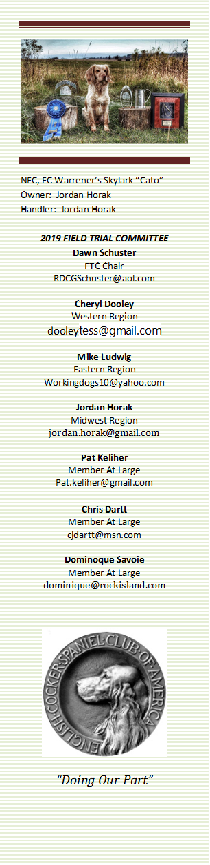
Call to Order - The meeting was called to order by Dawn Schuster at
6:20 PM CST.
FTC Members Present: Dawn Schuster (Chair), Ron Bullock, Chris Dartt, Jordan Horak, Mike Ludwig, Pat Keliher and Cheryl Dooley.
Others Present: Jon Hunke & John Alstad – Co-Chairs for 2020 NCC.
Approval of Minutes from August 20, 2020 –Pat made a motion to approve the minutes. Chris seconded the motion and the motion passed.
Approval of Agenda: Dawn indicated there are two additions to the agenda. Jon Hunke and John Alstad are present to give an update on the 2020 NCC – North Dakota. The Green Valley Club in California is looking for approval for a future Trial. Chris made a motion to approve the agenda. Mike seconded the motion and the motion passed.
Update on 2020 NCC – Jon Hunke and John Alstad were on-hand to give an update on the North Dakota National. Due to COVID there will be a need for a few changes. Jon, John and their Committee are sorting out the details and will release the information to the Field of Handlers as soon as possible. They reported they have asked an Agronomist to inspect the property for ‘mean seeds’. None were found, but they stressed there could still be some present and Handlers/Owners must be willing to accept the risk.
Potential Changes to Dog & Judge Qualifications for NCC– Based on the results of the Survey Monkey, it was decided the FTC would propose a change to NCC Dog Qualifications and NCC Judge Qualifications. The FTC will devote the next FTC meeting to discussing these two subjects. Upon determining new recommendations, the FTC will propose the changes to the ECSCA BOD for approval.
2021 NCC Location – The FTC discussed two proposals received for hosting the 2021 NCC. One Utah Club offered to host the event as long as the 2020 NOC (Springer National) would not be cancelled this year due to COVID. The Utah Club is hosting the springer event and, if cancelled, that event will be held in UTAH in 2021. The Club can’t host both in the same year due to the amount of work involved. An East Coast Club submitted a proposal for the 2021 NCC to be held at Flint Hill Preserve in New Jersey. The FTC discussed the proposals and decided with the uncertainty of the2020 NOC being held in Utah, it might be best to choose Flint Hill. Additionally, 2021 in the East would fit with the traditional rotation of regions (Midwest – West- East).

New Business:
High Point Dog for 2020 – A discussion took place around whether or not to award a High Point dogs for 2020 in light of the fact that a number of Folks were not able to run trials due to COVID. Points brought up included the fact that this award is a tradition and Folks who have run trials should not be penalized due to COVID. A vote was called and the majority of the FTC wanted to award the High Point dog in 2020.
Trial Result Submissions – Dawn asked all FTC Members to remind Club Secretaries when submitting Field Trial results to be certain to include the Dog’s Full name, Call Name & Owner/Handler. This information should be submitted to Bethann Wiley for posting on Fieldcockers.
Green Valley California Trial Applications – Dawn indicated Green Valley would like to hold a Trial March 13& 14. The FTC approved the application.
Adjournment – Mike made a motion to adjourn the meeting. Chris seconded the motion and the motion carried. The meeting was adjourned at 7:20 PM CST.

After some discussion about concerns with social gathering at the NCC, The FTC has opted to not hold the annual meeting at the nationals. The FTC gathered enough information and has given opportunity for discussion regarding the dog qualifications and national judge qualifications. The next meeting will be dedicated to discussion and possible motions on those two topics.

The next FTC Meeting will be held at 6:00 PM (CST) on October 13, 2020.
Respectfully submitted by Cheryl Dooley.

