Field Trial Committee Minutes

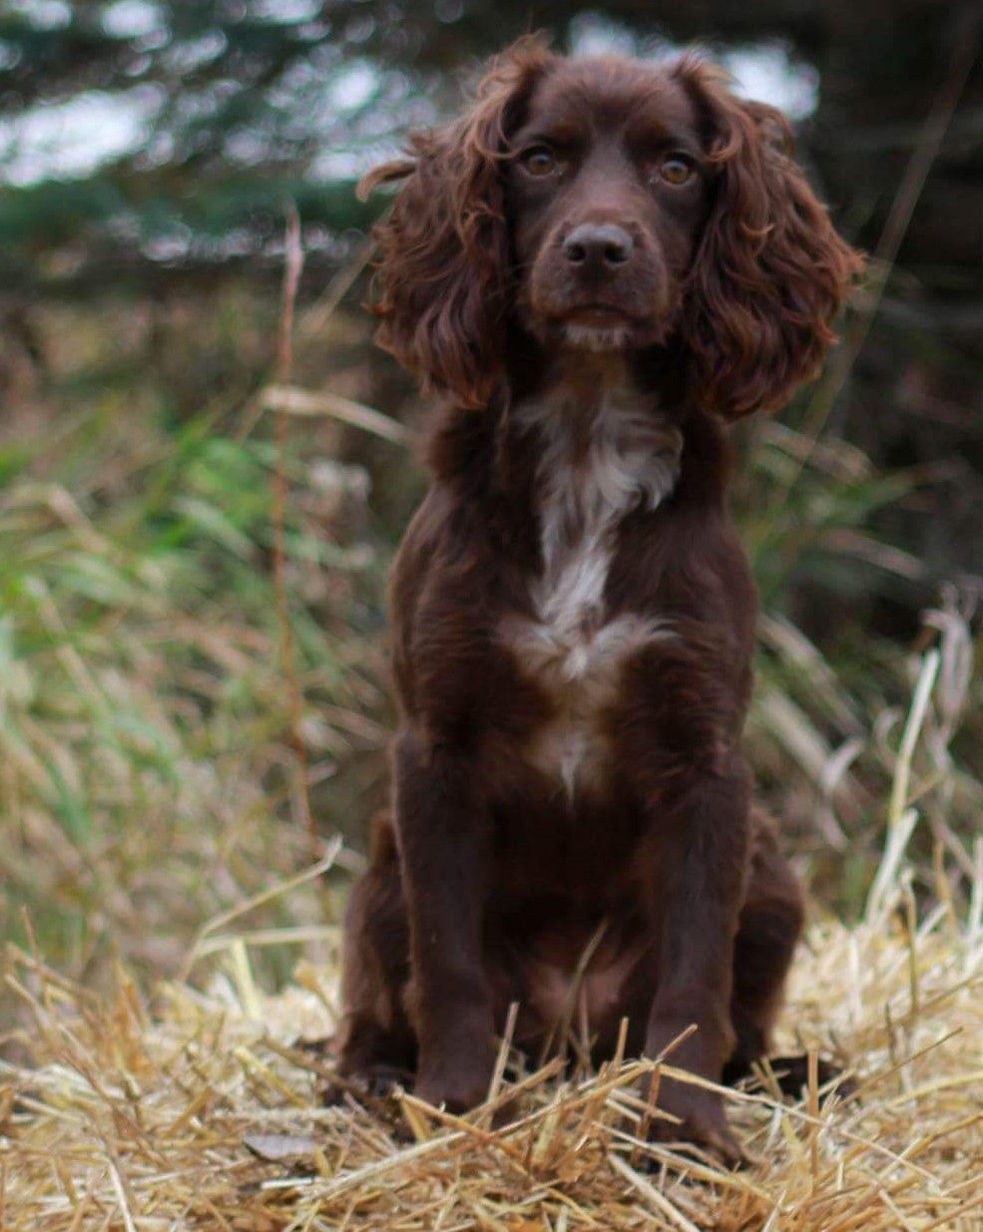

NFC, FC Absolute Winnie

Owner: Jim Leferman

Handler: Dan Murray

2017 FIELD TRIAL COMMITTEE

Deb Strohl
FTC Chair & Central Region
debstrohl@gmail.com

Vicky Thomas
Western Region
gigvicky@aol.com

Pete Rizzo
Eastern Region
workingdogs10@yahoo.com

Keith Meissner
Recorder & Member At Large
kjmeissner@yahoo.com

Dennis Joannides
Member At Large
djoannides2@gmail.com

Terry Reckart
Member At Large
osbllc@roadrunner.com

Mike Schroeder
Member At Large
besbeam@hotmail.com

“Doing My Part”

English Cocker Spaniel Club of America
Tuesday, September 12, 2017
8:00 p.m. Eastern Time
Members Present: Deb Strohl, Mike Schroeder, Vicky Thomas, Keith Meissner, Pete Rizzo, Dennis Joannides, Terry Reckart
Special Guest: Mike Ludwig 2018 NCC Chairman
- Call to order A call to order was made at 8:02pm
- Approval of minutes Keith moved to approve the minutes, Vicky seconded. All were in favor.
- Approval of the agenda Vicky added under “New Business” to discuss how the NCC Judges are nominated. Keith moved to accept the minutes and Mike seconded the motion. All in favor.
- 2018 Cocker National: Mike Ludwig the 2018 NCC Chairman updated the FTC on the 2018 NCC progress. The proposed grounds, owned by Ralph Botti, consist of several hundred acres that have been groomed for dog trials! Located in Horseheads, New York, just south of Elmira NY, is in the central-southern tier of New York State. The 1st and 2nd series will be held in a broom grass field, the 3rd& 4th series will be held in an overgrown brush field, the 5th series will be held in the woods. There is also a pond onsite for the water series. Mike will be working on upgrading the parking area as well as some of the roads. The date will be October 24th – 28th. Other Committee members consist of Tom Calabrese as Treasurer; Murry Tate will be the Secretary; Dawn Schuster will take on the Fundraising position; Deb Strohl will be the Patron Chair; and DaveBarto will be the Gun Captain. Pheasants and Chukar will be delivered fresh every morning. Mike and Tom will be traveling to the grounds in a few weeks to look at the courses, check on the hotels as this will give them a good idea of conditions for next year.
- Unfinished Business:
Elections: Within the next several days, ballots for the following 3 elections will be distributed. Please vote!
- AMATEUR NOMINEE’S update Nominees for the 2018 NACC include: Ken Hansen, Mike Wallace, Jason Givens, Bob MacDonald, and Lynn Miller. Ballots will be sent to everyone qualified to compete in the Cocker Amateur Championship in April.
- OPEN NOMINEE’S update Nominees for the 2018 NCC include Ralph Botti, Robert Griffin, Dominque Savoie, Mhari Peschal, Ken Hansen and Vern Knapp. Ballots will be sent to all dog owners that would have been qualified if the qualification period remained at 3 years. BUT, only those dogs that have had a placement within 2 years will be allowed to participate.
- AT LARGE NOMINEE’S Nominees for the FTC at Large Members are Pat Keliher, Dominque Savoie Christ Dartt, Susan Diehl, Dawn Schuster, and Jeff Janousek. Ballots will be sent to ECSCA field members.
- Amateur Eligibility – The FTC members want to thank the field for the comments they received on the subject. There was a lengthy discussion of several different proposals put forth and the committee discussed the pros and cons of each. After an exhausting debate it was decided not to rush to a decision. A special meeting is scheduled for Tuesday, September 19, 2017 to conclude the discussion.
- Regional Trophies: Pete and Vicky have completed the wording for our new “Regional High Point Trophies” that will be awarded at the 2017 NCC. A motion was made to approve the “Regional High Point Awards” by Vicky Thomas, seconded by Pete Rizzo. (ATTACHED) It was approved unanimously. We will now forward this to the ECSCA Trophy committee via Bethann Wiley. The FTC thanks Pete Rizzo and Keith Meisner for donating the Eastern Region High Point Trophy, Terry Reckart for donating the Central Region High Point Trophy and Vicky Thomas and Paul McGagh for donating the Western High Point Trophy. Each of these trophies will be “TRAVELING trophies” and are similar, and because they are constructed from re-purposed wood each will look different. They all have carrying cases to protect them.
- The FTC notes that a new High Point Bronze Trophy has been acquired and is in process of being cast. We hope it will be received before the 2017 NCC. Pete is working on getting the base prepared and all the prior engraving switched from the prior award. It will also become a Traveling Trophy and have a carrying case.
- We are still seeking a donor for the 1st place Cocker National Amateur Trophy. (Anybody interested?)
New Business:
- ECSCA – Board of Directors The FTC notes that Kim Wiley in 2019 will come to the end of his term on the ECSCA Board of Directors and we are looking for nominations for a new Field Representative for the Board for the 2019 vote. We do have a couple of names in mind, but if you are interested or know an ECSCA member who would be interested in serving on the ECSCA Board please let the FTC know. For several years we have been lucky to have field representatives on the Board and we feel it’s important to continue having a presence in the Parent Club.
- SPRING 2018 – Cocker Calendar to be continued at the next meeting
- 2019 Open National The FTC is looking for Clubs that would like to have the honor of hosting the 2019 Open National Championship. The FTC is also looking for host Clubs for the 2020 Amateur National Championship.
- Nomination procedures for future NCC’s to be continued at the next meeting.
- Meeting adjourned at 10:35pm EST (late!)
- Next meeting scheduled for October 10, 2017 at 8pm EST

Regional High Point Dog Open Stakes Trophies:

EASTERN REGIONAL High Point Open Dog Traveling Trophy, offered by Peter Rizzo in memory of FC AFC Hawthorne’s Miss Annie and Keith Meisner in memory of FC Hawthorne’s High Diver is constructed from repurposed barn wood mounted with the bronze head of a Cocker; and with engraved brass plates of the namesof the dog, owner, handler and year of all the past winners beginning in 2017. This award is presented to the Cocker that has accumulated the most points in AKC Open Stake Trials staged within the Eastern Region during the performance year starting the day after the NCC and will include points earned in the following year’s NCC regardless of location. An asterisk (*) will denote if the Cocker is also the United States High Point winner. If open stake trials fall below two per year, this will trigger the trophy will no longer be awarded, and it is to be retired to The Gun Dog Hall of Fame as a permanent record of the outstanding dogs from the Eastern Region, their owners and handlers.
A commemorative outright trophy will be offered by __________ to the winner.

CENTRAL REGIONAL High Point Open Dog Traveling Trophy, offered by Terry Reckart in memory of Jane & Delbert Reckart, is constructed from repurposed barn wood mounted with the bronze head of a Cocker; and with engraved brass plates of the names of the dog, owner, handler and year of all the past winners beginning in 2017. This award is presented to the Cocker that has accumulated the most points in AKC Open Stake Trials staged within the Central Region during the performance year starting the day after the NCC and will include points earned in the following year’s NCC regardless of location. An asterisk (*) will denote if the Cocker is also the United States High Point winner. If open stake trials fall below two per year in the region, this will trigger the trophy will no longer be awarded, and it is to be retired to The Gun Dog Hall of Fame as a permanent record of the outstanding dogs from the Central Region, their owners and handlers.
A commemorative outright trophy will be offered by __________ to the winner.

WESTERN REGIONAL High Point Open Dog Traveling Trophy, offered byGlencoe Kennels in memory of FC CFC Warrener’s Yellowhammer “Sydney” is constructed from repurposed barn wood mounted with the bronze head of a Cocker; and with engraved brass plates of the names of the dog, owner, handler and year of all the past winners beginning in 2017. This award is presented to the Cocker that has accumulated the most points in AKC Open Stake Trials staged within the Western Region during the performance year starting the day after the NCC and will include points earned in the following year’s NCC regardless of location. An asterisk (*) will denote if the Cocker is also the United States High Point winner. If open stake trials fall below two per year in the region, this will trigger the trophy will no longer be awarded, and it is to be retired to The Gun Dog Hall of Fame as a permanent record of the outstanding dogs from the Western Region, their owners and handlers dogs from the Western Region, their owners and handlers.
A commemorative outright trophy will be offered by __________ to the winner.

