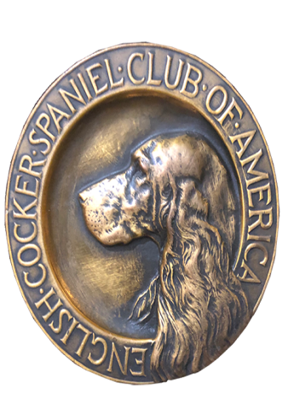
ECSCA
Field Trial Committee
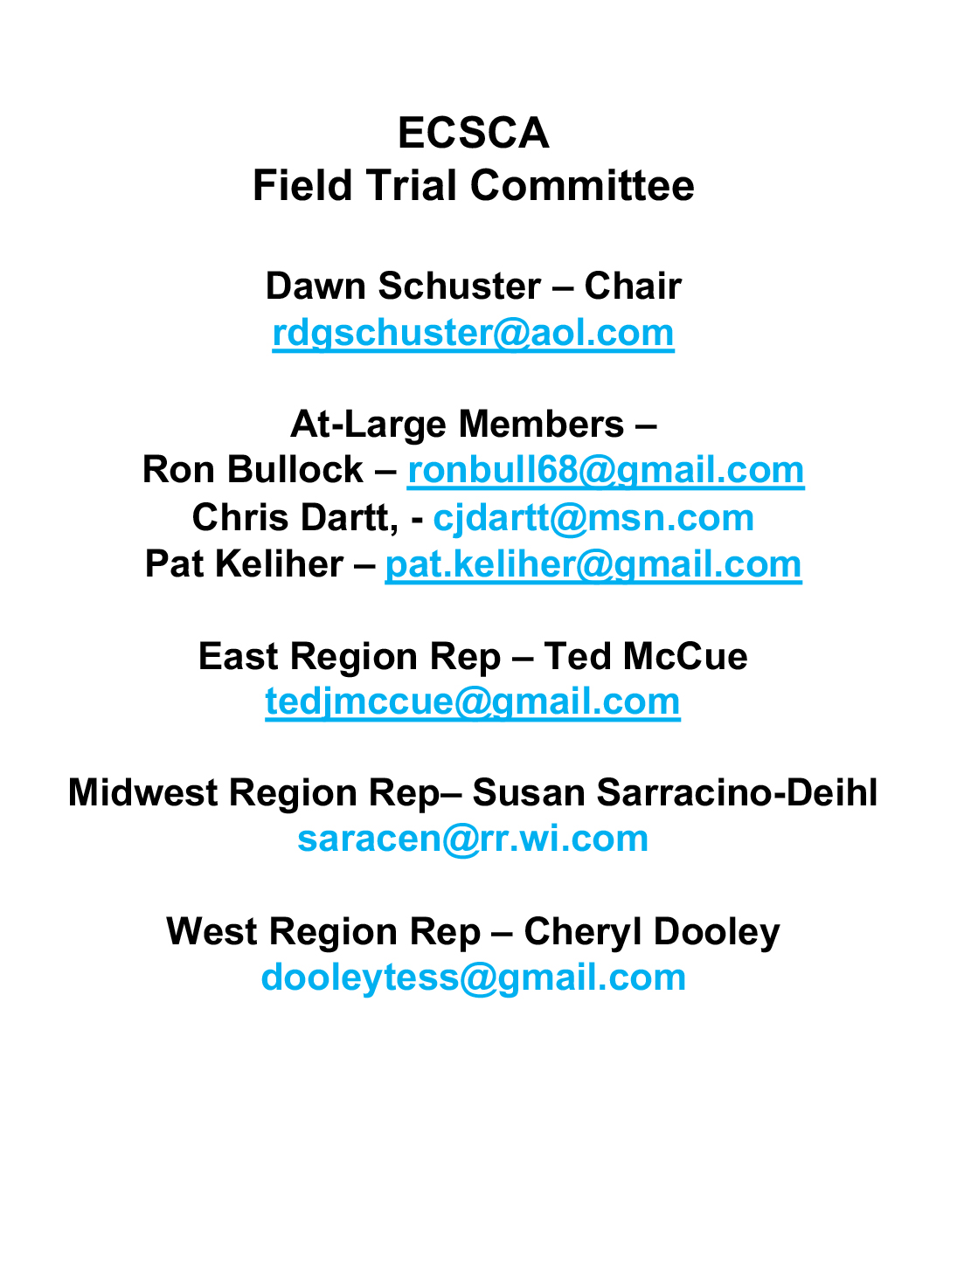
Dawn Schuster – Chair
rdgschuster@aol.com

At-Large Members –
Ron Bullock – robull@gmail.com
Chris Dartt, - cjdartt@msn.com
Pat Keliher – pat.keliher@gmail.com

East Region Rep – Ted McCue
tedjmccue@gmail.com

Midwest Region Rep– Susan Sarracino-Deihl
saracen@rr.wi.com

West Region Rep – Cheryl Dooley
dooleytess@gmail.com

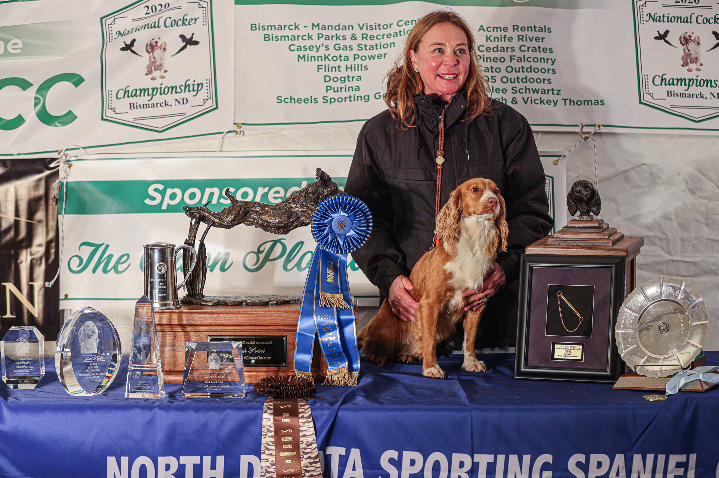

2020 National Champion
Warrener’s Tullinadaly “Tully”

2

- Call to order
Dawn Schuster, FTC Chair, called the FTC meeting to order on August 17, 2021, at 5:36 pm (CST).
Members present: Dawn Schuster, Ted McCue, Chris Dartt, Ron Bullock & Cheryl Dooley.
Susan Sarracino-Deihl and Pat Keliher were unable to attend.
- Approval of the minutes from the July meeting was previously accomplished by email, with a consensus of FTC Members in agreement. The minutes have been posted on fieldcockers.com.
- Agenda
  - Motion to accept the Agenda as presented
            - Moved by Chris Dartt
            - Seconded by Ron Bullock
            - Passed
- Patron Program
  - Deb Stroh and Vicky Thomas informed Dawn Schuster they are about 2- weeks out from finalizing plans for the 2021 NCC Patron Program. They will contact Dawn Schuster when the final plans are in place.
- 2021 Nationals Updates
  - 2021 NCC
            - Cheryl Dooley gave a brief update on the 2021 NCC plans. She indicated some details are still being sorted out, but details that are in place have been passed to Bethan Wiley for posting on fieldcockers.com. These items include: Marshals, Gun Team, HQ Hotel, Bird Planter, as well as various Chairs for different aspects of the Trial. As information becomes available it will be passed on to Bethan as well as Helena at Hunt Secretary.
            - One important issue pointed out by Cheryl Dooley is that the Farm basically lies between two towns. There are four entrances to various parts of the Farm. To avoid Folks getting lost and potentially interfering with the privacy of Residents, all NCC Handlers/Guests should enter through the LIFE CAMP Entrance. The address and directions will be noted in the Premium.
            - The FTC has requested Cheryl ask Richie Whelan and the NCC Committee to post signage for directing Folks to the proper location, in particular, placing signage where someone could easily be confused. The FTC also requests a Logistic Coordinator be assigned and present to assist Folks in navigating when transitioning between Series.
            - Cheryl Dooley also mentioned Flint Hill Preserve is a Private Club. As such, Folks will need to respect the rules regarding attire expected of Guests throughout the Event. The Dress Code does not allow Jeans, T-Shirts or Hoodies. Appropriate attire will be requested for the Banquet.
            - The FTC suggested the message regarding the Dress Code at Flint Hill be posted as soon and as much as possible. Chris suggest ‘banners’ be placed on the Premium posted on Hunt Secretary as well as fieldcockers.com. Suggested verbage: Please conform to the Dress Code: No Jeans, No T-Shirts, No Hoodies.
            - Cheryl Dooley indicated the NCC Committee needed the FTC Committee to decide when they wished to start the FTC General Meeting on Tuesday, November 2, 2021. The FTC discussed the potential length of the meeting and determined a 4:30 PM start time should be early enough to discuss business and still start the Welcome Party at 6:00 PM.
            - Cheryl Dooley indicated Vicky Thomas and herself were trying to sell ads for the NCC Catalog. She encouraged FTC Members to speak to their Clubs and encourage them to place an ad. The Catalog represents a large expense to the Committee. If 20- ads are sold, the catalog cost should be covered.
            - Chris Dartt reported that, so far, around 80%of the Trophy costs are covered by donations. She will continue to seek more Donors.
  - 2021 NACC
            - Dawn Schuster reported the AKC application for the 2021 NACC has been mailed to the ECSCA Treasurer – Kathy Moseley for a signature and check. Kathy Moseley will forward the application to the AKC.
            - Dawn Schuster reported two series will be run in open fields and two series possible in the woods. The 5th Series location has not been determined.
            - Dawn Schuster reported the Headquarters Hotel and lunches have been booked. More information will be posted soon.

- NCC Ballots for 2022 Judges
  - Cheryl Dooley sent out the Final Ballots on August 2, 2021. The Ballots are to be returned to Marissa Shepard with a postmark no later than September 15, 2021.
  - Dawn Schuster will announce the two 2022 Judges’ names at the 2021 NCC>
- How to Run an NCC Document
  - Cheryl Dooley reported that the largest issue regarding editing the How To… document revolves around the software program used to create the program. Anyone attempting to edit the document has found the document format is completely altered when one attempts to change anything. After some investigation, it was determined Cheryl would need to purchase software that will allow the document to be edited.
  - Cheryl Dooley reported that she will obtain the appropriate software and edit the document as soon as possible. The document will be completed before the next FTC meeting and emailed to all FTC Members for review.
- NACC Spring vs Fall vote
  - Due to the absence of two FTC Members, this topic was tabled until the September FTC meeting.
- New Business
  - Nominations for Harold Bixby Award
            - Dawn Schuster asked FTC Members to consider individuals they wish to nominate for the Bixby awards. Dawn indicated the nominees would be discussed and voted on at the September FTC meeting. The Winner will be announced at the 2021 NCC.
  - The FTC sends condolences to the Family and Friends on the passing of Barry Schroeder on August 13, 2021.
  - New FTC Members
            - Dawn Schuster informed the FTC on December 31, 2021 At-Large Member terms expire for: Ron Bullock, Chris Dartt, Pat Keliher & Dawn Schuster. Chris, Pat and Dawn have reached the two-term limit. Ron has the option to run for another term. Ron indicated he would let Dawn know what his decision might be.
            - Dawn Schuster encouraged the FTC Members to spread the word regarding the At-Large openings amongst ECSCA Field Trials Members and encourage Folks to submit their names and bios for the ballot.
            - Ballots will be sent out by Bethan Wiley in early November. Newly elected Individuals will be notified in December and start serving their first terms in January 2022.

The meeting was adjourned at 7:00 pm (CST).
Minutes submitted respectfully by: Cheryl Dooley
The next FTC meeting is Tuesday, September 21, 2021, 5:30 PM (CST)

