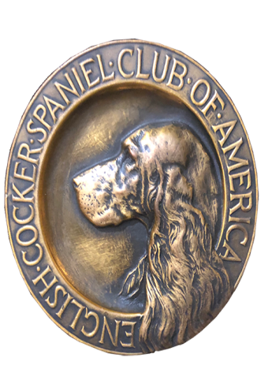
ECSCA
Field Trial Committee

Dawn Schuster – Chair
rdgschuster@aol.com

At-Large Members –
Ron Bollock – robull@gmail.com
Chris Dartt, - cjdartt@msn.com
Pat Keliher – pat.keliher@gmail.com

East Region Rep – Ted McCue
tedjmccue@gmail.com

Midwest Region Rep – Susan Sarricino-Deihl
saracen@rr.wi.com

West Region Rep – Cheryl Dooley
dooleytess@gmail.com

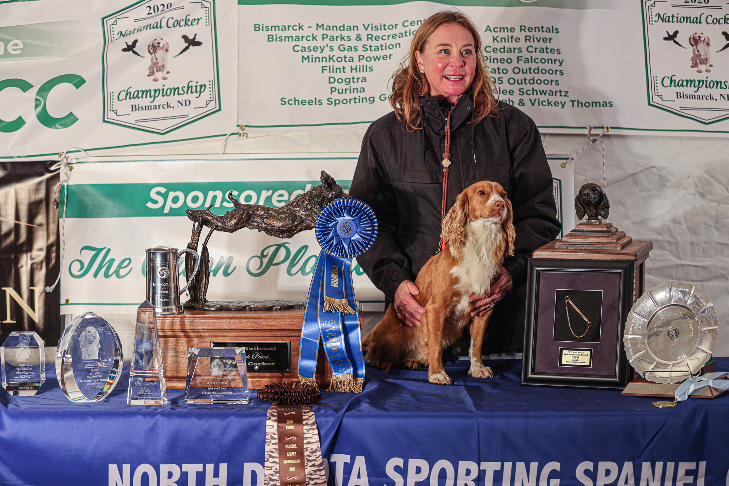

2020 National Champion
Warrener’s Tullinadaly “Tully”

2

ECSCA Field Trial Committee Meeting Minutes
Tuesday, April 20, 2021

Call to Order: The meeting was called to order by Dawn Schuster at 5:33 PM CST.

FTC Members Present: Dawn Schuster (Chair), Ron Bollock, Chris Dartt, Pat Keliher, Ted McCue, Susan Sarracino-Deihl and Cheryl Dooley.

Approval of March Meeting Minutes: The March Meeting Minutes were approved by email.

Approval of Agenda: Pat made a motion to accept the Agenda. Susan seconded the motion.

OLD BUSINESS:
Update on Changes to Fall Calendar:
Dawn reported a minor change to the North Dakota Fall Trial. They would like to hold a Cocker Trial on September 11 and 12.

Jim Keller of the Central Maine Club Informed Dawn they are currently trying to shore-up details on grounds, but would like to hold a Cocker Trial on June 12 & 13.

Chris indicated that the Clubs that moved Trials so as to avoid conflicts with a potential Fox Valley NACC (Steve Collins’ Club and Central Wisconsin) would like to keep the ‘new’ dates.

NCC/NACC bids 2022 & 2023:
Dawn indicated Fox Valley has pulled their proposal for a 2021 NACC. The question at-hand is whether there is time to re-open the 2021 NACC for bids.

Dawn reported Walt Leytham indicated some interest in holding the NACC in Virginia in mid-December. Walt informed Dawn he is working on Pete Rizzo as Co-Chair. They have acquired permission on 2000 acres of land that has a good deal of variability.

The main issue is a lack of lodging near the grounds. The drive to the grounds would be 40-50 minutes.

Dawn encouraged Walt to get a bid proposal into the FTC soon.

Pat indicated he felt no matter what our decision, this timeframe will not give a committee a lot of time to organize a National so it is important to have a strong Chair or Co-Chair, along with a strong Committee.
There was discussion around Judges for a 2021 NACC. Dawn suggested Casey Butz and Paul McGagh as they had been chosen for the 2020 NACC and neither could attend due to COVID issues with traveling. A tentative decision was made to contact both Casey and Paul once definite dates are chosen. If one or neither can attend, the FTC will need to conduct a new voting process.
The issue of scheduling a NACC in the fall and where it might fit on the calendar was re-discussed. Cheryl suggested, depending on the two locations, one week between the two might not be enough for travel time. It seems the required time between the two could vary from year to year.
Dawn reiterated the NCC takes precedence and would select the NCC dates first. The NACC date would need to schedule around the NCC.

There was also discussion around the rotation of the Nationals. Currently, the NCC rotates from East to Midwest to West. 2020 was held in the Western Region. 2021 will be held in the East. 2022 needs to be held in the Midwest.

The question arose as to whether the NACC would follow a similar protocol. Susan pointed out that there seems to be pressure on the same set of workers. Chris indicated some might be the same but not all.

Chris questioned if the rotation is actually a rule. She suggested the FTC revisit the Regional rotation of the NCC, but currently with the problem of trying to find Clubs to host the NACC it might be difficult to enforce a rotation. Susan requested the ‘rotation rule’ be placed on a future agenda for discussion.

Dawn reported that there are potential proposals being written as follows:
2021 NACC – Virginia (Leytham)
2022 NCC – Pickneyville, IL (Mommaerts)
2023 NCC – Clarkston, Utah (Riddle)

Cheryl inquired as to whether the respective Clubs would be submitting photos or a description of the Grounds, as it seems important to try to have some series work in ‘cocker cover’.

Dawn indicated the Grounds will represent the Region hosting the Trial. Woods type cover may not be available in all regions of the country.
Chris suggested that NCC/NACC Premiums make it clear to Owners/Handlers what type of cover there will be for series work. That would allow Folks a chance to decide whether to attend or not or bring appropriate clothing such as chaps, etc if the cover might indicate the need for such. Chris emphasized Cockers are hunting dogs and we shouldn’t be overprotective of them. Chris indicated it should be acceptable to have grounds that are difficult and challenging.

Dawn indicated that the ECSCA Trial Application form does not require a description of cover. The FTC was reminded that Chris and Pat were in the process of revising the form. Chris reported Susan volunteered to work on a better format. The revisions can be done using updated Adobe software. Susan is to purchase new Adobe software. The ECSCA NCC/NACC/Field Trial Discretionary funds will pay for the subscription which will cost $180/Year. Susan remarked that this new software will also make setting up the NCC and NACC Catalogs much easier.

Survey Monkey Part 1 & Part 2:
Part 1 includes the first Survey Monkey that was performed in 2020. Dawn indicated we still need to address the comments that some Folks added at the end of the questions. Dawn asked Cheryl to group together the comments into categories and email them to the FTC.

Part 2 refers to the drafted survey concerning Field Trial Quality and whether the FTC should get involved with issues/complaints. Dawn stated Handlers need to be heard and the FTC wants to address their concerns. The issue is what the process might be.

Pat acknowledged that Susan and Ted were not on the FTC when the discussion around this second survey was conducted. He pointed out to them that we were struggling as to whether or not the FTC should be fielding complaints and how we were to address them. Most felt if they could be used as teachable moments or mentoring it would be good to be involved. However, most do not want to address complaints that should be reported to the AKC.

Pat continued to explain that the survey was built around Trial quality. He suggested if we decide to conduct this survey we remove the beginning narrative and focus questions around issues with Trials involving grounds/cover, birds, bird planting, gunning, marshalling, etc.

Again, Pat reiterated the largest hang-up for the FTC is what the FTC would do with the information. Does the FTC have a basis to be involved and how could the FTC influence change?

Ron suggested, in terms of Grounds, the FTC should revise the Application form and stress a third series in cocker cover.

Susan pointed out that the Green Book states the Trials should be run in cover that closely resembles actual hunting grounds for the area.

Ted suggested Field Trials should be taken with a grain of salt. Stating they are meant to evaluate hunting skills and to closely resemble hunting in a particular Region but, Trials are not actually hunts.

Dawn suggested the FTC turn this issue into a ‘Learning Essay’ that can be circulated to all clubs. The essay could cover subjects such as the Handling of birds, etc.

Dawn also reported that Tom Meyers is returning to the AKC to serve as the Field Rep and should be able to attend Trials in the near future. There is likely to be a second AKC Rep. This may allow Handlers to go directly to the AKC with complaints, taking the onus off the FTC.

Dawn reported that there is a Field Trial Checklist on fieldcockers.com. She asked Pat to take a look at the checklist and revise it so it is current. Pat agreed to this, but indicated the soonest he would get this done would be June or July.

Dawn asked all FTC Members to take a look at all the documents on fieldcockers.com. She feels a number of them need to be revised or eliminated.
Chris suggested we add a tab with instructions for huntsecretary.com procedure.

Based on the discussions the FTC agreed that we would not move forward with this survey. FTC shall continue to encourage and educate clubs and handlers to hold high quality events. Anyone with complaints shall be directed to the AKC as rules dictate. Pat agreed to review the current documents on holding field trials and will update them and expanded where needed to emphasize “trial quality” and bring the updates back to the FTC at a late summer meeting.

Facebook & Social Media Page:
Dawn pointed out, while FACEBOOK could be used for posting Trial Dates and FTC minutes, having a FACEBOOK page could open the door for negative items getting posted. This could lead to ill feelings if negative comments are made about a recent Trials.

Susan indicated someone would have to monitor & moderate the page. The job could be complicated and time-consuming.

NEW BUSINESS:

Patron Program (Deb Strohl & Vicky Thomas Proposal):
Dawn reported that Deb & Vicky contacted her regarding a change in the Patron Program. She has asked them to join the FTC meeting in July to explain the program further. Basically, they would like to stop the print program for Patrons and propose a new idea for the NCC. There would be no cost to the ECSCA.

Vicky also informed that Jane Van Soest-Smith has offered to paint a portrait of the NCC Winner every year. The new idea to be proposed will incorporate the portrait.

Chris suggested that Jane be given a Full-Page Ad in the NCC Catalog as a Thank You for her willingness to donate a portrait each year.

NCC Judging Ballots:
There was a short discussion on the possibility of switching from a mail-in ballot to voting by email. Two major points to consider is the preliminary ballot currently is returned to Cheryl and the Final ballot is returned to a neutral party and, secondly, it is critical the voting be confidential.

NCC & NACC updated qualifiers list:
Bethann Wiley provided the FTC with a list of dogs qualified for the 2021 NCC.

There was a great deal of discussion around how voting for National judges would be conducted in the future.

Ted suggested the following:
Dogs qualified for 2020 NCC vote for 2022 NCC Judges
Dogs qualified for 2021 NCC vote for 2023 NCC Judges
Dogs qualified for 2022 NCC vote for 2024 NCC Judges
Dogs qualified for 2023 NCC vote for 2025 NCC Judges

Cheryl suggested the following:
For 2022 NCC Judge voting – continue with our current qualification rule where dogs who qualify for the 2021 NCC vote for 2022 NCC Judges
At the 2021 NCC we switch to the new rule of One Point within One Year and at that time voting would proceed as follows:
- Dogs newly qualified in 2021 Fall & 2022 spring vote for 2023 NCC Judges
- Dogs newly qualified in 2022 Fall & 2023 spring vote for 2024 NCC Judges
- Dogs newly qualified in 2023 Fall & 2024 spring vote for 2025 NCC Judges
The number of Dogs voting under these guidelines will range from 100 – 120.

No decision was made at this time so FTC Members would have time to consider the options.

Motion to Adjourn: Chris made a motion to adjourn the meeting. Susan seconded the motion and the motion carried.
The meeting was adjourned at 8:05 PM CST.
The next FTC meeting will be held May 18, 2021 at 5:30 PM (CST).

Respectfully submitted,
Cheryl Dooley

