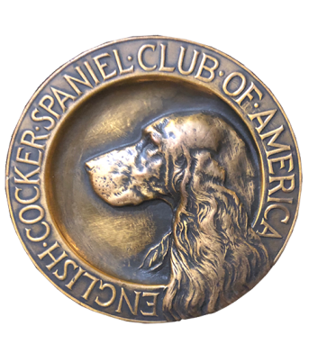
ECSCA
Field Trial Committee
Dawn Schuster – Chair
At-Large Members –
Ron Bollock, Chris Dartt, Pat Keliher
East Region Rep – Ted McCue
Midwest Region Rep – Susan Sarracino-Deihl
West Region Rep – Cheryl Dooley

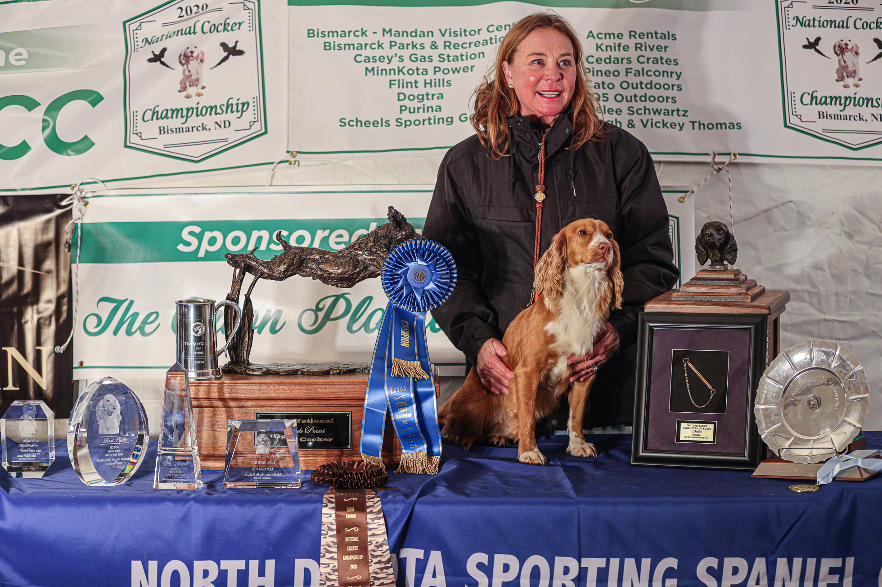
2020 National Champion
Warrener’s Tullinadaly “Tully”

2

ECSCA Field Trial Committee Meeting Minutes
Tuesday, March 16, 2021

Call to Order: The meeting was called to order by Dawn Schuster at 5:40 PM CST.

FTC Members Present: Dawn Schuster (Chair), Ron Bollock, Chris Dartt, Pat Keliher, Ted McCue, Susan Sarracino-Deihl and Cheryl Dooley.

Approval of February Meeting Minutes:
Susan noted a sentence that was incomplete in the February Minutes. Cheryl will check her notes and edit the minutes. Chris made a motion to approve the February meeting minutes as edited. Ted seconded the motion and the motion carried.

Approval of Agenda:
Pat suggested adding a discussion regarding the process of approving the meeting minutes. Dawn suggested this be added to New Business – B. Pat made a motion to accept the agenda as edited. Susan seconded the motion and the motion carried.

AKC Marketplace article (Guest – Bethann Wiley):
Bethann indicated she is on the ECSCA Marketplace committee. She gave the FTC a detailed overview of the AKC Marketplace, which lists Breeders who are selling pups from their kennel. Bethann stressed the need to provide appropriate and accurate information about each breed so Buyers can seek reputable Breeders. Thus, the reason behind writing the article regarding the qualities of Field-Bred English Cocker Spaniels.

There are 130-140 Parent Clubs that are Members of the AKC. Delegates from each Parent Club are elected to serve on AKC Committees. The AKC Marketplace, which is owned by the AKC, is one such Committee.

Bethann reported that the current article about Field Bred Cockers was written 15- years ago. Bethann has now updated the article and is seeking comment from the FTC.

Bethann addressed several questions from the FTC regarding the AKC Marketplace and how the information could be tied into the fieldcockers website or FACEBOOK. In particular; do Breeders get charged for listings, is there a time limit on listing, are photos provided, is it clear Field-Bred Cockers need a ‘job’, and does the AKC encourage proper breeding practices.

The FTC expressed no concerns over the article.

Board of Directors Meeting March 4, 2021:
Dawn announced that she attended the last ECSCA Board Meeting on March 4, 2021. At that meeting she presented the FTC proposal for a yearly NACC as well as changing the NACC qualification from three years to two years starting with the 2022 NACC. The Board voted immediately and approved the proposal.

Pat suggested the FTC have a conversation with the ECSCA around the FTC having an ex-officio Member to attend the monthly ECSCA Board Meetings. Dawn indicated she feels the Board would likely be receptive to the idea.

It was also mentioned the ECSCA Yearly National Meeting will be held April 13, 2021 and is OPEN to All. Other Board meetings are held the first Wednesday of each month.

There was discussion around whether the FTC Members should rotate attendance to the Board meetings or just assign one individual from the FTC to attend every meeting.

Pat suggested the FTC write a memo requesting this opportunity. The item was tabled until April allowing time to put a memo together.

OLD BUSINESS:

Additions to 2021 Fall Calendar:
Dawn noted the following requests:
North Dakota has requested the addition of an early June Cocker Trial.
Cocker Spaniel Field Trial Club of America would like to hold a Spring trial with Jerry Cacchio and Pat Keliher as Judges.

Survey Monkey:
The FTC discussed the latest Survey Monkey theme: Field Trial Quality. In particular, there was concern over whether the FTC should be involved in policing Trials. The consensus is the FTC should not act as Enforcers but instead as Mentors.

There was also discussion around whether FTC Reps in attendance at a Trial should get involved in any issues that might arise. It was decided such involvement could be disruptive and that FTC Reps likely should only be involved if Field Trial Chairs or Judges request their input.

The general FTC consensus is that Folks need to come to the FTC for direction when needed. Then, the FTC can either suggest they file a formal complaint with the AKC or the FTC can take the issue to the AKC.

It was also concluded that the FTC will maintain privacy with any issues. The FTC as a Group will discuss situations and determine the best possible course of action that will serve as an educational tool and not a reprimand. All such contacts with Field Trial Chairs or Committees will be handled in a confidential fashion.

In regards to the Survey Monkey, Pat and Cheryl will complete the editing of survey questions and submit them to the FTC Members for final approval.

Limited Entry Trials/Low Bird Numbers:
There was a brief discussion around Limited Entry Trials. To date, only the Missouri Headwaters Gun Dog Club has a limited entry. When their Trial opened on Huntsecretary.com it filled in an hour and now has a large waiting list.
*Minnesota Hunting Spaniel Assoc has now also established a limited entry trial in May.
It was mentioned that the way to keep things fair for any Limited Entry Trial is to have a ‘Hard Opening’ for sign-up. HuntSecretary is posting day and time of openings on each of the trial premiums now. It is recommended that anyone wishing to enter these trials be watchful of opening dates and times on Huntsecretary.

NEW BUSINESS:

NCC Updates/correspondence/bids 2022 (NCC/NACC):
Dawn reported the developments with Chair positions:
Deb Strohl – Sponsor/Patron Chair
Chris Dartt – Trophy Chair
Cheryl asked for clarification regarding Raffles or Silent Auction. Dawn indicated Raffles are acceptable if pre-approved by the ECSCA Treasurer and Silent Auctions are allowed as that would not be considered gambling.

Dawn indicated Richie Whelan will be invited to attend the July FTC meeting and provide a NCC update.

Clarification of FTC Meeting Minutes Approval:
There was a brief discussion around how much info needs to be included in the minutes. Included in this discussion was whether or not to identify FTC members by name when an idea or thought is presented. The general consensus was to try to have a balance between being too vague versus providing enough information so Cocker Folks will have a good idea of what was discussed at the meeting.
The subject of when to post the minutes was discussed. Currently, the minutes are emailed to the Group. If Dawn does not hear any objections they are posted by Bethann on fieldcockers.com. It was suggested the minutes be approved at the next monthly meeting, but decided this could result in a significant delay in getting information out to Members.

Dawn suggested the FTC follow the previous FTC practices. Cheryl will email the minutes as soon as they are typed. Everyone needs to read the minutes posted in the email. Dawn will expect a 48-hour turnaround in approval. Then, Dawn will take the Approval of Previous Meeting Minutes off the agenda. That will be replaced by a comment at the bottom of the monthly minutes that indicated the previous meetings were approved by an email vote.

Future NCC Locations:
The FTC discussed the need to line out NCC locations for the next several years (2022, 2023, 2024).

It was determined that for 2022, under the current rotation system of East, Central, West) the 2022 would fall into the Central Region. Dawn indicated the FTC will now be seeking bids for the 2022 NCC.

The question of the 2022 NACC location arose. There was some discussion around Maine hosting the NACC. Pat indicated the Club has not officially committed to this idea. He will try to meet with the Club and get an answer by the April FTC Meeting.

2021 NACC Proposal from Fox Valley Club:
Rumi Schroeder, President of the Fox Valley Club, informed the FTC the Club would like to host the 2021 NACC starting October 4th thru October 6th. Some FTC Members indicated these dates would clearly impact some local Trials; including Maine, Minnesota, Michigan and Nevada.

The was discussion around last month’s FTC motion that there needed to be at least 1- week between the NCC and NACC. And, that the FTC’s motion included making the NCC a top=priority. The 2021 NCC is scheduled to be held from November 3rd thru November 6th. The Welcome Party and Annual FTC Meeting will be held November 2nd.

The FTC discussed the importance of allowing time for Folks to get from one National location to the next, again, with the NCC being the priority. It was mentioned the NOC (Springer) (Kansas) and NAC (Springer) (New York) trials are slated for November 29th and 14th, respectively. With these National dates and the late October dates of some local Cocker Trials, it seems the most logical dates for the NACC would be after the NCC.

A letter will be drafted to the Fox Valley Club indicating the FTC concerns about an early October Trial and suggest a date be selected that would fit within the new guidelines established in February’s NACC yearly proposal.

It was asked whether the FTC would seek bids from, other Clubs or groups should the Fox Valley Club decline to hold the NACC 2021. The FTC unanimously agreed to open the NACC up for bids.

Facebook/Social Media Page: Due to the length of the agenda this evening, this item will be moved to the April Meeting.

Motion to Adjourn:
Ron made a motion to adjourn the meeting. Ted seconded the motion and the motion carried.
The meeting was adjourned at 7:52 PM CST.
The next FTC meeting will be held April 20, 2021 at 5:30 PM (CST).

Respectfully submitted,
Cheryl Dooley

