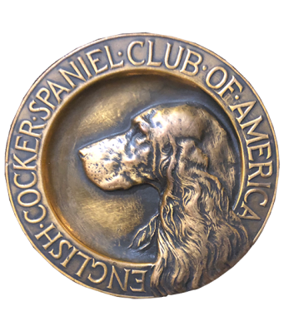
ECSCA
Field Trial Committee
Dawn Schuster – Chair
At-Large Members –
Ron Bollock, Chris Dartt, Pat Keliher
East Region Rep – Ted McCue
Midwest Region Rep – Susan Sarricino-Deihl
West Region Rep – Cheryl Dooley

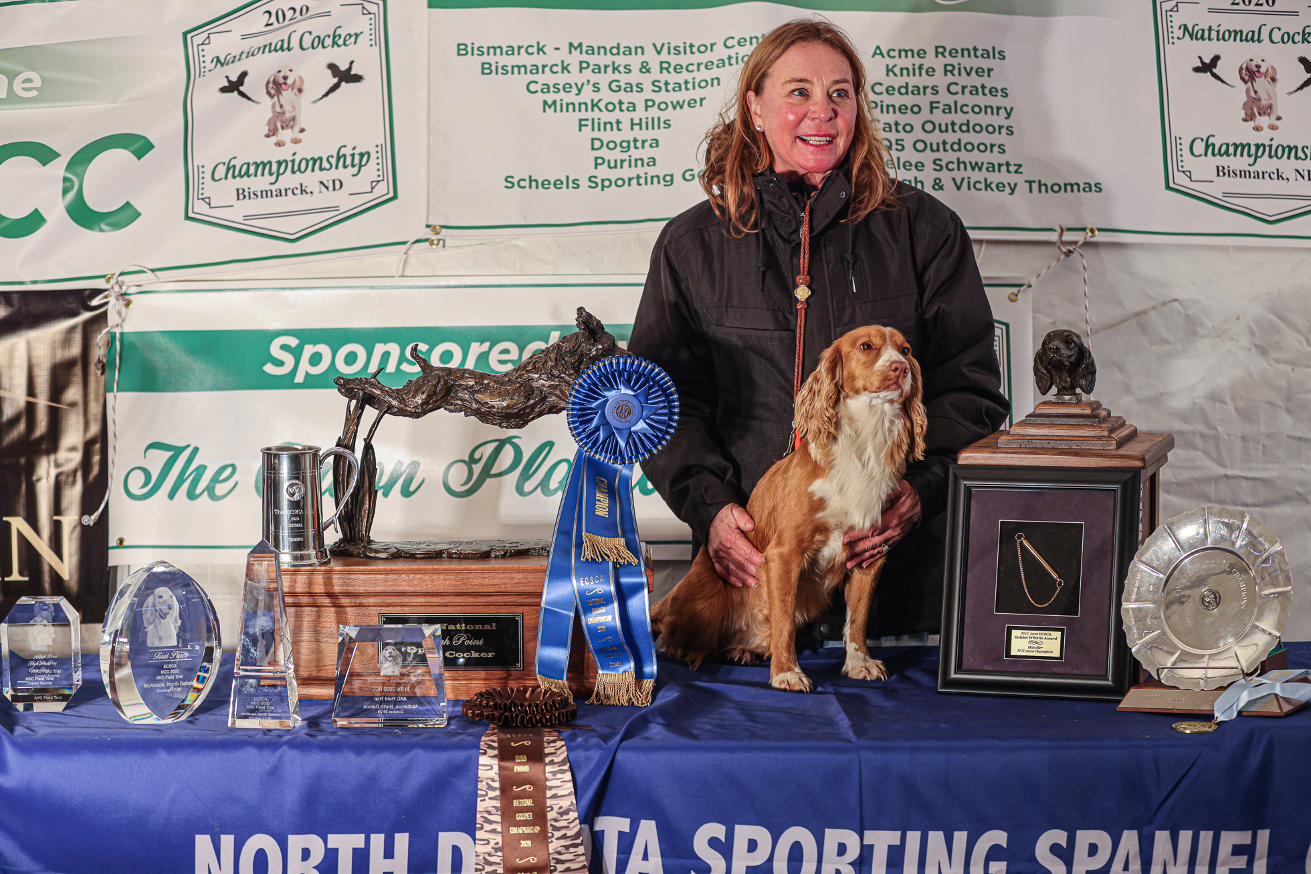
2020 National Champion
Warrener’s Tullinadaly “Tully”

2

ECSCA Field Trial Committee Meeting Minutes
Thursday, February 16, 2021

Call to Order: The meeting was called to order by Dawn Schuster at 5:45 PM CST.

FTC Members Present: Dawn Schuster (Chair), Ron Bollock, Chris Dartt, Pat Keliher, Ted McCue, Susan Sarracino-Deihl and Cheryl Dooley.

Approval of January Meeting Minutes: Ted made a motion to approve the January meeting minutes. Chris seconded the motion and the motion carried.

Approval of Agenda: Ted requested two items are added to the agenda: Limited Entry Trial proposed by North Dakota and quality grounds. Pat also requested there be an Update on How to Run an NCC. Pat made a motion to approve the agenda as amended. Ron seconded the motion and the motion carried.

OLD BUSINESS:

NACC 2020 Budget Comparisons: Dawn reported that she and Susan Sarracino-Diehl had a phone conversation with Karen Spurlin (ECSCA Treasurer). The three sorted through nine pages of notes attempting to sort out the differences between Dawn’s initial report and Karen’s end of the year report. Dawn indicated some items in question were: Purina donation, Agronomist Charge, Travel expenses for two original Judges, Judges Gifts, and accommodations for some Field Trial Committee Members. There was discussion around whether other National Trials have compensated Trial Chairs or other Committee Members for travel expenses (transportation, hotel, food). Chris and Ron, previous National Chairs, indicated they did not compensate any Committee Members. After some discussion, Ron & Pat suggested How to Run an NCC should be updated to indicate no compensation shall be provided to Committee members. Chris & Susan added that if the Committee wants to try to cover such costs, they need to solicit for extra dollars and find someone to pay for the bills. After the recent phone call with Karen Spurlin it appears the deficit will be closer to $500 than the original report of nearly $4000.

NACC Yearly or Every Other Year: Dawn asked the FTC Members for their final thoughts on whether or not to hold a NACC yearly.
Pat suggested the FTC reopen this discussion this evening by addressing local Amateur Trial numbers. He indicated the local trials go hand in hand with the NACC, affecting both the number of dogs able to qualify and the quality of the dogs qualified. Pat emphasized, no matter what, the FTC decision should be based on what is best for the breed and the sport. He added any social considerations should not factor into the decision.
Overall the FTC would like to see the status of the NACC be similar to the National Amateur Springer Trial. To get to that level, the FTC recognizes we need a quality event with quality dogs.
Chris indicated she feels the first decision is to address the impact of changing the NCC qualifications to one point/one year. This qualification will not take effect until the 2021 NCC FIFTH series is completed. So, it could be almost two years before any effect of the NCC qualification change is detected.
In the meantime, it seems critical to promote Amateur Trials at the local level.
Susan provided the group with data she has collected regarding the number of Amateur Trials held over the past 5- years.
Year - # of Amateur Trials
2016 – 9
2017 – 21
2018 – 17
2019 – 24
2020 – 20 (COVID year)
2021- 27 on the Calendar
Noting that the number of Amateur Trials has increased over the past 5- years, the FTC discussed how to continue this upward trend. The main issue - How can we grown Amateur Trial entry numbers as well as the number of Amateur Trials held? Dawn checked the 2021 Calendar and counted potentially
Pat indicated the Maine Club has been uninterested in hosting an Amateur Stake, however, if they were to host a NACC, they would certainly consider adding an Amateur stake to their Trial weekends in order to get local dogs qualified.
Chris pointed out, while it is very possible to hold an OPEN and AMATEUR in the same day entries for each are generally low. Citing most Folks don’t want to run their Cocker in two Trials in the same day. She also mentioned that there was a time having a Field Championship Title was a bid deal, now with lower entries it is easier for dogs to obtain an FC. As such, the FC Title has lost some impact.
Susan mentioned that while in the past there was only a NCC, it is possible that if there is a NACC yearly, more new Folks might lean toward the Amateur Trials. She also indicated that she checked the running orders of both the 2020 NCC and NACC and found there were 12-15 dogs that ran in both trials.
There was a brief discussion around potentially offering incentives to Clubs that hold an Amateur stake, but no consensus was reached.
There was a discussion around the increase in competitiveness of OPENS. Chris mentioned early on, Amateurs were able to compete with Pros. Now there are many more Pros and much more competition.
There was discussion around changing the qualification requirement for the NACC. Currently the qualification is any placement within 3- years.
Pat made a motion to initiate a yearly NACC in 2021 with all future NACC Trials scheduled after local trials are completed and allow a 3-year qualification for 2021, but change to a 2- year qualification for 2022. Ted amended the motion to include there needed to be a 1- week separation from the NCC. Ron seconded the motion as amended and the motion carried. Dawn informed the group that she will seek final approval for this proposal at the ECSCA Board of Directors meeting on March 3, 2021.
Cheryl asked if the NACC locations would be based on a rotation similar to the NCC (East, Midwest, and West). It was decided that decision would be made later once a calendar date is decided; noting some parts of the Midwest might have weather issues.

Now that a decision has been made to have a 2021 NACC, Cheryl brought up the issues of Judge Selection. Dawn suggested that since the two Judges picked for the 2020 NACC could not make the Trial due to COVID reasons (Paul McGagh & Casey Butz), we invite them to judge the 2021 NACC. When a date has been set for the Trial, Dawn will contact both Paul and Casey. If for some reason one or both are unable to judge, there will be a need for a new vote.

The Fox Valley Proposal as Hosts for the 2021 NACC was discussed. Susan pointed out she looked carefully at the budget. She noted the budget is set for 70 entries and she feels that number is not likely. The other Members of the FTC agreed. Therefore, there the FTC would request a re-working of the budget based on a more reasonable number of 45-50 entries. Susan made a motion to tentatively approve the Fox Valley proposal pending a revised budget using a 50- dog entry. Ron seconded the motion and the motion carried.

Additions to 2021 Fall Calendar: Dawn noted that the 2021 AKC Calendar started with the First Week as January 9th not the first week of January. As such this has ‘thrown off’ the Cocker calendar. Dawn asked all Regional Reps to contact the Clubs in their regions and confirm which weekend they plan to host their annual Trials.

Update on “How To Run An NCC”: Pat mentioned that Vicky Thomas put in many hours revising the document to the point where decisions needed to be settled by the FTC. The FTC discussed more edits including the edit regarding the new Judges qualifications. Dawn indicated we are still waiting for AKC approval on that change, which will be 12- total Trial with at least six of the twelve Cocker Trials.
The FTC decided two addition changes needed are:
- The NCC (Open National) will always take priority over the NACC on the Calendar.
- Committee Members (Chairs, etc) will not be able to include their rooms, food or transportation expenditures in the budget. Those are personal expenses they must pay on their own.

NEW BUSINESS:

First Aid Equipment at Trials: There was discussion around the need for First Aid equipment for Dogs & Humans being available at Trials. IN particular, the need for AED devices. Multiple pros and cons were cited including cost and whether Clubs could afford such equipment. It was mentioned that Clubs who host more than one event per year (Field Trials and Hunt Tests) might be in a better position to afford the equipment and also have a greater need. The issue of training individuals to be able to use AED devices was discussed. It was mentioned that newer models require little or no training.
Other cons discussed were the level of responsibility placed on a Club as well as Liability issues,
In addition to the AED, it was discussed that it might be a good idea to encourage Clubs to have on-hand a fully-equipped First Aid Kit. Ted cited a recent Trial where many dogs were bloodied on a course.
Chris asked if it was the intention of the FTC to dictate to Clubs the type of First Aid supplies they needed to have on-hand. Dawn indicated the FTC would only suggest Clubs be prepared and consider fundraising money to cover the cost of supplies.

Limited Entries at Trials: North Dakota Sporting Spaniel Club has informed the FTC they have limited access to birds this spring for their Cocker and Springer Trials (held on separate weekends). They have petitioned the AKC to allow them to limit the entries for their Trials to 30 dogs per event. The AKC is evaluating such requests on a case by case basis and has approved North Dakota.
The FTC discussed on what might be the fairest approach to notify Handlers of this limited entry event so everyone has an equal opportunity to attend. Ted suggested it would be a good idea to have a ‘hard open’ where the North Dakota and the FTC alert Folks of the issue and announce in advance the date when it will be possible to enter the event. Cheryl was asked to contact Sue Wilson (ND Secretary) and has her to inform the FTC of the date and time entries would be open on Huntsecretary.com
*North Dakota has found a solid supply of birds and will no longer have a limit on the trial.

A discussion took place in regard to FTC involvement with Trials. Ted and Pat both expressed these issues can be used as ‘coachable moments’. Everyone agreed the FTC has no authority over where Folks hold their Trial. The FTC can only suggest and offer guidance. Pat expressed that the emphasis of the FTC should be to encourage quality birds, quality grounds and quality Judges. Chris pointed out that the FTC keeps going back to the same debate. Is the FTC going to refuse to allow Clubs with ‘offenses’ to host a trial in 2022? OR does the FTC required Clubs to provide more detailed descriptions regarding every aspect of the Trial. Pat suggested the Field Trial application form be modified/updated to allow a path for the FTC to ask for information and then encourage appropriate cover, etc. Pat also suggest the FTC finish editing the Survey Monkey questions and find out from Handlers how much they would like to see the FTC get involved in these issues. Chris agreed to edit the Field Trial application form and submit it to Pat for a second opinion. After they have revised the form they will send copies to FTC Members for review.

Motion to Adjourn: Ron made a motion to adjourn the meeting. Ted seconded the motion and the motion carried.
The meeting was adjourned at 7:54 PM CST.
The next FTC meeting will be held March 16, 2021 at 5:30 PM (CST).

Respectfully submitted,
Cheryl Dooley

