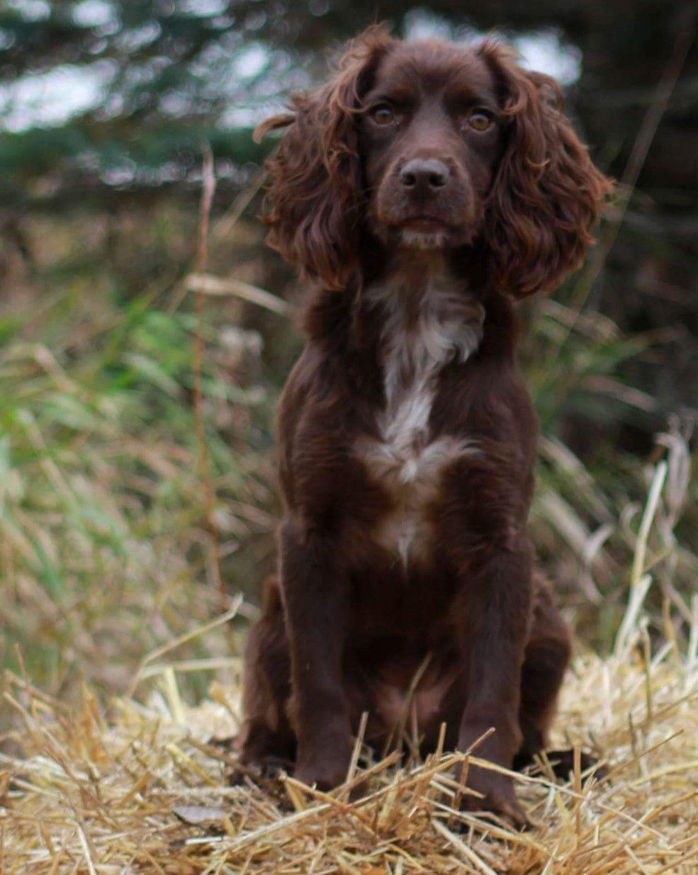

NFC, FC Absolute Winnie

Owner: Jim Leferman

Handler: Dan Murray

2017 FIELD TRIAL COMMITTEE

Deb Strohl
FTC Chair & Central Region
debstrohl@gmail.com

Vicky Thomas
Western Region
gigvicky@aol.com

Pete Rizzo
Eastern Region
workingdogs10@yahoo.com

Keith Meissner
Recorder & Member At Large
kjmeissner@yahoo.com

Dennis Joannides
Member At Large
djoannides2@gmail.com

Terry Reckart
Member At Large
osbllc@roadrunner.com

Mike Schroeder
Member At Large
besbeam@hotmail.com

“Doing My Part”

English Cocker Spaniel Club of America
Field Trial Committee

Meeting Minutes

Wednesday, December 13, 2017
8:00 p.m. Eastern Time
Members Present: Deb Strohl, Mike Schroeder, Vicky Thomas, Keith Meissner, Dennis Joannides, Terry Reckart. Absent: Pete Rizzo,
Call to order was made at 8:03pm
Approval of minutes Terry made a motion to approve the minutes, Dennis seconded the motion
Approval of the agenda Vicky made a motion to approve the agenda, Terry seconded the motion
Unfinished Business Dominque has had surgery and is unable to attend. The FTC wishes her well in her recovery. When she is healed the FTC would like to get some closure on the 2017 NCC, expenses, etc Deb will pass the info on if she can get it prior to the next meeting.
Seed Awns Vicky stated that we had an issue with seed awns at the 2017 NCC. Mike stated that the seed awns are all over the Mid-West. If we don’t want to have trials where there are seed awns, we may not be having trials in the Mid-West. We need to be aware of what is in the fields that we trial, train and hunt. A good idea would be for a trial committee to walk the grounds to check for seed awns prior to the trial. Terry noted that if there are seed awns in the field and the committee misses it, is there any liability for the committee? Do we cancel the trial? Vicky stated that there was a large number of people at the meeting that had previous issues with seed awns. Dennis stated that each person working their dog should be paying attention to their ground both trialing/training/airing etc and if seed awns are found, it should be brought to the attention of the committee. Seed awns might just become one of the risks of the game, similar to running in very hot weather or conducting water tests in freezing water. Hunters face these issues every time they enter the woods.
Closing comments on Gunning – Mike / Terry. The Gunning Program is the same as always. Essentially the Cockers are following the Springer gunning program.
ANCC 2018 – Updates - Deb stated that the ANCC for 2018 is moving forward. The Chairperson for the ANCC will give a presentation to the FTC at the January meeting. Vicky stated that there is only 4 months till the ANCC. Mike stated that the grounds are all set; permits are paid for etc... Birds are coming out of Illinois w/ Chukar & Pheasant. The hotel blocks are all set. -
The FTC would like all Amateur Trialers who are planning on running in the 2018 Amateur National Cocker Championship to notify the FTC of their intentions by emailing Deb Strohl at debstrohl@gmail.com so that we can get an idea of the number of entries. This will help to order birds, hotel rooms, banquet facilities etc..
Kuni Smith trophy Pete Rizzo has the contact info for Kuni and will be contacting her in order to return the trophy to her. He will get a signed receipt for the delivery of the trophy.
New way of selecting judges for Nationals Cheryl Dooley is working on a new letter to be sent out to all NCC & ANCC qualified judges. The letter will be sent out at the end of May to all qualified judges.
- NCC 2018 – JUDGES – Mhari Peschal and Ralph Botti alternate???????????
- ANCC2018 – JUDGES – Jason Givens and Lynn Miller alternate/Mike Wallace
- FTC At-large Positions 92 ballots were sent out 62 ballots were sent back. Those elected are Dawn Schuster, Chris Dart, Jeff Janousek, Pat Keliher. The new 2018 FTC will be: Deb Strohl, Vicky Thomas, Pete Rizzo, Dawn Schuster, Chris Dart, Jeff Janousek, Pat Keliher, effective January 1, 2018.
New Business:
- 2019 NCC There has been a bid for hosting the 2019 NCC by Ron Bullock of The Iowa Sporting Spaniel Club. Deb has been in contact with Ron. There is a concern about the cost of grounds. Deb is working with Ron to put together a budget and go over the workings of the NCC.
- Next FTC MEETING, Tuesday, January 09, 2018

HAPPY HOLIDAY and a VERY MERRY CHRISTMAS TO YOU ALL!

