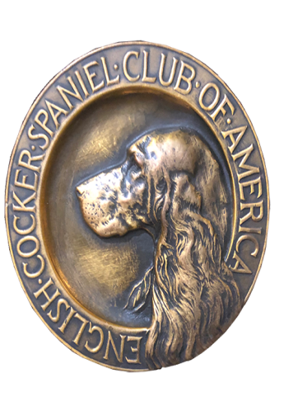
ECSCA
Field Trial Committee
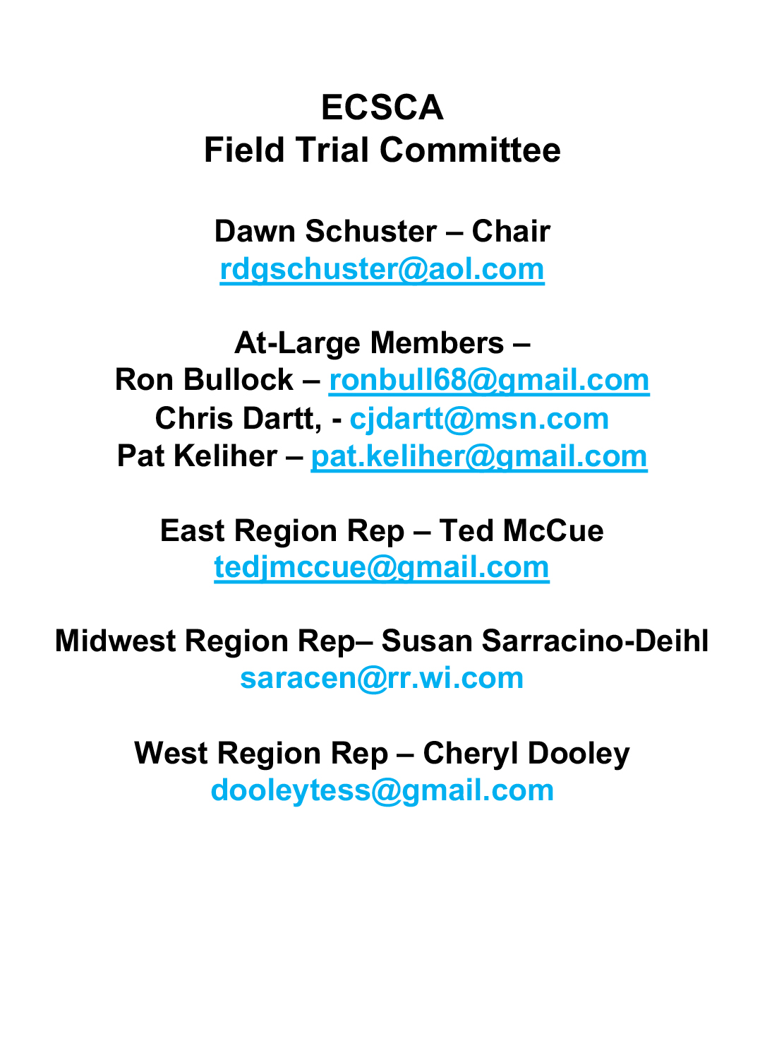
Dawn Schuster – Chair
rdgschuster@aol.com

At-Large Members –
Ron Bullock – robull@gmail.com
Chris Dartt, - cjdartt@msn.com
Pat Keliher – pat.keliher@gmail.com

East Region Rep – Ted McCue
tedjmccue@gmail.com

Midwest Region Rep– Susan Sarracino-Deihl
saracen@rr.wi.com

West Region Rep – Cheryl Dooley
dooleytess@gmail.com

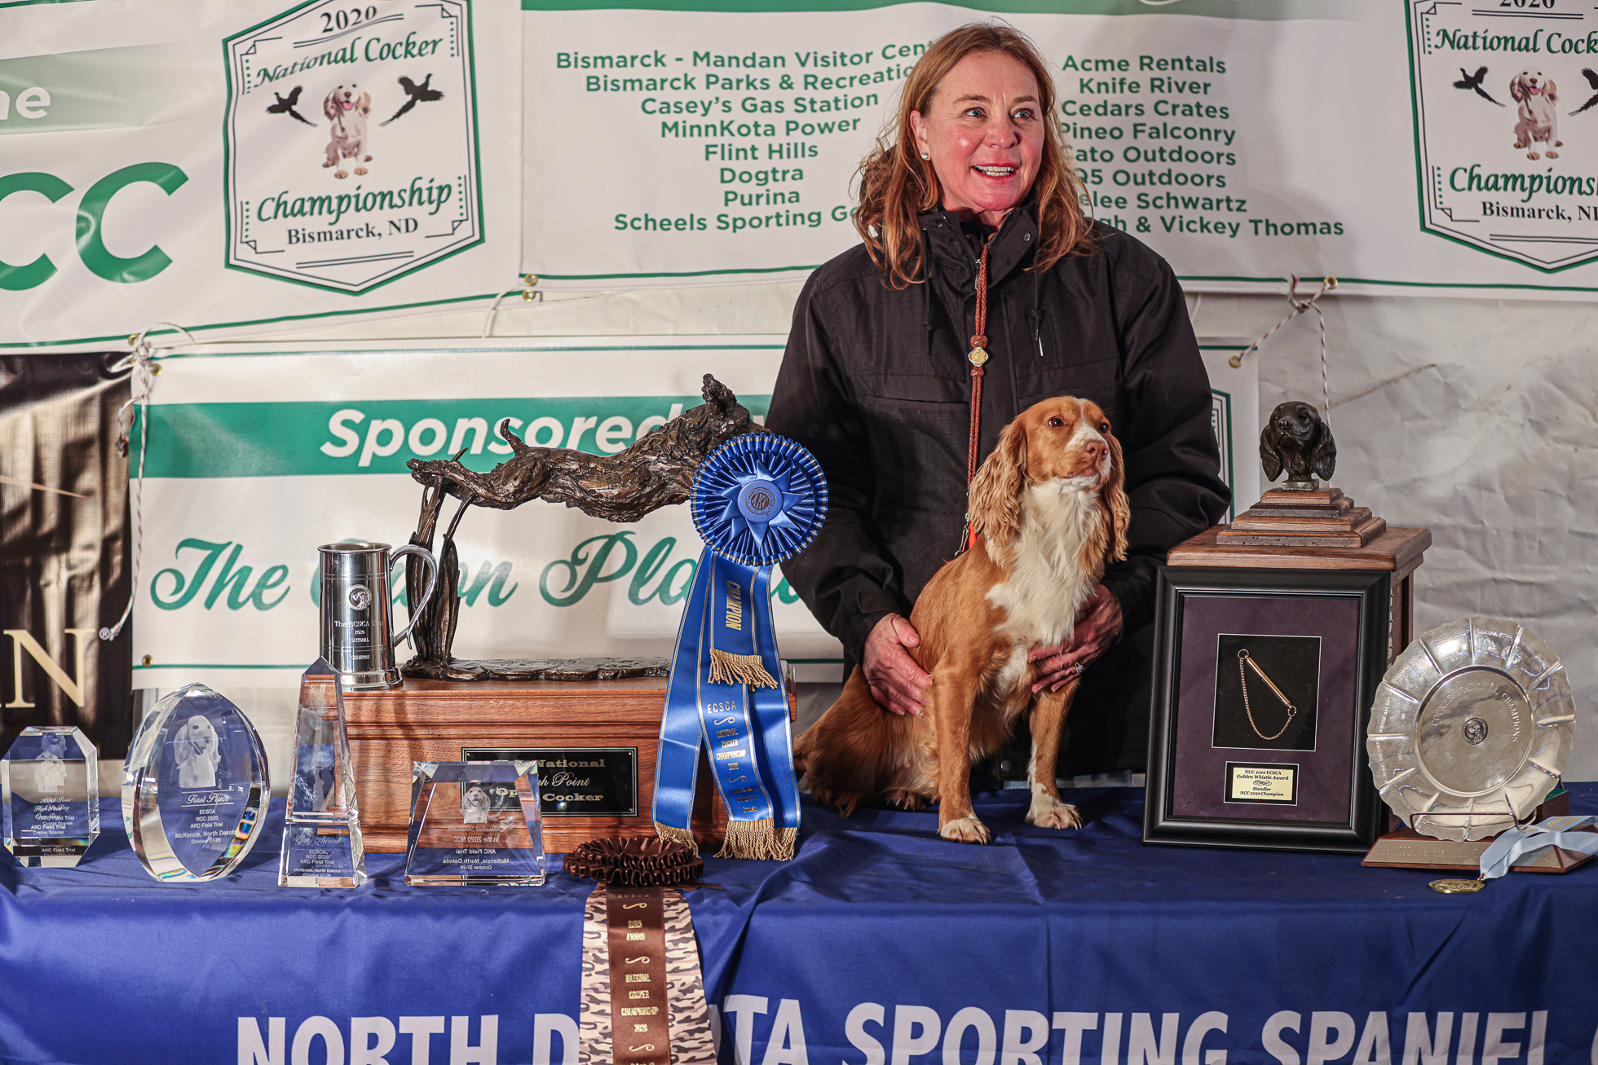

2020 National Champion
Warrener’s Tullinadaly “Tully”

2

ECSCA Field Trial Committee Meeting Minutes
Tuesday, November 16, 2021
- Call to order
Dawn Schuster, FTC Chair, called the FTC meeting to order on November 16, 2021, at 5:36 pm (CST).
Members present: Dawn Schuster, Ron Bullock, Pat Keliher, Ted McCue, & Cheryl Dooley.
- Approval of the minutes – Approval of minutes from the November General meeting was previously accomplished by email, with a consensus of FTC Members in agreement. Bethann Wiley noticed one edit. North Dakota NACC has not been approved by the ECSCA BOD. Bethann edited the minutes accordingly. The minutes have been posted on fieldcockers.com.
- Agenda
  - Motion to accept the Agenda as presented
            - Moved by Ted McCue
            - Seconded by Pat Keliher
            - Passed
- NACC Update – Now that the NACC entry deadline has passed and there are 37 entries, Dawn provided an updated budget. The original proposal was based on 50 dogs.
Income expected has been adjusted for the lower amount entries. Expenses have been adjusted to reduce the bird expense, Judge lodging expense and Judge’s gifts.
Dawn mentioned some income is uncertain at this point as they are still looking for series Sponsors and Flag sponsors.
Susan indicated she needed all the information for the catalog by tomorrow.
- NCC 2021 wrap-up –
Susan indicated she is sorting out the ad income.
Dawn indicated it could be a month before a final budget is received as some expenses are paid after the Event.
It was mentioned that the Patron Program gifts were shipped to patrons at a sizeable cost. There was discussion about avoiding that expense in the future by making an effort to get the Patron gifts delivered to the Event.
- How to Run an NCC Document
Dawn asked the Group if everyone had the opportunity to read the How to Run an NCC document. Everyone indicated they had. Susan pointed out a typo on page 12. Ron made a motion to accept the document after the typo is ‘fixed’… Pat seconded the motion and the motion passed. Cheryl will send the document to Dawn so she can send it to the ECSCA BOD for approval.
- Regional Representation
The FTC continued the discussion as to whether or not to change the make-up of the current three Regions (east, central, west) or create a new region. This discussion stems from the thought that some Members are receiving adequate representation.
Dawn provided a breakdown of ECSCA Members by Region:
West – 46
Central – 30
East – 28

Pat suggested a potential solution would be to look at the make-up of the FTC and assign each At-Large Member a portion of a region. For example, the east could be divided into North East and South East with the East Representative assigned one of the two and an At-Large Representative assigned the other.

The FTC decided these ‘assignments’ could be determined at the start of each year as the make-up of
the FTC might change from year to year.

- Finish Spring Calendar
The Group briefly discussed the Spring Calendar and it was noted that there were some East coast Clubs who have yet to submit their dates. The consensus was to allow time for those Clubs to get their dates to Dawn. After adjusting the calendar, Dawn will forward the final version to the Group.
NEW BUSINESS
  - NACC Judging Criteria
The Group discussed as to whether to have the same Judging criteria for the NACC Judges that are used for the NCC and also whether the 3- year waiting period should encompass both Nationals or just the National for which the Judge served. For example, should a Judge who judges the NCC be excluded from both the NCC & NACC ballots for 3- years or ONLY the NCC ballot. The Group decided the Judge should only be exclude from the National for which they judged for three years, not both the NCC and NACC.
  - Regional Rotation of National Events
There was a brief discussion around the fact that the NCC has an exciting rotation of East-Central-West whereas the NACC has yet to establish a rotation.
Considering the 2021 NACC will be held in the east and the 2022 NACC in the west, it seems the 2023 would be in the central region. However, if the NACC rotation is established as East-West-Central the 2024 NCC and NACC would be held in the East Region.
There was a brief discussion around whether anyone felt this would be an issue or if Owners/Handlers might be concerned about another year of NCC – EAST, NACC- EAST.
It was decided the FTC would take the month to think more about this situation before establishing any sort of NACC rotation.
  - Electronic Balloting –
Cheryl gave a synapsis of the electronic balloting process recently researched. The Company, Simply Vote, allows 10 ballots for $334.00 in a Calendar Year. Currently we spend about $350- $400 per year on balloting by paper.
Items needed to be addressed include:
ECSCA Permission- Dawn will check on this
Emails- we will need a valid email for each Dog Owner. Currently, we probably have about 90% of the emails.
One Person: One Vote- currently we allow one vote per dog. Electronic balloting willnot allow this as each email address is assigned only one IDENTIFIER Code.
Due to the absence of Chris and a couple of FTC Members who had to leave early, it was decided to continue this discussion via email and try to get a motion and vote before the December meeting.
  - NCC 2021 Placements & Annual Awards -
The FTC would like to offer Congratulations to the following 2021 NCC Placements and Annual Award Winners:
2021 National Champion – “Ike”; Owner/Handler: Jaelee Schwartz
Second Place – “Posie”; Owner/Handler: Jeff Lusk
Third Place – “Ripples”; Owner: Rumi Schroeder; Handler: Ralph Botti
Fourth Place – “Finley”; Owner: John Kriegle & Mark Schinderle; Handler: Jason Givens
Gun’s Award – “Posie”; Owner/Handler: Jeff Lusk
Best Amateur Handler of the NCC – Jeff Lusk
Weighted Average High Point Dog – “Molly”; Owner: Frank Brown; Handler: Dan Murray
High Point East Region Dog – A TIE OCCURRED
“Toula”; Owner: Dawn Smith; Handler; Ralph Botti
“Brunie”; Owner/Handler: Ted McCue

High Point Central Region Dog – “Ginger”; Owner: Scott Fitzgerald; Handler: Jason Givens
High Point West Region Dog – “River”; Owner/Handler: Jackie Juniker- Pitts
High Point Dog – “River”; Owner/Handler: Jackie Juniker- Pitts
High Point Handler – Jason Givens
High Point Puppy – “Alfie”; Owner: Rumi Schroeder
High Point Lady Handler – Jackie Juniker – Pitts
Harold Bixby Award – Cheryl Dooley
Adjournment – moved to adjourn the meeting. Seconded the motion and the motion carried.
The meeting was adjourned at 7:14 pm (CST).
The next FTC meeting will be held December 21, 2021 – 5:30 PM (CST)
Respectfully submitted: Cheryl Dooley

