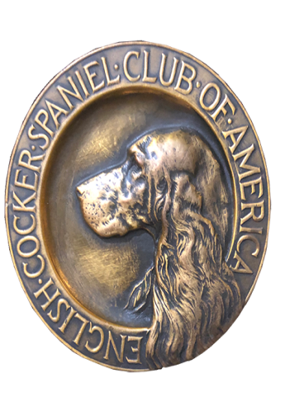
ECSCA
Field Trial Committee
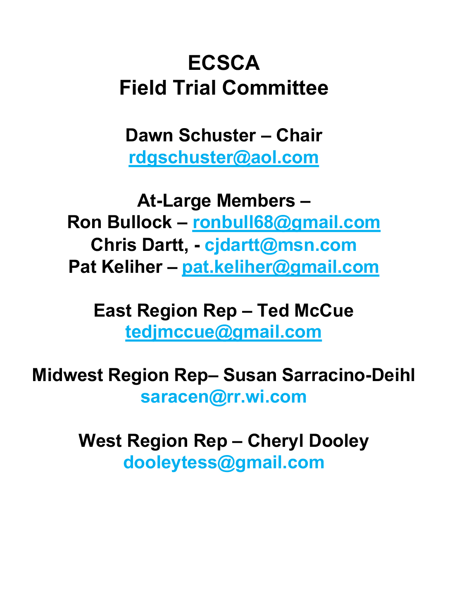
Dawn Schuster – Chair
rdgschuster@aol.com

At-Large Members –
Ron Bullock – robull@gmail.com
Chris Dartt, - cjdartt@msn.com
Pat Keliher – pat.keliher@gmail.com

East Region Rep – Ted McCue
tedjmccue@gmail.com

Midwest Region Rep– Susan Sarracino-Deihl
saracen@rr.wi.com

West Region Rep – Cheryl Dooley
dooleytess@gmail.com

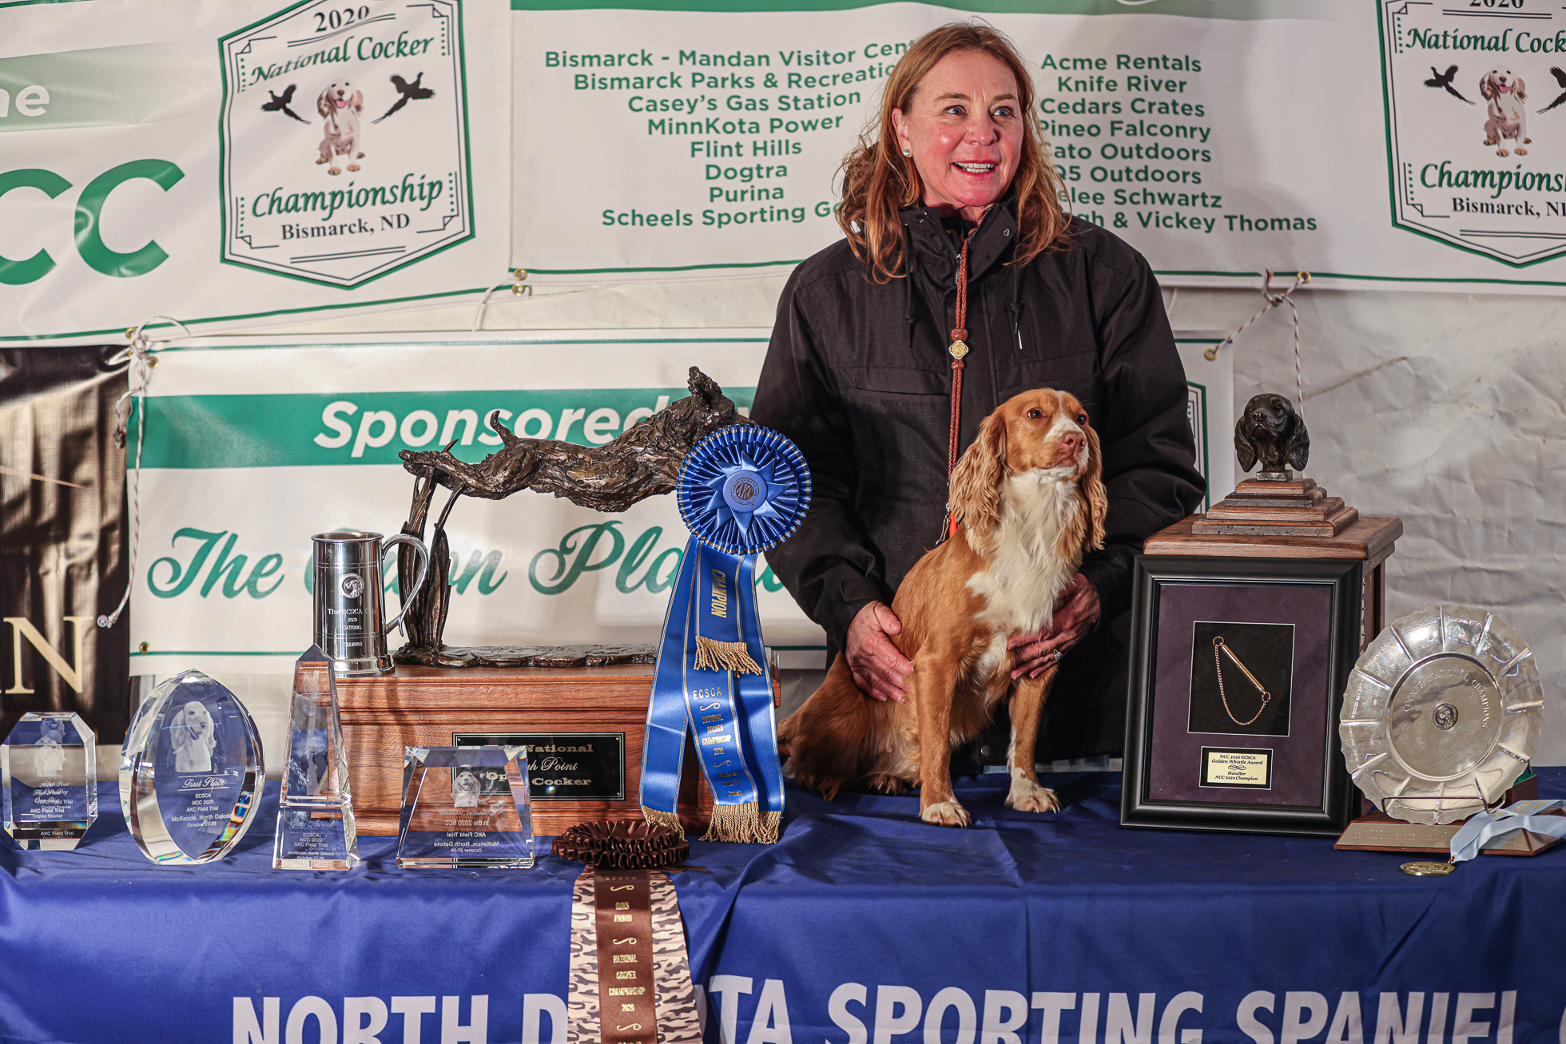

2020 National Champion
Warrener’s Tullinadaly “Tully”

2

ECSCA Field Trial Committee Meeting Minutes
Tuesday, October 19, 2021
- Call to order
Dawn Schuster, FTC Chair, called the FTC meeting to order on October 19, 2021, at 5:32 pm (CST).
Members present: Dawn Schuster, Ron Bullock, Chris Dartt, Pat Keliher, Ted McCue, & Cheryl Dooley.
Guest present: Robin Putnam
- Approval of the minutes – Approval of minutes from the September meeting was previously accomplished by email, with a consensus of FTC Members in agreement. The minutes have been posted on fieldcockers.com.
- Agenda
  - Motion to accept the Agenda as presented
            - Moved by Pat Keliher
            - Seconded by Ron Bullock
            - Passed
- High Point Awards Process – Robin Putnam
Robin Putnam explained the process used to determine High Point Regional Dog Awards, as well as provided recommendations on how these awards should be determined in the future.
Robin explained that the high point regional awards are calculated through the regular Trial Season and conclude with the current year’s NCC for the region where the NCC is held. In the case of a tie at the conclusion of the NCC, the dogs are declared Co-Winners and a second trophy is acquired.
Robin recommended the NCC consider changing the tabulation period to start with the prior year NCC and conclude with the last Trial of the season in mid-October, before the current year’s NCC. The idea being, all awards would be tabulated prior to the NCC.
Pat made a motion to accept Robin’s recommendation where future awards will be tabulated starting with the NCC and concluding the following year with the last regular/local Trial of mid-October so all awards are tabulate prior to the NCC.
For example, for 2022 Awards, the tabulation will begin with the 2021 NCC and conclude in Mid-October of 2022, at the conclusion the last Trial(s).
The motion was seconded by Ted and carried.
Ron made a motion to break ties in the future. Cheryl seconded the motion. A vote was taken and the majority voted to allow ties to continue to exist.
- NCC 2021 FTC meeting topics and agenda
Dawn indicated she will set-up a tentative NCC General Meeting agenda and email the draft to the FTC in a week.
Potential items for the Agenda will likely be:
Regional High Point Award - change in tabulation time period
National Open & Amateur Qualification criteria- remind Folks of the change beginning with the 2021 Nationals.
Harold Bixby Award
A general overview of what the FTC has accomplished this past year.
A general discussion about the quality of Trials and encouraging Folks to report to the FTC what they feel went well or not so well.
Pat will officiate the General meeting as Dawn will not be present.
There was discussion around potentially having the meeting broadcast via Teams Meeting or Zoom. Cheryl will discuss this with Sara Ike (Flint Hill Preserve).
Chris inquired about a LINK to the NCC FACEBOOK page where results might be posted during the NCC. Cheryl will discuss this with Sara Ike, as well.
- How to Run an NCC Document
Dawn inquired as to whether FTC had opportunity to review the latest version of the How to Run an NCC Document. Hearing that Folks needed more time, this topic was tabled until November.
- NEW BUSINESS
  - NACC 2022 ballots
There was a discussion around potentially slating Judges for the 2022 NACC, particularly now that a proposal has been received from the North Dakota Club.
Cheryl indicated she would start the process by sending out an inquiry letter to potential Judges who have judged at least 12- Total Trials with 6- of the 12 being Cocker Trials at 3- different venues.
The actual balloting will not begin until 6- weeks are allowed for the Judges’ responses.
There was discussion around potentially changing the voting process to an electronic system instead of paper ballots. Cheryl agreed to check with some Folks in the ‘springer world’ about how that process works and any costs associated.
  - Member-at-Large positions open for 2022- FTC
Dawn asked the FTC Members if anyone had anymore nominations for the At-Large FTC positions. No one had heard of any other interested Folks.
  - Spring Calendar
Dawn mentioned the 2022 Spring Calendar is near completion, but we are still waiting to hear from some East Region Clubs on their Trial dates.
  - 2022 NACC Proposal
The North Dakota Sporting Spaniel Club offered a bid to Host the 2022 NACC. The FTC reviewed the proposal but had concerns regarding the net profit. Ron or Cheryl will ask the Club to try to revisit their budget proposal and allow more ‘cushion’ for the net profit. Two suggestions were to ask them to increase their Entry fee or consider more Fundraising.
Adjournment – Pat moved to adjourn the meeting. Ron seconded the motion and the motion carried.
The meeting was adjourned at 7:12 pm (CST).
The General Meeting is to be held at the 2021 NCC - Tuesday, November 2, 2021 4:30 PM (EST).
The next FTC meeting will be held November 16, 2021 – 5:30 PM (CST)

