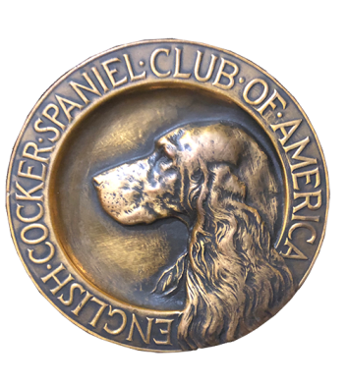
ECSCA
Field Trial Committee
Dawn Schuster – Chair
At-Large Members –
Ron Bullock, Chris Dartt, Pat Keliher
East Region Rep – Ted McCue
Midwest Region Rep – Susan Sarricino-Deihl
West Region Rep – Cheryl Dooley

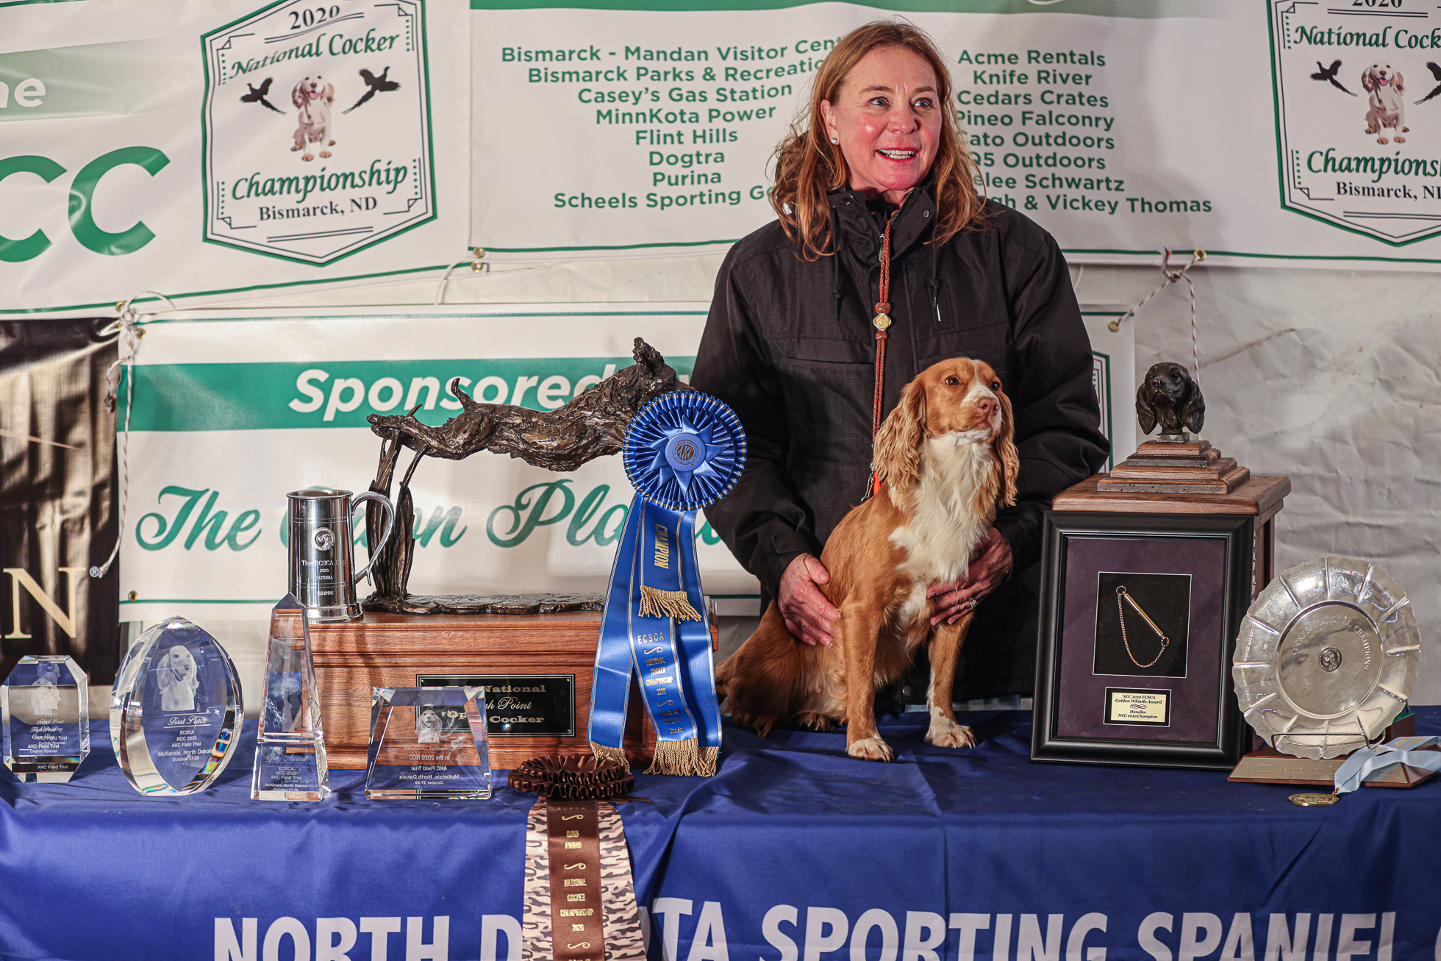
2020 National Champion
Warrener’s Tullinadaly “Tully”

2

ECSCA Field Trial Committee Meeting Minutes
Thursday, January 21, 2021

Call to Order: The meeting was called to order by Dawn Schuster at 6:04 PM CST.

FTC Members Present: Dawn Schuster (Chair), Ron Bullock, Chris Dartt, Pat Keliher, Ted McCue, Susan Sarricino-Deihl and Cheryl Dooley.

Approval of December Meeting Minutes: Chris made a motion to approve the December meeting minutes. Ron seconded the motion and the motion carried.

Approval of Agenda: Cheryl asked if we could add a discussion around the regular meeting night of the FTC. During the past two years, the meeting night was moved from the traditional third Tuesday to Wednesday and then Thursday. Pat made a motion to approve the agenda as amended. Susan seconded the motion and the motion carried.

Welcome to New Regional Reps: Dawn welcomed both Susan Sarricino-Deihl as the new Midwest Rep and Ted McCue as the new Eastern Rep. Dawn asked each to indicate why they wanted to be members of the FTC. Ted indicated he wanted to give back to the sport and offer positive input. Susan thanked everyone for welcoming her to the Committee and gave a brief history of her involvement with Cockers. Since 2002. She has been involved with Field events (Trials and Hunt tests), organizing the NCC Catalog and served on both Field Trial and Hunt Test Committees.

FTC Chair and Recording Secretary Selection: Ron nominated Cheryl for the Chair position. Dawn indicated she wishes to remain as FTC Chair for a third year. Chris made a motion to approve the FTC Chair slate as Dawn Schuster and Cheryl Dooley. Susan seconded the motion and the motion carried. A vote was taken from each Member of the Committee. The votes casted by each Member were:
Pat – Cheryl
Ted – Dawn
Susan - Dawn
Ron – Cheryl
Chris – Dawn
Dawn – Dawn
Cheryl - Cheryl
Dawn will remain Chair by majority vote.
Chris nominates Cheryl as Recording Secretary. Susan seconded the motion and the FTC cast a unanimous vote.

OLD BUSINESS:

Survey Progress: For the sake of the new FTC Reps, Pat explained the background behind a Survey Monkey as the result of the FTC hearing some complaints about a few Trials held in the past year. He indicated the FTC discussions have been around having the Field Trial Chair fill out an evaluation after their Trial. Pat explained that, for now, the FTC feels it would be best to submit a Survey Monkey so Members could express their views on how they would like ot see the FTC handle issues. Pat also emphasized the FTC would like to see any involvement be in the form of teachable events, not actual reprimands. That said; should a second offense occur the Club could be in jeopardy of not getting future Trials approved.
Dawn mentioned the issue of small entry Trials not holding a Third Series.
Pat brought up the point that sometimes when this happens a Dog could be awarded a Field Championship after running only Two Series.
Cheryl mentioned that Cockers need to be challenged with a Third series, pointing out that Both Judges will be watching the dog with no brace mate, but tested on at least their fifth & sixth birds of the day. Some cockers have issues ‘holding it together’ when given so many birds in a short period of time. Cheryl also mentioned that even if there are 4 or less dogs standing after the second, placements could change given a third series.
The FTC discussed the point that due to COVID the AKC has not been sending a Field Rep to Trials. The question of whether if an AKC Rep had been in attendance if some of the issues would have been addressed by the Rep not presented to the FTC.
Dawn asked if the FTC felt we should ask the ECSCA to lobby the AKC to send a Field Rep to Trials, if possible.
Cheryl mentioned a rumor floating about that the AKC has actually contacted Tom Myers to come back to the AKC and serve that position once COVID is ‘under control’,
It was pointed out that All Clubs and Field Trial Handlers have the option to contact the AKC regarding any issues or complaints. For now, it is possible to contact Tom Myers remotely and discuss issues privately.
Pat had prepared a draft of 12- questions for the FTC was to review. Ron pointed out that Survey Monkey requires 10 or less questions.
Question 8 regarding 4- judges at an NCC – The FTC felt this questions should be eliminated from the Survey. The general consensus was to keep this survey’s topic geared toward ‘regular’ field trials not the NCC or NACC. However, Pat did mention that this issue is something all FTC Members should discuss with Field Trial Handlers as we attend 2021 Trials.
Questions 11 requests any additional comments, but this could be eliminated as well since after every question Survey Monkey allows for comments.
Question 12 asks for the Respondent to put down their name and contact info. The idea behind having Folks identify themselves stems from the FTC not wanting to address anonymous complaints. The general consensus of the FTC is that if someone wants to complain about a Trial they should be willing to attach their name to the complaint. This issue could be eliminated if the Survey is set up to require Respondent identification.
Finally, the general consensus of the FTC is that this Survey ultimately be a chance for Field Trial Members to express their opinion as to whether they think the FTC should be involved in Field Trial issues or if all such issues would be reported to the AKC.
Pat mentioned that it is possible that some Folks might not feel comfortable filing a Formal Complaint with the AKC and prefer to bring issues to the FTC to keep them ‘in the Family’.

Completion of “How to Run an NCC/NACC’ Document:

NEW BUSINESS:

2022 Judge Survey Letter and Ballot Timeline: Cheryl provided the FTC members with a copy of the 2021 NCC Judge Survey Letter and a potential draft of the 2022 NCC Letter. The main change is in regard to the new Judge qualification of 12- Total Trials judges with at least 6- of the 12 being Cocker trials. The question Cheryl has currently is in regard to any requirement as to the number of locations for those 6- trials. In the past we required 3- Cocker trials at 3 different venues. The current requirement of 6- Cocker trials does not specify the number of venues. Dawn will contact Doug Lundgren (AKC) and ask him to change the reading to include 6 Cocker trials at 3- different venues.

NACC yearly or Every Other Year: Chris indicated she has received input from some Wisconsin Folks. Deb Strohl has told Chris she feels having a NACC in 2021 is too soon. Rumi Schroeder is lobbying to have a NACC October 2021.
Both Susan and Chris indicated the dates selected by Rumi would interfere with traditional ‘regular’ Trials held in early October.
Pat also mentioned a potential Maine Trial conflict.
Ted indicated he felt the FTC is attempting to discuss two questions at the same time: 1-Is the NACC to be held yearly?
2- Is the NACC to be held in the spring or fall?
Cheryl pointed out that she had contacted 4- Western Region Dog Handlers who attended the 2020 NACC and asked for their input. Two of the 4- indicate they would like to see the NACC held in the Fall. Two indicated they would like to see the NACC held in the spring. All four indicated they would like to see the NACC held yearly, with one person commenting that the competitive life of a dog is short. Not having the NACC yearly could potentially cause a dog to miss opportunities to ‘shine’.
Chris felt the FTC needed to address two important questions:
- Is the NACC a viable event?
- Is the NACC making and impact on increasing the number of Amateur Stake trials held throughout the year?
Chris indicated while she recognizes the NCC is highly competitive with many Pros, she not certain we are ready to have a NACC every year. Instead, the FTC needs to put more effort into increasing the number of Amateur Stake Trials. Chris did acknowledge that holding a yearly NACC would likely increase the number of Handlers signing up for Regular Amateur Trials.
Pat suggests that a NACC held in the spring might be sub-par conditions making it difficult to crown an appropriate Champion.
Ron suggested the NACC might be more attractive to Amateur Handlers, especially since we are moving to a 1- year qualification for the NCC.
Chris also mentioned that the NACC entries were low. While some of that could be blamed to COVID, some could be due to the Trial being scheduled close to the NCC. She indicated also that if the number of Qualified Amateur Dogs doesn’t increase, the NACC could be in jeopardy.
Chris proposed a question to the FTC Members: Do we have an NACC in 2022 or 2021?
Pat, Chris, Ron, and Cheryl indicated it would be better in 2022, allowing time to get ‘ducks in a row’ and try to increase the number of Amateur stakes held.
Dawn and Susan indicated 2021 could be done, but only if held in the fall.
Cheryl indicated looking forward she would like to see a three-year plan in place for both the NCC and NACC, with a list of Clubs hosting the events and locations.
Dawn encourage all FTC Members to challenge Clubs to hold Amateur Trials in support of the NACC.
Dawn also suggested each FTC Member sort out what they feel is Pros & Cons to holding a 2021 NACC. Then the FTC could continue this discussion via email.

ECSCA Dues Reminder: Dawn reported if dues are not paid by February 1, 2021 ones name will be removed from the Membership list.

New Jersey Spring Trial Approval: The New Jersey Group is currently addressing the possibility of changing the date of their spring trial. The FTC will table approval until a new date is submitted. (Date submitted March 13 and 14, 2021, two open and a puppy stakes, Approved via email)

Updated Trial Calendar: Dawn provided the FTC Members with an updated version of the Field Trial Calendar for 2021. Cheryl noted that Southern California and Tamarin are missing from the calendar. Dawn suggested Regional Reps contact their Clubs and get Chairs to submit their dates soon so the Calendar can be finalized.

Year-End ECSCA Board Meeting: Dawn attended the year-end ECSCA Board of Directors meeting and presented a FTC year-end report. Dawn provided the FTC Members with a copy of her report.

FTC Monthly Meeting Day: Cheryl mentioned that traditionally the FTC has met on Tuesday evenings. In 2019 the day was moved to Wednesday night and in 2020 Thursday nights. With the change of FTC Membership, Cheryl asked if the FTC could revisit the ‘best fit’ night for the Group.
Dawn asked each FTC Member which night they would prefer to attend meetings. All seven Members chose Tuesday. As such future FTC monthly meetings will be held the third Tuesday of the month.

Motion to Adjourn: Pat made a motion to adjourn the meeting. Susan seconded the motion and the motion carried.
The meeting was adjourned at 8:19 PM CST.
The next FTC meeting will be held February 16, 2021 at 5:30 PM (CST).

Respectfully submitted,
Cheryl Dooley

