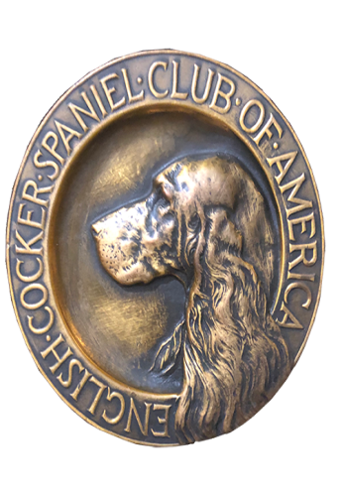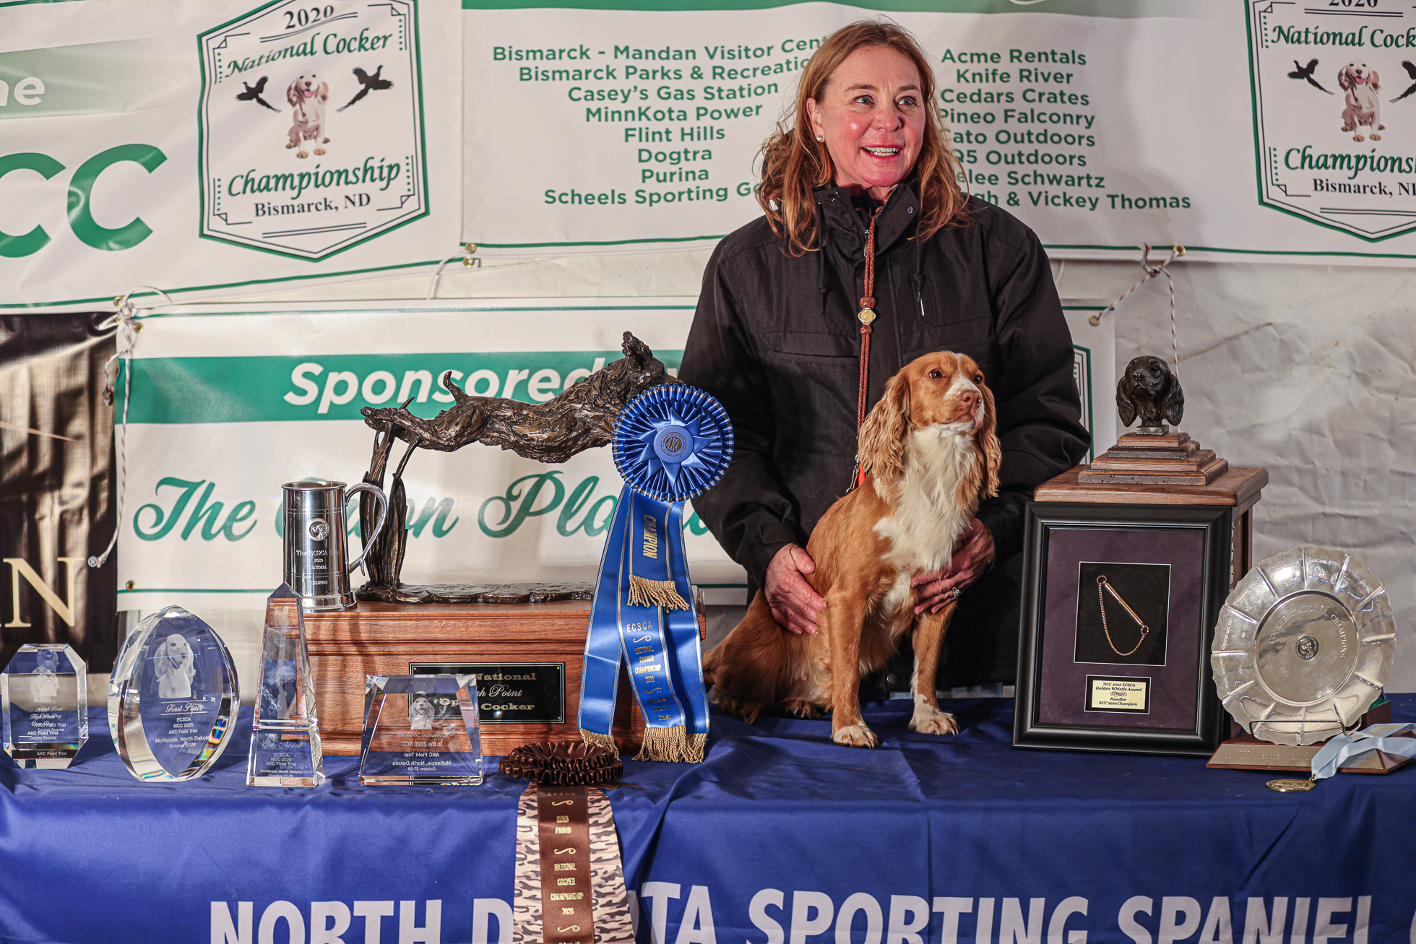
ECSCA
Field Trial Committee
Dawn Schuster – Chair
rdcgschuster@aol.com
At Large Members:
Ron Bullock - robull68@gmail.com
Chris Dartt - cjdartt@msn.com
Pat Keliher - pat.keliher@gmail.com
Ted McCue - East Region Rep-tedjmccue@gmail.com
Susan Sarracino-Deihl - Central Region Rep - saracen@rr.wi.com
Cheryl Dooley - West Region Rep - dooleytess@gmail.com

ECSCA FieldTrial Committee General Membership Meeting Agenda
Tuesday November 2, 2021 4:30 PM EST

Call to Order – Pat Keliher, Acting Chair called the meeting to order at 4:32 PM.
Present – Pat Keliher, Ted McCue & 11 General Members.
Remote Attendees: Dawn Schuster, Ron Bullock, Chris Dartt,
Susan Sarracino-Deihl & Cheryl Dooley

Introduction of FTC Members & General Members – Pat asked everyone in attendance introduce themselves.

2021 FTC Highlights
- COVID Impacts –
There was mention of the impacts of COVID on Field Trials. Included with this was a brief discussion about the absence of an AKC Rep at Trials. Tom Meyer has informed the FTC that he will be able in attendance at the 2021 NCC as well as 2022 Spring Trials.

- Surveys –
Pat asked the General Membership how they felt about the two Surveys conducted by the FTC in 2021. He expressed the purpose was to reach out to the Members and get a feel for their viewpoints on certain subjects. Those in attendance seemed to feel the surveys were a good idea and appreciated being asked their opinions.

- Future NACC –
Pat informed the Group the FTC recently had a vote on the timing of NACC Trials. The FTC decided to hold an NACC yearly and during the fall season. It was mentioned the NCC will still continue to take priority, so future NACC trials would need to schedule around the NCC.

- New National Judging Criteria –
In 2021, the FTC changed the Judging criteria for future NCCs. In order to get their name on the Preliminary Ballot Judges will need to have judged at least 12- Total Trials with 6 of the 12- being Cocker Trials.

- New National Open & Amateur Dog Qualifications –
Following the National Open Championship, dog qualification criteria will change from a 2- year/1- point requirement to a 1-year/1- point requirement.
Following the National Amateur, dog qualification criteria will change from 3 – year/1- point to a 2- year/1-point requirement.

In each case, dogs earning placements in each 2021 National will be automatically qualified for the respective 2022 National.

On-going FTC work
- Bids for future NCC and NACC Trials
Pat reported the FTC will be seeking bids for both NCC and NACC of the future. They would like to get National locations slated three years in advance.

- “How to Run a National Field Trial” documentation –
Pat informed the Group that the final edits have been made on the “How To Run a NCC” document. Acknowledgements were given to Dominique Savoie and Vicky Thomas for their editing efforts. The FTC Members are individually reviewing the final product and will address the document at the next FTC meeting.

- Regional Representation
No decision has been made as yet, but the FTC has been closely examining the breakdown of the 3- Regions (East, Central, West) designated by States. There has been some discussion around potentially changing the distribution of States &/or adding a fourth region.

Open Forum
Comments were accepted from the General Membership.
Comments included:
- Issues with the AKC.org website.
- The Cocker Spaniel Club of America (New York) has discussed hosting the 2024 NCC as that will be their 100th Anniversary. No commitment has been made and further discussion is needed.
- In regards to changing the Regions, it was suggested it would be better to find Folks in various areas who would be active in the FTC.
- A question arose regarding AKC rules and how they can be changed.

Adjournment – Pat adjourned the meeting at 5:12 PM (EST)

Respectfully submitted,
Cheryl Dooley

