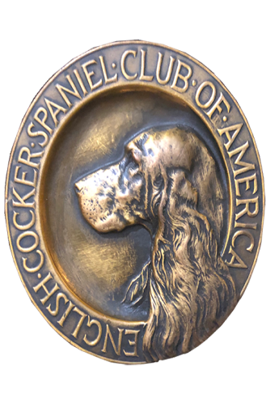
ECSCA
Field Trial Committee
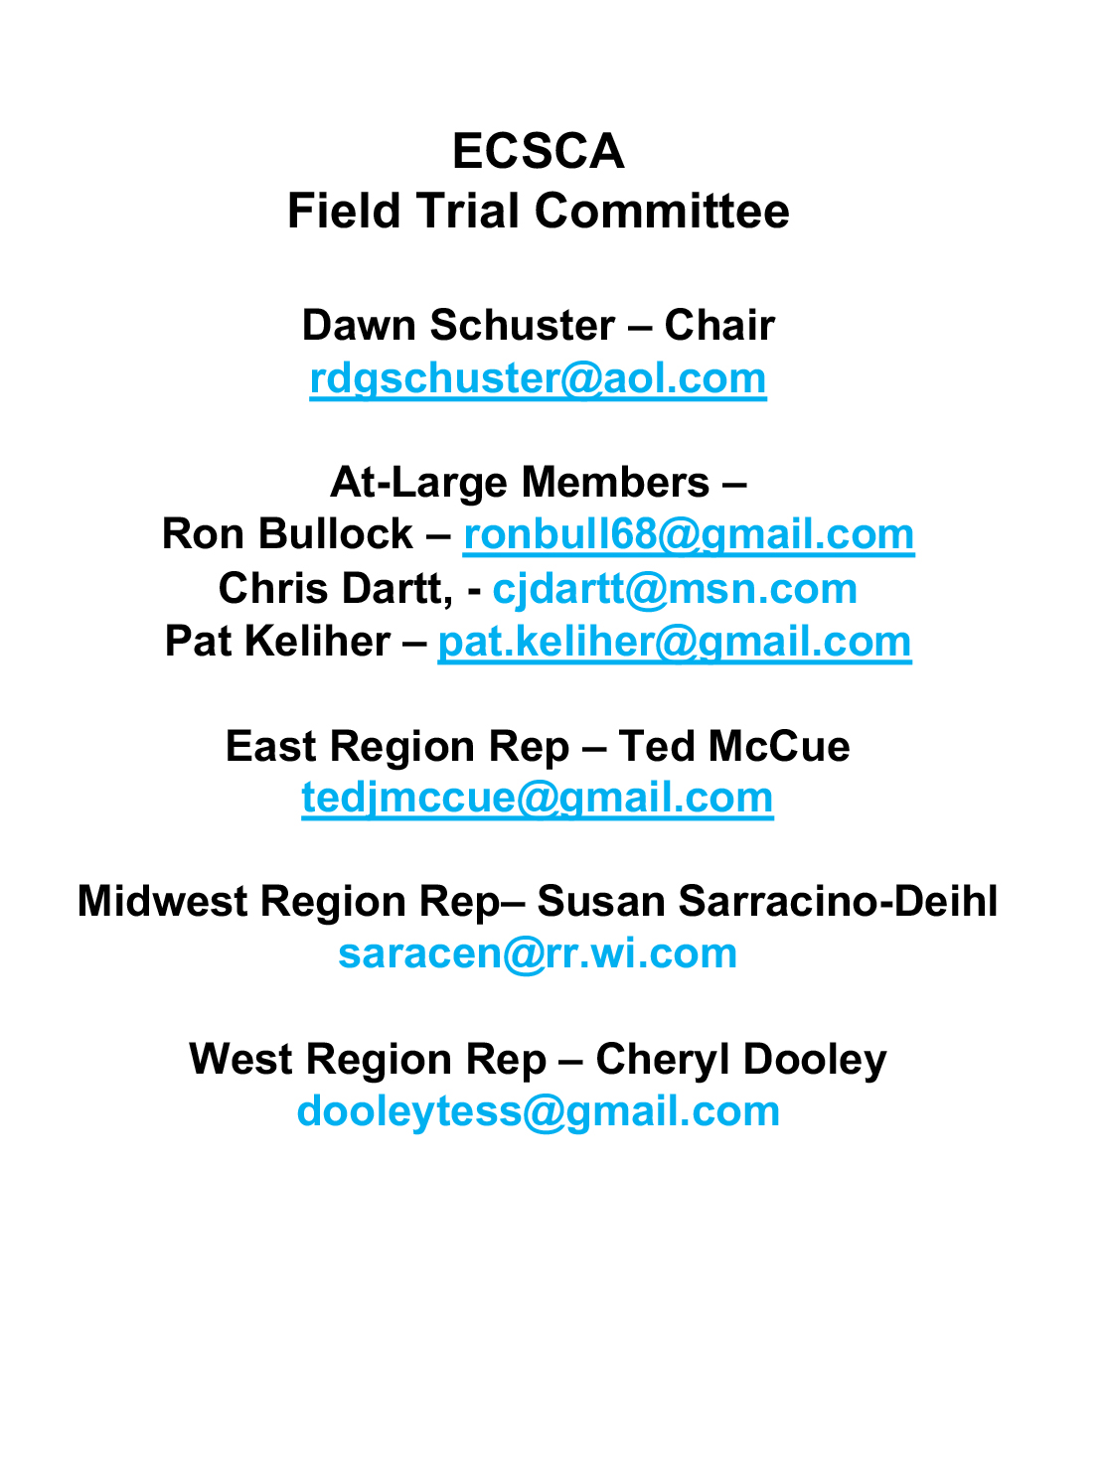
Dawn Schuster – Chair
rdgschuster@aol.com

At-Large Members –
Ron Bullock – robull@gmail.com
Chris Dartt, - cjdartt@msn.com
Pat Keliher – pat.keliher@gmail.com

East Region Rep – Ted McCue
tedjmccue@gmail.com

Midwest Region Rep– Susan Sarracino-Deihl
saracen@rr.wi.com

West Region Rep – Cheryl Dooley
dooleytess@gmail.com

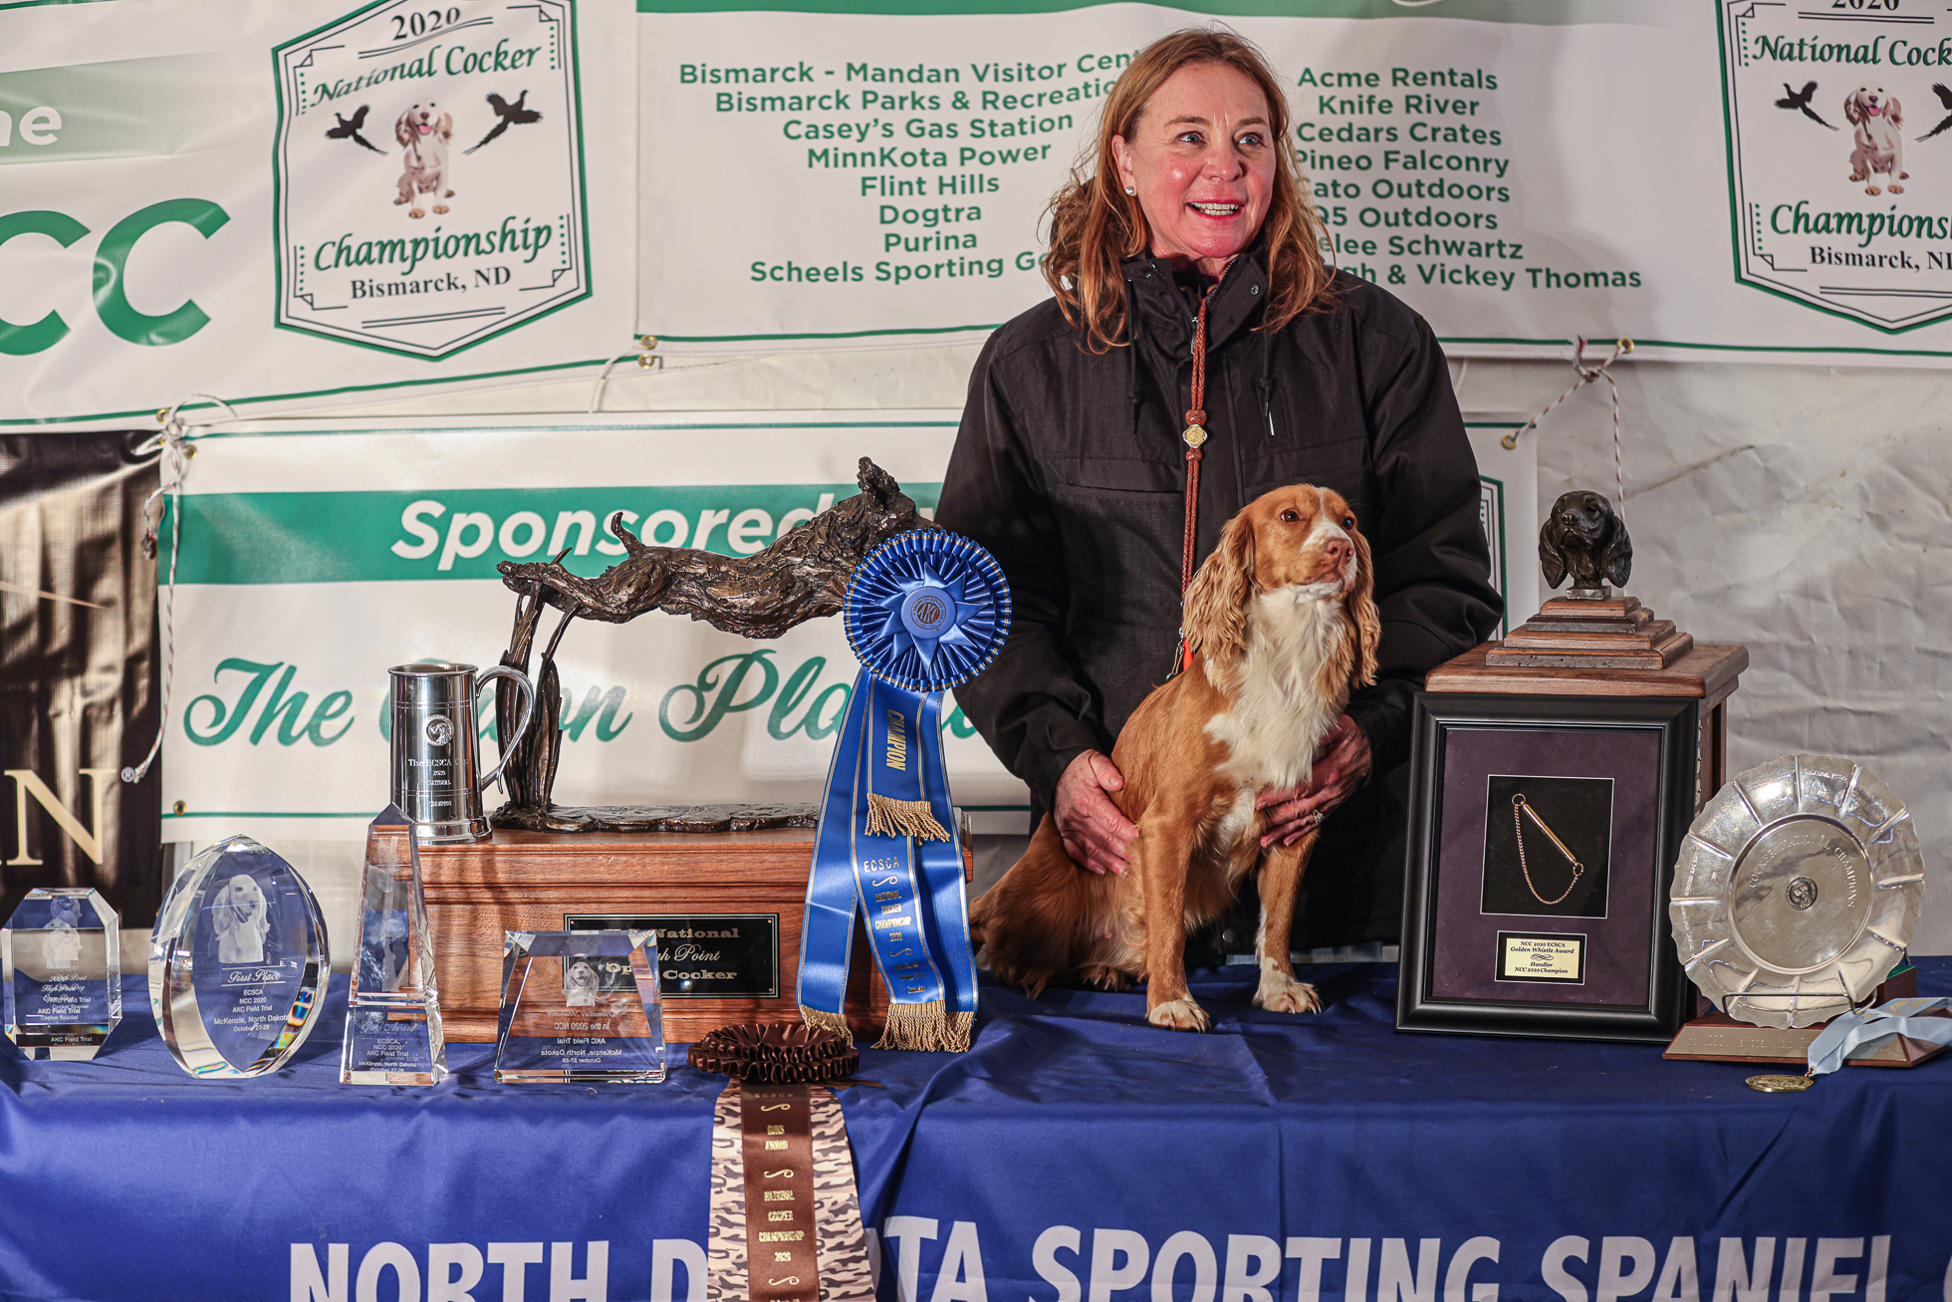

2020 National Champion
Warrener’s Tullinadaly “Tully”

2

- Call to order
Dawn Schuster, FTC Chair, called the FTC meeting to order on September 27, 2021, at 5:35 pm (CST).
Members present: Dawn Schuster, Ron Bullock, Chris Dartt, Pat Keliher, Ted McCue, Susan Sarracino- Deihl & Cheryl Dooley.
- Approval of the minutes – Approval of minutes from the August meeting was previously accomplished by email, with a consensus of FTC Members in agreement. The minutes have been posted on fieldcockers.com.
- Agenda
  - Motion to accept the Agenda as presented
            - Moved by Susan Saraccino-Deihl
            - Seconded by Chris Dartt
            - Passed
- National Updates - Patron Program
  - Past Print Program – Currently the ECSCA budgets $1500 for the Print Program. Susan provided the FTC with information on a new idea proposed by Vicky Thomas and Deb Strohl. This proposal is to replace the Print Program that has been in place since 1998.
  - Trading Cards – Instead of having prints made from artwork of last year’s NCC winner, there will be a complete set of trading cards printed of all NCC Champs since 1998 (22-sets). These sets of cards will be given to 10- Patrons that have been loyal Patrons for 10- years. The other sets printed will be offered for sale to NCC Attendees. The 10- patron sets could potentially be matted and framed.
  - FTC Questions & Suggestions –
Don’t add to cost by framing sets. Give in a decorative box.
Time is running low. Need to decide soon on this project. Next ECSCA BOD meeting is October 6th. Need to present it then and get approval.
How many years before expense is recouped? 2-5 years
Chris made a motion to allow printing of cards for $3750. The motion was not seconded.
Is this set of cards in place of a Patron Gift? Patron letter not clear.
  - It was decided Susan will speak with Vicky and try to get some answers to the concerns.
- NACC 2021 Update
  - Dawn Schuster reported the 2021 NACC has been approved by the AKC.
  - Information regarding the Trial is posted on fieldcockers.com and the AKC website.
  - Dawn is working with Helena at Hunt Secretary to get the premium posted. The projected posting date is Wednesday, September 29th.
- NCC Ballots for 2022 Judges
  - The Final Ballots for the 2022 NCC Judges have been received and tabulated by Marissa Sheppard.
  - Dawn has contacted the two highest vote-getters and confirmed their willingness to judge the 2022 NCC Trial. Both agreed.
  - Dawn will announce the 2022 Judges at the 2021 NCC.
- How to Run an NCC Document –
  - Cheryl reported that sometime in August she completed the edits on the How to Run an NCC Document and emailed them to the FTC Members. No one responded.
  - Cheryl will resend the document to everyone by email.
  - Dawn asked the Committee to read the document and indicate their approval or suggested questions or changes.
  - Discussion will continue via email. After FTC approval, the document will be sent to the ECSCA BOD.
- Spring vs Fall NACC –
  - Dawn Schuster called for a vote on the issue of hosting the NACC in the Spring/Fall or Fall only.
  - The vote was taken and three for spring/fall and four for fall.
  - A fall NACC yearly will stand.
The FTC encourages any club interested in hosting the NACC 2022 to please contact any FTC member. Currently the 2021 NACC will be held in Virginia and it is suggested that there be a regional change for 2022. (Western or Central region)

- Opening At-Large FTC Positions –
  - Dawn Schuster reminded the FTC Members that the At-Large positions are reaching the end of their Terms this December. Ron Bullock has informed Dawn he would like to re-run (he has not filled the term limit). However, Dawn, Chris and Pat have filled the term limit and will need to step off for at least one year.
  - Names already presented to Dawn as potential candidates are: John Alstad (North Dakota), Jack Glinsky (New York) and Scott Mason (Washington). Dawn has not received bios to-date.
  - Dawn encouraged FTC Members to reach out to the Membership for other interested individuals who are willing and able.
  - If only 4- names are put forth, those 4- individuals will serve. If more than 4- names are put forth a mail in vote will take place between November and December.
- Harold Bixby Award
  - The FTC discussed two nominations for the Harold Bixby Award.
  - A vote was taken.
  - The Winner will be announced at the 2021 NCC
NEW BUSINESS
A-Rough Handling of Dogs during Trials
- A report was made regarding rough handling of dogs at Field Trials.
- The FTC discussed their role in such issues and the proper protocol to follow if such behavior is witnessed or reported.
- It was mentioned that the on-site Field Trial Chair is ultimately responsible to handle these situations.
- The FTC discussed the proper protocol to address such an issue as it is lined-out in the 2019 AKC Dealing with Misconduct booklet guide.
- Ultimately, it was suggested that FTC Members stay vigilant at Trials for such issues and take a proactive approach by reporting to the Field Trial Chair. Then, the FT Chair and Committee should take appropriate measures as outlined in the AKC ‘Blue Book’.
The meeting was adjourned at 7:09 pm (CST).
Minutes submitted respectfully by: Cheryl Dooley
The next FTC meeting is Tuesday, October 19, 2021, 5:30 PM (CST)

