ECSCA Field Trial Committee Meeting Minutes
Wednesday, September 18, 2019
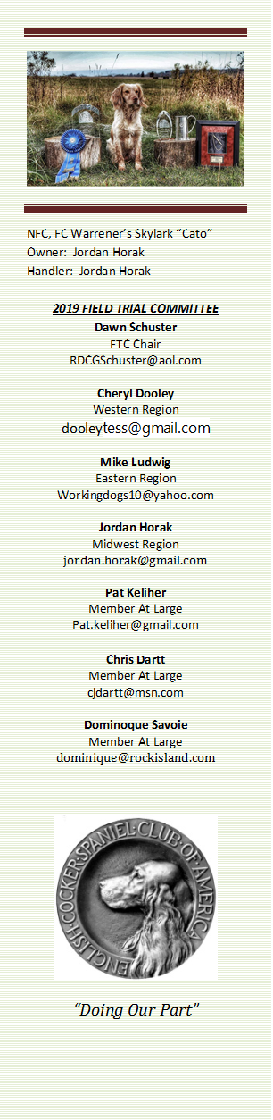
Call to Order- The meeting was called to order by Dawn Schuster at 6:02PM CST.
Present: Dawn Schuster (Chair), Chris Dartt, Cheryl Dooley, Jordan Horak, Pat Keliher, & Dominique Savoie
Approval of Minutes from August 28, 2019 – Chris made a motion to approve the minutes. Cheryl seconded the motion and the motion carried.
Approval of Agenda – Jordan made a motion to approve the Agenda. Chris seconded the motion and the motion carried.

NCC 2019 Update– Ron Bullock was on-hand to report on the status of the IOWA NCC. He indicated the grounds have been checked for noxious weeds and none were spotted. He also mentioned Patron donations are down this year. The FTC inquired about the use of ATVs. Ron indicated there will be a dog trolley to haul dogs from the parking area to the field, but no personal ATVs will be allowed on the course gallery line.
Bid for NCC 2020 – Jon Hunke, John Alstad, & Vicky Thomas were on-hand to discuss the North Dakota bid to host the 2020 NCC. Copies of the bid and budget were present to each Member of the FTC. John Hunke reported he and John Alstad will act as Co-Chairs, with Sue Wilson as Secretary. Entries will be conducted through Hunt Secretary and will be $265 per dog. A number of Chair positions are filled including: Hospitality- Jamie Mowder, Judge Steward – Rod Beck, Stewards of the Beat – Paul McGagh, Dan Murray & Tom Ness, Gun Captain – Bob David, Game Steward – Bruce Britton & Head Marshall - Cheryl Dooley. The Trial will be held on the Gus & Mary Ann Wolbaum Farm. They will need to rent a tent as no buildings are present to serve as a Base Camp. The Welcome Reception will be held at the North Dakota Heritage Center on Monday, October 26th. The FTC inquired about no indication of Banquet plans. The pros and cons around the purpose of a banquet were discussed. The FTC encouraged the Committee to reevaluate scheduling a banquet the first night of the Trial (Tuesday, October 27th). Jon indicated he would discuss the banquet issue with the Committee. Dominique made a motion to accept the North Dakota bid for the 2020 NCC. Pat seconded the motion and the motion carried. The bid will be presented to the ECSCA Board of Directors.
2020 Judges Ballot– Dawn reported Shannon Loritz has completed the tally for the 2020 NCC Judges. Dawn will be announcing the names of the two Judges at the Iowa NCC in October.
Harold Bixby Award Nomination – The FTC discussed nominations, voted, and selected a Recipient. Dawn will submit the name to the ECSCA BOD and an announcement will be made at the 2019 Iowa NCC.
NEW BUSINESS:
Reimbursement for costs associated with FTC duties– Dawn reported to the FTC that any pre-approved incurred expenses can be reimbursed thru Karen Spurlin of the ECSCA Board. There is a form on the fieldcocker website to fill out and send in to Karen with receipts.
Should an FC/AFC Title include at least 1- Pheasant Trial- Dawn indicated she had been approached regarding changing the requirement for a dog to be titled FC or AFC. It was suggested that any dog seeking either title would need to place in at least one all pheasant trial. The FTC discussed the suggestion and determined the cons outweigh the pros on this issue. It was noted that spring trials likely cannot use pheasants and it would put a strain on Owners/Handlers to find an all pheasant trial that may or may not be within reasonable driving distance.
Adjournment – Pat made a motion to adjourn the meeting. Dominique seconded the motion and the motion carried. The meeting was adjourned at 7:30 PM CST.
The next FTC Meeting will be held at 4:30 PM on October 28, 2019 prior to the Welcome reception for the Iowa NCC.
Respectfully submitted by Cheryl Dooley.
- As the fall season is well under way, Spring Trial dates need to be submitted to Dawn Schuster as soon as possible to be put on the 2020 calendar. A trial request form can be found on the home page of Fieldcockers.com
- Secretaries, please submit your trial results to Bethann Wiley at Bethannwiley@yahoo.com
Please include.. Stakes, results, guns award, each placement with Dog’s complete registered name, call name, handler and owner

