ECSCA Field Trial Committee Meeting Minutes
Thursday August 20, 2020
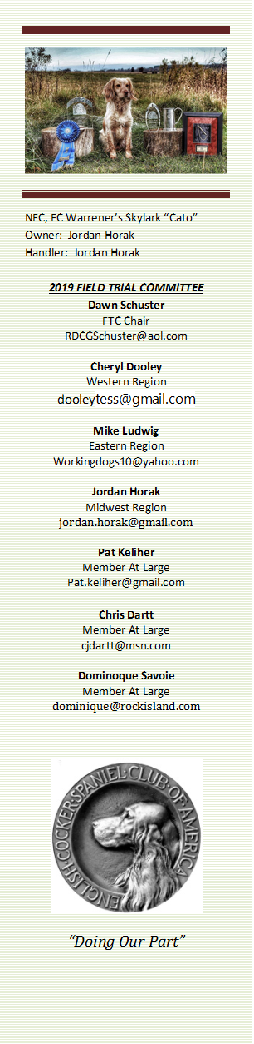
Call to Order - The meeting was called to order by Dawn Schuster at
6:18 PM CST.
FTC Members Present: Dawn Schuster (Chair), Ron Bullock, Chris Dartt, Cheryl Dooley, and Pat Keliher.
Approval of Minutes from July 16, 2020 –Pat made a motion to approve the minutes. Ron seconded the motion and the motion passed.
Approval of Agenda: Chris made a motion to approve the agenda. Ron seconded the motion and the motion passed.
Update on 2020 NACC – Dawn indicated there will be a Committee meeting next week.
Update on Voting for Judges for 2021 NCC– Cheryl reported that out of 189 Preliminary ballots mailed out, 157- ballots were returned. The Final Ballot has been mailed and the postmark deadline for returning these ballots is September 14, 2020. The Final Ballot will be returned to Marissa Shepard. She will count the votes and report to Dawn on the outcome.
Update on Survey Monkey – Prior to tonight’s meeting, Cheryl emailed out a summary of the Survey Monkey to all FTC Members. There was a separate email with the comments and suggestion responses for Question #10. Cheryl suggested the FTC think about the #10 comments, categorize them and discuss them by topic over the next couple of months. In the meantime, it was decided to write a brief summary of the outcome for questions 1-9 for the General Membership. Cheryl will draft the summary and forward it to the FTC Membership for approval before having it posted on Fieldcockers.com or emailing the results to Members. There was a clear consensus that results need to be conveyed to the Membership with an idea on how the FTC plans to proceed/use the information. Pat suggested the FTC Members make an effort to speak to Folks at Fall Trials and get a rough idea on how Members feel they would like to see the FTC proceed with the Survey information.
One point was made in regard to a Question #10 comment regarding asking Clubs to hold trials in ‘better Cocker cover’. Pat reported that Canada has recently changed their rule regarding course selection. He suggested all FTC Members take a look at their new change.
NCC – Dawn reported COVID info will be posted. Clearly the bird count will need to be adjusted if Entrees are lower than expected. Jon Hunke has reported to Dawn that they have received a $2500 donation from Flint Hill Preserve.
New Business:
Harold Bixby Award – A discussion took place around nominations for the Bixby Award. The FTC voted and selected a Candidate. The winner will be announced at the 2020 NCC – North Dakota.
MHGDC – Dawn indicated she received an application for a Cocker/Springer Trial for May 1 &2, 2021. Chris suggested this might be a conflict with Minnesota’s Trial, held annually that same weekend. She indicated she feels both Clubs will try to draw entries from North Dakota and Wisconsin. Chris will reach out to the Wileys and get their opinion on this issue.
Adjournment – Ron made a motion to adjourn the meeting. Pat seconded the motion and the motion carried. The meeting was adjourned at 7:37 PM CST.
The next FTC Meeting will be held at 6:00 PM (CST) on September 17, 2020.
Respectfully submitted by Cheryl Dooley.

