ECSCA Field Trial Committee Meeting Minutes
Wednesday, July 17, 2019
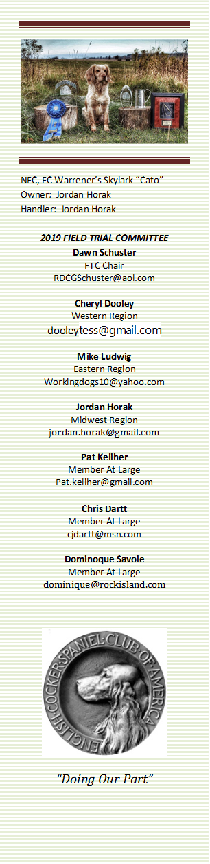
Call to Order- The meeting was called to order by Dawn Schuster at 6:03 PM CST
Present: Dawn Schuster (Chair), Chris Dartt, Cheryl Dooley, Jordan Horak, Mike Ludwig, & Dominique Savoie
Approval of Minutes from June 19, 2019 – Mike made a motion to approve the minutes. Jordan seconded the motion and the motion carried.
Approval of Agenda –Jordan made a motion to approve the Agenda. Mike seconded the motion and the motion carried.

Update on NCC Ballots 2020 – Cheryl reported Preliminary Ballots for the 2020 NCC Judge selection were to be postmarked by July 12th. The Judge tally will take place this Friday and she will let Dawn know the 6-names of those with the top votes. Dawn will confirm willingness to have their name on the Final Ballot. The Final Ballot will be mailed July 25th. That ballot will need to be postmarked by September 14th and mailed to Shannon Loritz (envelopes will be included with the ballot).
Genetics Flyer – Due to recent discussions around Field Cocker health issues it is the intention of the FTC to prepare an educational flyer on inherited traits, how traits are passed from Parents to offspring and the importance of genetic testing. This flyer will be mailed with the Final NCC Ballot on July 26th. There was discussion around what needed to be included in the flyer and how the FTC could encourage Folks to have DNA testing done on their Cockers and be willing to share results. Cheryl will finish a final draft of the flyer and send the document to the FTC Members this week.
2020 NACC – Pete Rizzo, Chair of the 2020 Amateur National has prepared a Proposal for the 2020 NACC Trial as well as a budget. Those items are ready for submittal this week. There was discussion around the time of year the Trial should be held (Spring vs. Fall) and whether the Trial should occur yearly or every other year. The main concern is fairness to dogs located in northern regions who might not have a chance to train for a Spring National. After a lengthy discussion, it was decided that Dawn will prepare a Question to Individuals in the Field Trial World to get input from Handlers/Owners on this subject. For now, the plan is to continue with every other year in the spring.
2019 NCC information for Fieldcockers.com- Dawn indicated the Cockers in the Field website is missing critical information for Handlers/Owners to plan their attendance. She plans to speak with Ron Bullock to see that information is posted soon on the website.
“How to Run an NCC” Update – Dominique presented the revised document indicating that most National Chairs have experience running Trials and do not necessarily need to be told “How To”. However, there should be rules in place around having an Approved Preliminary Budget, all members of the Nationals Committee are required to be ECSCA Members and all purchases must be approved IN ADVANCE by the Chair. Upon completion of the Trial, the Chair shall write detailed report to the FTC within 30 days. This report is meant to assist the next year’s Chair. Those details will include: # of birds, what worked, what didn’t work, # lunches served, # banquet dinners, etc….Dominique will continue to revise the document and try to streamline the guidelines so the document is more User friendly.
Health Survey from the ECSCA Health Committee – Dawn mentioned there is now a Survey on fieldcockers.com asking for information from Field Cocker Owners regarding health issues. The intention of this survey is for the Health Committee to obtain enough data on Working Cockers in order to request funding from the ECSCA Parent Club. The intention of the funding will be to allow the Health Committee to study specific health issues in Working Cockers. The Health Committee has informed Dawn that, to date, only 26-Folks have participated. They indicated to Dawn that they need 100- participants to make a solid plea for funding. The FTC recognizes that the survey is lengthy, but feels the information gathered could be very beneficial. As such, the FTC plans to make every effort to encourage Folks to go to the website and fill out the survey. The survey is completely anonymous.
Field/Working English Cocker Health Survey Link

Progress on Growth Ideas & Education-. Dawn asked each Regional FTC Member to report on the status of growth and education that is taking place this year. All regions indicated that there are Fun Trials planned this summer to help educate Folks on how a Trial works and encourage interest. Jordan indicated he is making progress on an educational video. Dominique indicated there is a resurgence of a former Club in the Bozeman area and they plan to hold a combined Springer/Cocker Trial May 2020. Cheryl reported that there are now 148- dogs qualified for the 2019 Iowa NCC. Some of the new qualifiers from 2019 Spring Trials appear to be new to the sport. Jordan indicated he is preparing to set-up a FACEBOOK page for the FTC. This will provide an avenue for keeping Folks abreast of Trial information, concerns, education or important dates.
NEW BUSINESS:
Spring 2020 Calendar: Dawn asked all Regional Reps to contact their respective Clubs and let them know the FTC needs their Proposals for 2020 Spring Trials. She would like to get these Trials on the Calendar so Folks can start planning their schedules.
Adjournment – Chris made a motion to adjourn the meeting. Mike seconded the motion and the motion carried. The meeting was adjourned at 7:59 PM CST.
The next FTC Meeting will be held August 21, 2019.
Respectfully submitted by Cheryl Dooley.

