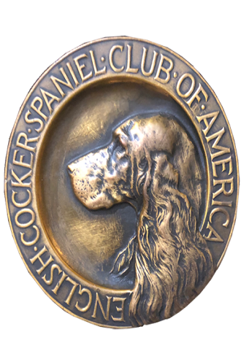
ECSCA
Field Trial Committee
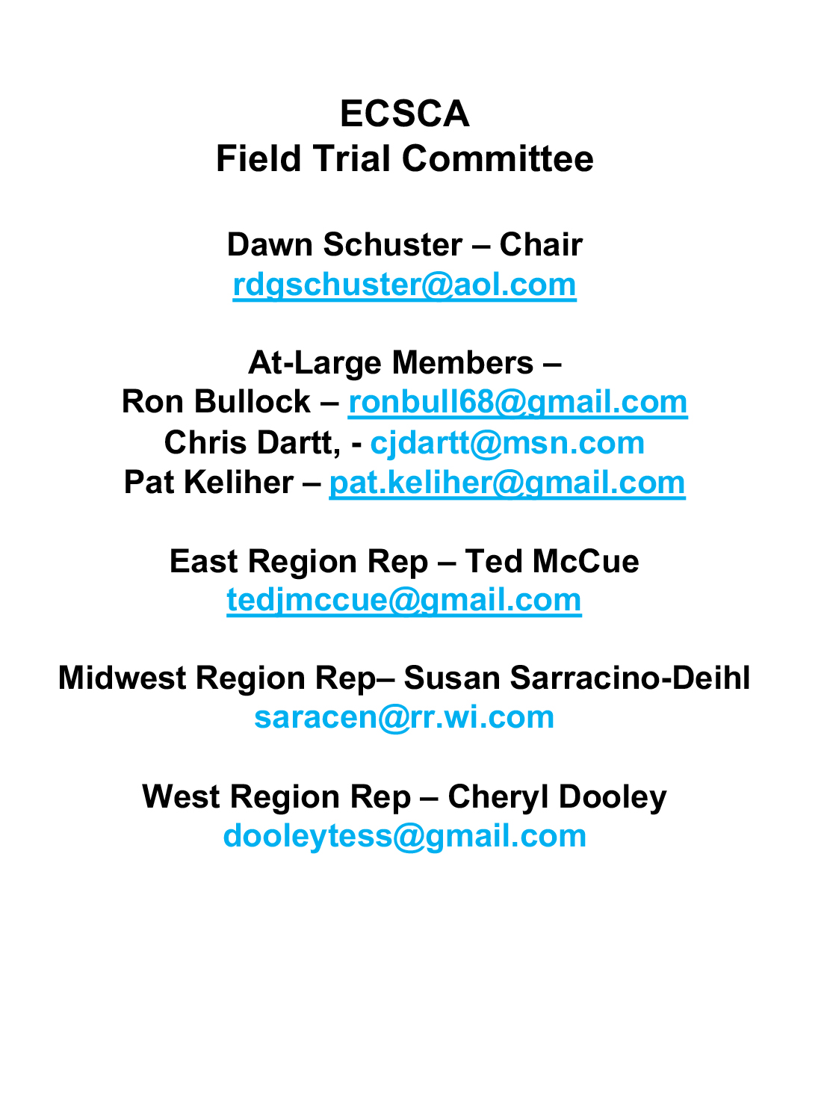
Dawn Schuster – Chair
rdgschuster@aol.com

At-Large Members –
Ron Bullock – robull@gmail.com
Chris Dartt, - cjdartt@msn.com
Pat Keliher – pat.keliher@gmail.com

East Region Rep – Ted McCue
tedjmccue@gmail.com

Midwest Region Rep– Susan Sarracino-Deihl
saracen@rr.wi.com

West Region Rep – Cheryl Dooley
dooleytess@gmail.com

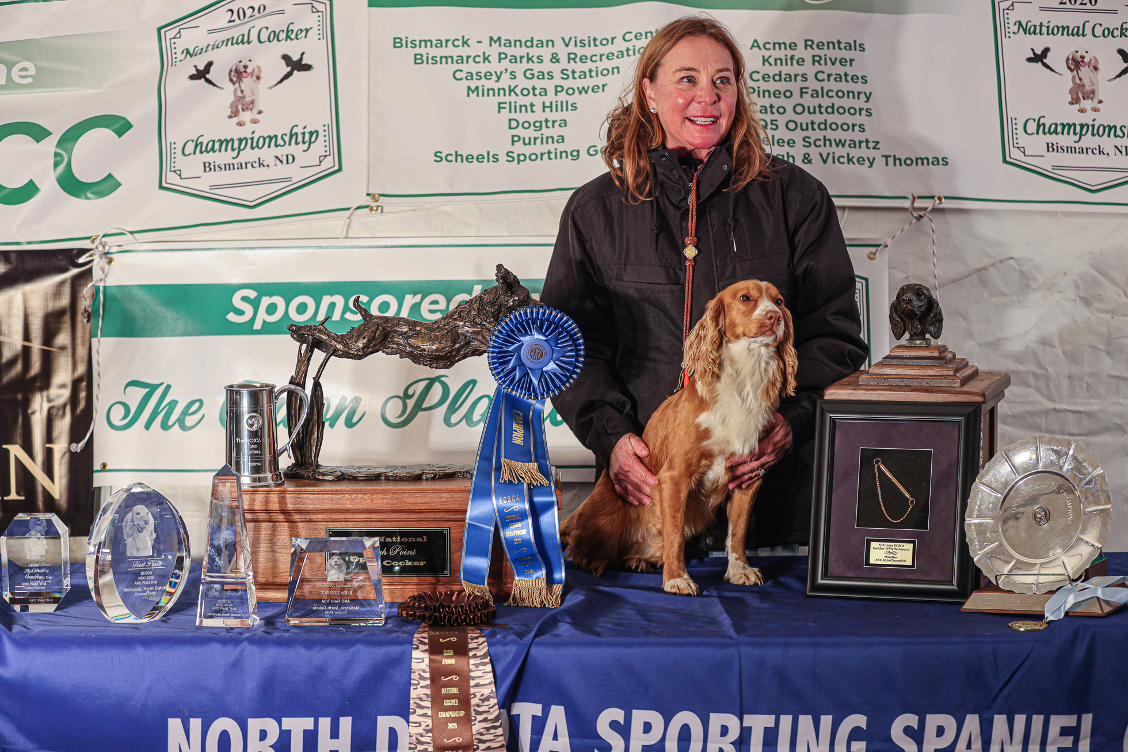

2020 National Champion
Warrener’s Tullinadaly “Tully”

2

- Call to order
Dawn Schuster, FTC Chair, called the zoom meeting for the FTC to order on June 15, 2021, at 5:27 pm.
Members present: Dawn Schuster, Ted McCue, Susan Sarracino-Deihl, Pat Keliher, Chris Dartt and Ron Bullock. Cheryl Dooley was unable to attend.
- Approval of minutes from last meeting
Minutes were approved via email and posted to Fieldcockers.com
- Agenda
  - Addition to New Business
            - Trophies – Chris Dartt
            - Field Trial Judging Seminar – Dawn Schuster
  - Motion to accept additional items to New Business
            - Moved by Pat Keliher.
            - Seconded by Ted McCue.
            - Passed.
- National Updates
  - 2022 NCC
            - Tentative dates: Oct. 26, 2022, to Oct 28, 2022
            - Location: Pyramid State Park, Pinckneyville, IL
            - Paul Mommaerts, Chair for the 2022 NCC is working on the formal written proposal for the 2022 NCC. The formal budget was presented to the FTC at the April 2021 meeting
            - The ECSCA BOD has approved the deposit for the Pyramid State Park, Pinckneyville, IL location for the 2022 NCC.
  - 2023 NCC
            - Dawn talked to Gary Riddle. He has submitted a proposal and budget for the 2023 NCC. In addition, Dawn will let him know that he and all 2023 NCC Committee members will need to join the ECSCA. Dawn is to touch bases with Gary in 2 weeks.
  - 2021 NACC
            - The ECSCA BOD approved the proposed budget for the 2021 NACC
            - The 2021 NACC will be held in Esmont, VA Dec.1, 2021 – Dec. 3, 2021.
            - Judges for the 2021 NACC - pending.
- NCC Ballots
  - Cheryl Dooley has overseen sending out the ballots.
  - Bethann Wiley reported to the FTC that the list of NCC qualifiers for spring is not updated yet since the last Open field trials for this spring were last weekend (June 12 – 13). The updated list of qualifiers will be posted on www.fieldcockers.com soon.
  - New qualifiers from those trials will be added to the ballot list. Any new qualifier in the Open who has not received a ballot for the 2022 NCC from Cheryl Dooley by July 4, 2021 should contact Cheryl Dooley.
- NACC Survey –
  - The survey closed on June 15th and Cheryl Dooley will distribute the results to the FTC prior to the next regularly scheduled meeting in July.
- New Business
  - Review of current division of field trial regions
            - The current field trial regions divided into three regions was instituted in 2015 with the recommendation that this be reviewed in 3 years.
            - Discussion: The three regions were based on the present locations of current ECSCA members in 2015. Bethann reported that there are currently 47 ECSCA members who field trial or have field trialed in the West region, 34 in the Central region and 29 in the East region. A lengthy discussion was held in which these issues brought up were:
              - The FTC needs to look at the 1) members in the ECSCA who trial or who have an active interest in trialing and their locations and 2) new people who are trialing and their locations to determine if a new region is needed.
              - If a 4th region is added, how will that be determined?
              - If a 4th region is added, we need ECSCA club members in that region and we would need ECSCA parent club members to help run the trials.
              - Of note, the number of FTC members in 2015 when there were 4 regions was reviewed.
- Under the system with 4 regions there were 4 Regional Members and 3 Members-at-large.
- Under the current system with 3 regions, there are 3 Regional Members and 4 Members-at-large
- If a 4th region is created, the FTC member numbers would be adjusted accordingly.
              - Chris Dartt pointed out that the ECSCA members on the current list may not be actively field trialing now or may not necessarily be active in field trials right now.
              - The point was raised by and reiterated by many members that in order to create a 4th region, there have to be ECSCA parent club members in that region and that those parent club members need to be able to represent their area.
  - The FTC received a comment on the current Judging requirements for regular field trials. As a reminder to those in the field the requirements to be approved to judge an ECS field trial are:
            - Attend an AKC FT Spaniel Seminar
            - Apprentice 2 times under two different 12-pt judges.
  - North Texas Sporting Spaniel Club trial – request for approval to hold a 1-day ECS open field trial.
            - The members of the FTC would like to expand and grow the sport of Cocker Spaniel field trials. Therefore, we request that the North Texas Sporting Spaniel Club offer 2 Open Cocker trials or an Open Cocker trial and an Amateur Cocker trial. This will give other the opportunity to travel to the event.
  - Trophies
            - Chris Dartt reported that the High Point Amateur Dog and High Point Amateur Handler trophies had for years been presented at the NCC. Since the NACC is to be offered each year, she felt it was more appropriate to off those trophies at the NACC.
            - It was moved by Chris Dartt and seconded by Ron Bullock that for 2021 the High Point Amateur Dog and the High Point Amateur Handler Trophies be presented at the 2021 NACC. The motion passed unanimously.
            - Chris will send Walt Leytham a list of the trophies that need to be offered at the 2021 NACC.
  - Request to hold a Field Trial Judging Seminar
            - Wateree Spaniel Club would like to hold a Spaniel Field Trial Judging Seminar Sept. 12, 2021. Kim Parkman was instructed to send the request to the FTC of the ECSCA.
            - Dawn Schuster will verify that FTC approval is required to hold the seminar and report back to the FTC.
  - The FTC sends its condolences to the Family and Friends of Terry Stubbs on his passing.
  - The FTC sends its condolences to Sue Sellers Rose on the passing of her husband, Bob Rose.

The meeting was adjourned at 7:21 pm.
Minutes submitted respectfully by: Susan Sarracino-Deihl
The next FTC meeting is Tuesday, July 20, 2021, 5:30 PM.

