ECSCA Field Trial Committee Wednesday, June 19, 2019
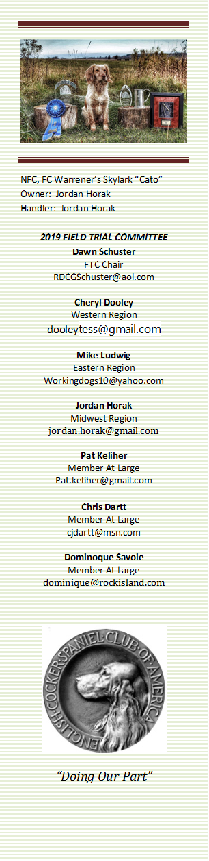
Call to Order- The meeting was called to order by Dawn Schuster at 6:03 PM CST
Present: Chris Dartt, Cheryl Dooley, Jordan Horak, Pat Keliher, Mike Ludwig & Dawn Schuster, guest Pete Rizzo
- Approval of Minutes from May 15, 2019 – Mike made a motion to approve the minutes. Chris seconded the motion and the motion carried.

- Approval of Agenda – Pat made a motion to approve the Agenda. Chris seconded the motion and the motion carried.

- Update on NCC Ballots 2020 – Cheryl reported the Preliminary Ballot for the 2020 NCC Judge selection was mailed June 7, 2019 and will need to be postmarked July 12, 2019. This is the Ballot where Owners of Qualified Dogs will pick 4- Judges. After July 12th, the top six vote getters will be determined and place on the Final 2020 NCC Ballot, which will be mailed around July 25th. If you believe your dog is qualified and you have not received a ballot, please contact either Bethann Wiley at BethannWiley@yahoo.com or Cheryl Dooley at Dooleytess@gmail.com to confirm your dog’s qualification.

- “How to Run an NCC” Update – This discussion was ‘tabled’ until the July FTC Meeting.

- 2020 NACC – Pete Rizzo, Chair of the 2020 Amateur National was on-hand to update the FTC on planning progress. The 2020 NACC will be held in Marysville, Ohio, approximately 30 miles northwest of Columbus, Ohio. Dawn, Pete and some Local Ohio Club Members met recently to examine 5-6 farms to determine where course for 5- series could be set-up. They narrowed the search to one farm where Series 1-4 could be held and a second, nearby farm that would be perfect for the 5th series work and water. There is also room on the first farm for Training Grounds. They also indicated there are plenty of hotels, restaurants and shopping nearby. There are accommodations for parking at the Trial Grounds. A question arose regarding the quality of cover during the spring. There was discussion around the inability to predict the condition of the cover in the spring of 2020 as winter weather and spring rains would have a large impact. However, the visit to the area occurred Memorial Day Weekend (2019) and the cover appeared to be excellent. There was a question regarding noxious weekends (Canadian Rye, etc.). It
was reported that no noxious weeds were spotted during the visit. There was a question regarding dates conflicting with spring trials or, in general, dogs from winter zones being trial-ready. It was mentioned that dogs from southern regions might have an advantage. A discussion occurred around potentially moving the NACC to a later fall date that would not be in conflict with the NCC. No final recommendation was determined at this time. Dawn will put this topic on the agenda for the next FTC meeting allowing time for Folks to consider the Pros and Cons of having the two National Trial dates close to each other on the calendar. General membership input is requested. Pete presented a NACC Budget to Dawn. Mike made a motion to accept the budget. Chris seconded with an amendment of changing the Trophy fees from $1700 to $500. Mike again made a motion with Chris’s amendment. The motion carried.
AMS (Acral Mutilation Syndrome) – A discussion occurred around the recessive inherited disease AMS that recently manifested itself in two littermates. It was suggested this genetic health issue should be addressed by the ECSCA and the FTC roll should be limited to education. It was, however, mentioned that the FTC should lead by example in future cocker breeding by performing DNA analysis on breeding partners. There was discussion around Companies that provide DNA testing. Some Companies will perform single gene analyses and other provide a complete profile. It was again mentioned that some companies will offer a discount for large orders. A question arose regarding whether OPTIGENE would have stored back (frozen) DNA samples for dogs. Chris will check in to this and report back to the group. Dawn reported that Danae Steele has offered to prep an informational PowerPoint presentation for the General FTC meeting during the IOWA NCC. This was discussed and it was mentioned that this could set a ‘negative tone’ for the NCC and it might be better to have this presentation set up as a Webinar. A webinar would also allow for this information being available sooner as the FTC feels it is important to educate Field Cocker owners now.

Adjournment – Mike made a motion to adjourn the meeting. Chris seconded the motion and the motion carried. The meeting was adjourned at 7:14 PM CST.
The next FTC Meeting will be held July 17, 2019, 6:00 PM CST.
Respectfully Submitted – Cheryl Dooley

