ECSCA Field Trial Committee Meeting Minutes
Thursday June 18, 2020
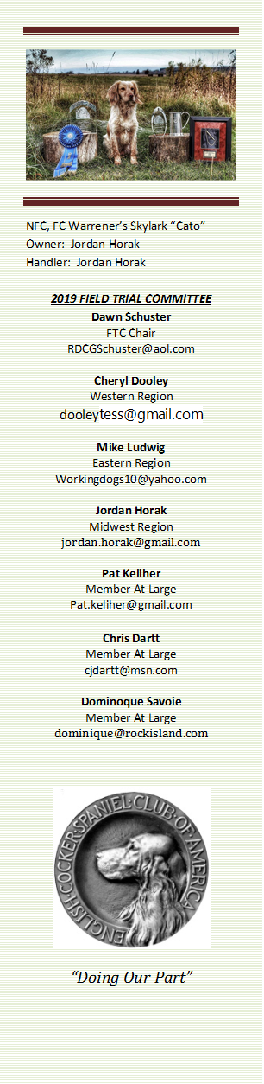
Call to Order - The meeting was called to order by Dawn Schuster at
6:04 PM CST.
FTC Members Present: Dawn Schuster (Chair), Ron Bullock, Cheryl Dooley, Jordan Horak, Pat Keliher and Mike Ludwig.
Approval of Minutes from May 20, 2020 –Pat made a motion to approve the minutes. Ron seconded the motion and the motion passed.
Approval of Agenda: Pat suggested adding a discussion regarding meeting by ZOOM instead of teleconference. Cheryl suggested discussing changing the qualification for dogs eligible for the NCC (Open National). Pat made a motion to approve the agenda as presented. Ron seconded the motion and the motion carried.
Update on Judges Affirmation letters– Cheryl reported that 77 letters were mailed to potential Judges. Of those, 44 were returned. Of the 44, 2 Judges want off the list permanently, 18 do not want to be on the ballot this year, and 24 agree to be on the ballot. The preliminary ballots were mailed on June 17 and 18.
There was an issue with one Judge indicating they were qualified but did not receive a letter. It was determined that the spreadsheet from the Springer Group was incorrect. That Judge’s name was added to the ballot. Cheryl will contact Holly Boggess and try to determine how we can avoid this problem in the future.
There was a brief discussion around the Judge Qualification Criteria. Jordan suggested that issue be discussed at the 2020 North Dakota National.
Update from Tom Ness on the North Dakota Trial –Dawn asked Tom Ness to report on the North Dakota Trial held June 12-14, in particular, regarding Covid precautions. Tom sent Dawn and email message that she forwarded to the FTC. In the message, Tom indicates the Trial conditions were very hot, very windy, very green, used spring birds and yet the Trial went well. Tom indicted Folks tried to social distance and minimize handshakes. Jordan and Cheryl, who were both in attendance, indicated there were no masks worn and most people didn’t seem to show any concern regarding the virus. Conditions seemed to be like any other Trial. Pat mentioned he spoke with a couple of Attendees and it seemed Folks were mostly concerned about Folks traveling in from a ‘hotspot’ but not any others.
Bird Handling Letter to Brian Schmidt from FTC – No letter has been drafted at this point.
Gunning Section of How to Run an NCC – Dawn made 3- motions regarding the Gunning Section of the How To document. The motions were as follows:
Motion #1 - In regards to who should notify the Gun Team Members - Dawn made a motion the Gun Captain chooses his/her team and notifies each of the team members selected along, with 2 alternates. They then will submit the team members to the NCC event Chair. All NCC gun team members and alternates must be qualified, approved and listed on the official gunning list
Ron seconded this motion and the motion passed.
Motion #2 – In regards to announcing the NCC dog selected for the Gun’s award – Dawn made a motion the Gun Captain shall give the name of the gun dog award to the Chair of the event. Should the Chair have a dog still competing in the event, the name should be given to another committee member who does not have a dog still in the event. The NCC Chair can decide to allow the Gun Captain to announce the winner of the Gun’s Award.
Pat seconded the motion and the motion passed.
Motion #3 – In regards to Gunner expenses and the NCC Committee’s obligation to meet said expenses- Dawn made a motion to allow the Chair and Committee decide on what expenses shall be paid for the gun team. Generally, covered expenses would include – Banquet, Lunches and gun shells. Any extra expenses paid, ex. gifts, lodging or evening meals must come from fundraising and donations, earmarked for the gun team and must be noted in the budgets.
Jordan seconded the motion and the motion carried.
Changing Dog Qualification for NCC (Open National) – Cheryl suggested this item be placed on the July agenda, allowing a month for FTC Members to reach out to General Members and get opinions on changing the qualification from TWO years to ONE year. Cheryl indicated Folks are still commenting that there are too many dogs qualified for the Open National and in order to have a more competitive and more manageable event, it might be best to change the criteria. Suggestions to date are varied, but two prominent suggestions are either ONE year or 3 points over a 2- year period. Dawn suggested Mike and Jordan reach out to the Folks they represent in their regions for opinions. Dawn also suggested this be discussed at the National Meeting in North Dakota. Both Pat and Ron questioned if there would be enough representation present. And Ron also questioned whether it was necessary to be an ECSCA member in order to vote. Dawn could not recall the FTC ever having a membership vote at the NCC as much as just asking whoever is in the room who cares should vote. There was discussion about a vote taken at the 2016 NCC regarding changing the 3- year qualification to two years. No one seemed to have a clear memory of how that vote was taken. Pat suggested potentially doing a Survey Monkey to get a good feel from as many Folks as possible.
New Business:
Meeting via Zoom versus Teleconference – Pat asked Members what they thought of the idea to hold meetings via Zoom instead of a phone call. Dawn questioned that Zoom was limited to 50 minutes. Both Pat and Cheryl indicated they have been on Zoom meeting lasting over 2- hours. Cheryl indicted it might be easier to communicate with a ‘visual’. Ron indicated he has attended Zoom meeting thru work and feels they work quite well. Jordan expressed concern over lag issues due to being located in a rural area as well as issues when someone is traveling. Ron suggested when traveling it would be possible to access the meeting via phone. Jordan suggested the FTC try a Zoom meeting and see how it works. The issue was tabled for the July 2020 meeting.
Iowa Club September Field Trial – Ron, on behalf of the Iowa Spaniel Club requested permission to hold the following trials – Friday, September 25th – Open Cocker, Saturday September 26th Open and Amateur Cocker, and Sunday September 27th Open Cocker. Ron will be Chairman and Terry Stubbs will be the Trial Secretary. Gun Captain will be Dave Crews. The FTC agreed to approve the Trial.
Adjournment – Pat made a motion to adjourn the meeting. Ron seconded the motion and the motion carried. The meeting was adjourned at 7:00 PM CST.
The next FTC Meeting will be held at 6:00 PM (CST) on July 16, 2020.
Respectfully submitted by Cheryl Dooley.

