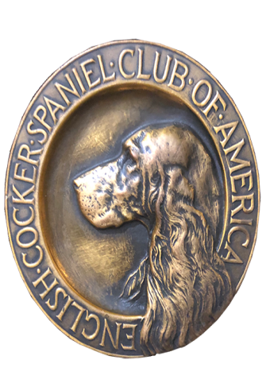
ECSCA
Field Trial Committee

Dawn Schuster – Chair
rdgschuster@aol.com

At-Large Members –
Ron Bullock – robull@gmail.com
Chris Dartt, - cjdartt@msn.com
Pat Keliher – pat.keliher@gmail.com

East Region Rep – Ted McCue
tedjmccue@gmail.com

Midwest Region Rep– Susan Sarracino-Deihl
saracen@rr.wi.com

West Region Rep – Cheryl Dooley
dooleytess@gmail.com

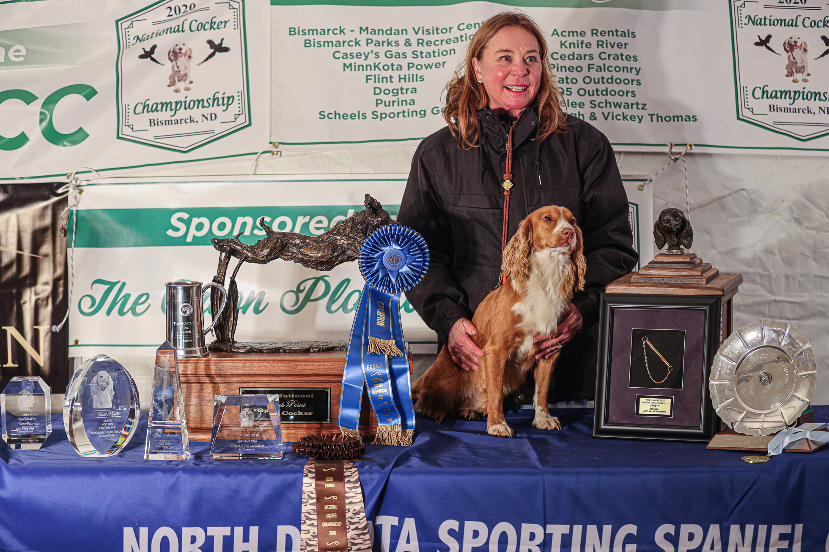

2020 National Champion
Warrener’s Tullinadaly “Tully”

2

ECSCA Field Trial Committee Meeting Minutes
Tuesday, May 18, 2021

Call to Order: The meeting was called to order by Dawn Schuster at 5:35 PM CST.

FTC Members Present: Dawn Schuster (Chair), Ron Bullock, Chris Dartt, Ted McCue, Susan Sarracino-Deihl and Cheryl Dooley.

Approval of March Meeting Minutes: Suggestions were made to the April Regular Meeting Minutes (4-20-21) and the Special Meeting Minutes (4-28-21). Cheryl will edit the minutes, email them to FTC Members so a vote can be taken by email.

Approval of Agenda: Chris made a motion to accept the Agenda. Ron seconded the motion and the motion carried.

OLD BUSINESS:
Discussion of National Proposals:

- NACC 2021 Virginia Proposal & Budget Revisions (Leytham):
The FTC reviewed the Budget Revisions proposed by Walt Leytham and his Committee.
Bird Planter fee: There was still concern over the Bird Planter fees being too high. The planting of a National Trial and difficulties involved with such were discussed, as well as, the importance of the Bird Planter role. However, in light of the fact the NACC has lower entries than the NCC and runs 2.5 days as opposed to 4.5 days it was suggested a higher payment would set a precedence that may not serve future Nationals well. Chris made a motion to lower the fee per day and allow reimbursement for Food, Lodging and Transportation for submitted receipts. Susan seconded the motion and the motion carried.
Entry numbers proposed: The submitted budget proposed 60 entries. The FTC feels 50 entries is a more reasonable number. Dawn refigured the income based on 50 entries.

A question arose regarding no number or price submitted for lunches, just a general expense of $500. Dawn explained currently the Committee is not certain what the Lunch price might be and instead estimated $500 for the entire Trial.
The final net for the proposed budget is approximately $4100.00.

Ted made a motion to approve the Budget as revised this evening by Dawn.. Susan seconded the notion and the motion carried
Dawn will email the updated spreadsheet to the FTC Members.

- NCC 2022 Illinois Proposal (Mommaerts):
Dawn reported she has not received any official proposal from Paul.

Paul did request a land fee from the ECSCA to reserve the Trial Ground Property. The check was provided and will be refunded is the Trial doesn’t take place.

Dawn added that Bethann Wiley and Vickie Dahlk are assisting Paul with details.

- NCC 2023 Utah Proposal (Riddle):
Dawn indicated we still need more information from Gary Riddle and Committee. Dawn will phone Gary in the next week or two and offer assistance at putting details together

Dawn will also send Gary a couple of previous National Budgets so he has some guidelines.

- NACC 2022/2023 Wisconsin Proposal (Strohl):
It was reported that Deb Strohl’s proposal for a Spring NACC was tabled pending results of a new survey. Dawn informed Deb there was no vote and the discussion was tabled.

Chris suggested we decide first if we would consider a Spring National and whether Folks would be willing to have alternating seasons (Fall one year and Spring 15-18 months later).

Dawn suggested in light of Pat’s absence this evening, this conversation be tabled.

Susan also suggested it might be best to wait until we receive results from the Survey Monkey that addresses NACC and when it should be held.

Ted brought up three topics to consider and discuss in the future:
- Does having a Spring National make it difficult for dogs in Northern climates to be in condition to compete? Are Northern dogs at a disadvantage?
- The FTC should discuss the impacts of alternating NACC from Spring to Fall at 15-18 months apart.
- Would having October/November NACC in the South allow for more exposure of Cockers to area/people where Cocker Trials aren’t common, thereby increasing interest in the Southern States.
Survey Monkey #2 (Subject Spring vs Fall NACC):
The survey intended to seek opinions on holding the NACC in the spring vs fall is in the final editing stages. Cheryl will go thru the latest version and recent email thread to try to put the 7-days to review and respond. The goal is to get the survey out soon and have responses back before the next FTC meeting June 15th.

Maine Trial Judge Change:
Dawn indicated Maine has requested a Judge change. The Judges for their Trial will be Dan Lussen and Richie Whelan.
.

NEW BUSINESS:

Potential Regional Addition:
Dawn explained to the FTC Members that in 2015 the current FTC decided to switch from 4- Regions (East-South-Midwest-West) to 3- Regions (East-Central-West). At that time the FTC indicated this change should be reviewed after three years. Dawn suggested the decision be reviewed now.

Dawn continued by pointing out the idea would be to have 4- Regional Reps on the FTC and one less At-Large. This could potentially allow for better representation of members of the ‘cocker world’.

Dawn explained the current 3- regions are listed at the top of the 2021 Calendar on fieldcockers.com. Under those headings the States included in each region are listed. She recommended the FTC Members visit fieldcockers.com to obtain the information. As a starting point, she encouraged Members to review the 2015 Calendar to see how the 4- regions were split up by States.

There was a short discussion around whether or not to add a 4th region and how the country would be divide. Again, Dawn suggested the FTC view the Calendar and see where Trials were being held and then determine if there was a need to split-up a region that has large number of Trials.

Cheryl pointed out that recently she obtained Trial entry data for Purina and now has a spreadsheet listing all the Trials for one year (July 1, 2020 to June 30, 2021). The sheet indicates States where Trials are being held and could be used to help determine, if a new Region were to be added, how the States might be assigned. Cheryl will email the ‘Purina data’ to all FTC Members.

For now, the discussion was tabled allowing time for FTC Members to view the data and determine if there is a need for a 4th Region.

Hall of Fame 2020 Inductions:
Dawn indicated that due to COVID restrictions, the 2020 Hall of Fame Induction Ceremony was postponed. The ceremony is now slated for June 12, 2021 at the Bird Dog Hall of Fame.

The FTC extends sincere CONGRATULATONS to the new Inductees:

People:
Tawney Crawford
Hartwell S. (Buckey) Moore

Dogs:
FC AC CFC Ballymena Lucky Shamrock MH - “Cassie”
NFTCH FC Camino’s Cheetah- “Cheetah”

The Hall of Fame Committee will be accepting nominations for 2021 from June 1 – August 31. Forms for nominations can be found on fieldcockers.com. In the upper left-hand corner there is a Hall of Fame tab. Criteria for eligibility is listed on this site.

Assistance with recording FTC minutes:
Dawn indicated it might be a good idea to take turns serving to take meeting minutes. Pat has agreed to do the minutes in July. Susan indicated she might be able to take minutes in June. If not June, Susan will take minutes in August.

Survey Monkey #1 Comments entered on Question 10:
Cheryl complied a Table summarizing the comments that were received on the First Survey Monkey. The Table has been emailed to FTC Members. Cheryl encouraged Members to review the list and prioritize what they feel the FTC needs to address. She also pointed out that, while it is difficult to place all the comments in a particular Category, some topics did rise to the surface. Those topics include: Judging, Dog Qualifications, Guns, Marshals, Water Tests, Cocker Cover and Amateur Trials.

In particular, Cheryl indicated that since the FTC seems focused on having a yearly NACC, it makes sense special attention should be awarded to the comments on Amateur Trials. The most common comment being: ‘There are not enough Amateur Trials available’.
The topic of Comments was tabled for now to allow FTC Members time to review the entire Table.

Motion to Adjourn: Ron made a motion to adjourn the meeting. Ted seconded the motion and the motion carried.
The meeting was adjourned at 7:47 PM CST.
The next FTC meeting will be held June 15, 2021 at 5:30 PM (CST).

Respectfully submitted,
Cheryl Dooley

