ECSCA Field Trial Committee Meeting Minutes
Thursday March 19, 2020
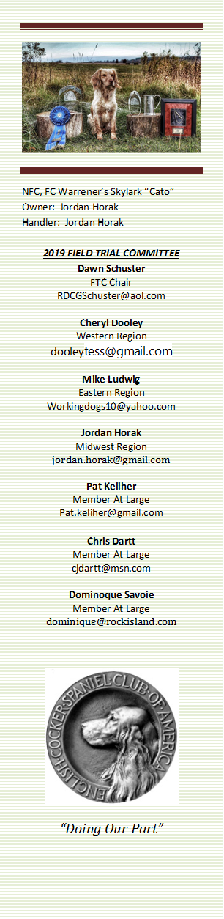
Call to Order - The meeting was called to order by Dawn Schuster at
6:18 PM CST.
Present: Dawn Schuster (Chair), Ron Bullock, Chris Dartt, Cheryl Dooley, Jordan Horak, Pat Keliher, and Mike Ludwig.
Approval of Minutes from February 20, 2020 –Chris made a motion to approve the minutes. Ron seconded the motion and the motion carried.
Field Trial Cancellations/Postponements– Pat has been contacted by a couple of Clubs from the East Region asking if they can use the same Event # if they reschedule their Trial. Dawn has been in touch with the AKC and they have informed her they will handle this issue on a case by case basis. Each Club will need to contact the AKC and make this request on their own. A question arose regarding the criteria the AKC is planning to use to decide if the same number can be used. And, there was a second question as to why the AKC couldn’t have a blanket policy? Dawn indicated she will post the AKC contact info on fieldcockers.com and Facebook. Clubs can contact AKC with trial questions at perfcancel@akc.org

It was noted that some Clubs are not cancelling/postponing. It was mentioned that States may help with that decision as a number of States are forbidding such gatherings. Dawn suggested the FTC release a statement that indicates we suggest Clubs give serious consideration to cancelling or postponing their Trial. Pat and Cheryl will draft a statement.
(statement is now posted on Fieldcockers home page)
A question arose as to whether the FTC will be governing the approval of new dates or is the decision made by the AKC? It was noted Regional Reps need assistance/guidance on how to field this question.
(new dates will require a trial request to be sent to the FTC for approval)
A second question was around what date does the FTC give to Clubs in regard to how soon we would consider a date. Pat noted the state of Maine is telling Folks 60-90 Days. It was suggested Clubs pay close attention to State Guidelines. Clubs need to make certain the postponement date meets state guidelines.
Any Club wishing to reschedule for a ‘new’ date needs to notify the FTC.
2020 NACC– Dawn indicated the Committee for the NACC will be holding a teleconference meeting to discuss rescheduling the NACC and issues involved with postponement. After the conference call, Dawn will notify the FTC regarding the outcome of that meeting as well as seeking approval for a new date.
Items around the postponement of the NACC were discussed including the following:
Have major donors, such as Purina been informed? And do they want their donation back? – Dawn indicated Purina has been informed and they indicated they want the NACC to keep the donation for the new date.

Chris indicated the trophy money has already been sent to Karen Spurlin, ECSCA Treasurer. Chris was giving thought as to how to change the date. There was discuss around leaving the trophies as is and Folks might consider them to be a special keepsake.

Has the food been received from Purina? Dawn indicated the food has been received and it is being stored at Mike Ludwig’s home. Mike indicated the Purina vests arrived today and will be stored at his place as well.

Has hotel been cancelled? Yes and the Hotel indicated they will reserve a block of rooms once the new date is selected.
It was noted that anyone with reservations at the hotel will need to cancel within 24- hours of their scheduled arrival date.

Land – no money has been paid to-date for the land.

VFW for social events – VFW is currently closed, so this issue is unresolved. They do however have the deposit and will hold for a future date.

PortaPots – funds have been paid but will be refunded.

Birds – A $4000 deposit was paid. The Supplier will hold the money, sell the birds he had set aside for the event, and provide birds when the date is set.

Silent Auction – Items are to be held in storage.

Judge travel - Sue Wilson is working with the Airline to change or cancel Paul McGagh’s ticket. Casey Butz will take care of changing his ticket.

Qualified Dogs – A discussion occurred around whether or not to open up entries so dogs who qualify in the fall will be eligible to enter. Points noted were: 46 dogs were entered, but it is possible some of those will not be able to attend in the fall, so it seems important to open up entries to ensure the number of entries stays above 35.
Dawn made a motion to allow dogs who have placed in an Amateur Trial between April 2017 to just before the 2020 NACC date be allowed to enter. Ron seconded the motion and the motion carried.

Fall NACC Trials – The question arose as to whether the FTC should now vote to hold ALL future NACC Trials in the fall. Some Members of the FTC were not ready to vote at this time. It was suggested the FTC wait until after the 2020 NACC, look at the number of entries and the outcome/success before deciding to move all future Trials to the fall or remain in the spring.
Dates to determine Individual dog awards–It was suggested the FTC consider using the 12-month period between September 1st to August 31st to determine the various individual dog awards (high point dog, high point amateur, etc….). After considerable discussion, it was decided to leave the 12- month period as is (day after the NCC thru the end of the next NCC) since some dogs might peak from spring to fall and not necessarily fall to spring. Discussion tabled to a future date.
Mid-Atlantic Club Trial – Dawn reported she received a phone call from someone in attendance at the recent Mid-Atlantic Field Trial, during the trial. The individual indicated the Trial was a “catastrophe” and the FTC needed to act on this issue. Issues sited included the care and state of the birds, citing the birds were overcrowded in crates, left without food & water and were so weak many did not fly. In short, it was viewed that the bird treatment was inexcusable. Dawn made contact with the acting chair as well as other committee members in attendance of that trial the day the trial began, issuing a written warning.
The FTC discussed the issue including what avenues might be available to sanction the Club, the fact that we preach about recovering game as well as how to handle game, and should the Field Trial application be amended to include actions that will be taken if there is mishandling of game. It was suggested the FTC not approve any future Field Trial applications from the Mid-Atlantic Club until they demonstrate there is someone with experience as Chair and the FTC is allowed to monitor every aspect of the Trial. It was suggested the AKC be asked to send a letter of reprimand. Dawn indicated a complaint would need to be filed within 5-days of the Trial, so it is too late. Chris made a motion the FTC draft a letter to the Mid-Atlantic Club. Mike seconded the motion and the motion carried. Dawn will draft the letter and send it to the FTC for approval before it is mailed.
Adjournment Chris made a motion to adjourn the meeting. Ron seconded the motion and the motion carried. The meeting was adjourned at 8:05 PM CST.
The next FTC Meeting will be held at 6:00 PM (CST) on April 16, 2020.
Respectfully submitted by Cheryl Dooley.

