ECSCA Field Trial Committee Special Meeting Minutes
Saturday March 14, 2020
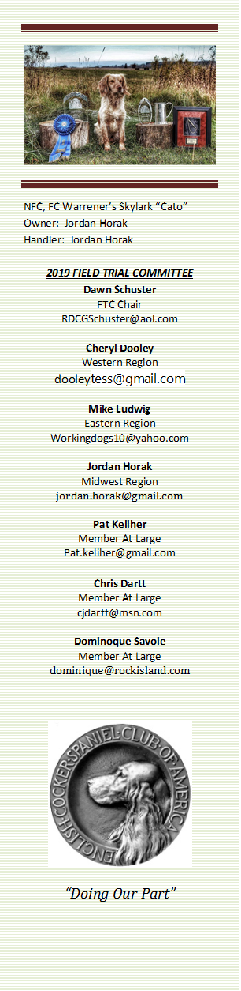
Call to Order - The meeting was called to order by Dawn Schuster at 8:04 PM CST.
Present: Dawn Schuster (Chair), Ron Bullock, Cheryl Dooley, Jordan Horak, Pat Keliher, and Mike Ludwig.
This special meeting was called by Dawn Schuster to discuss the postponement of the 2020 NACC.
Dawn started the meeting by posing a couple of questions to the Group regarding the Coronavirus pandemic.
1)What are we telling local Clubs?
2)How does the FTC feel about Clubs holding Spring Trials?
Pat indicated he was encouraging Folks to listen to their State’s recommendation and/or to consult their local CDC or the National CDC.
Dawn indicated she would like to see the FTC offer a recommendation to the Cocker World encouraging them to error on the side of caution. She indicated the FTC can’t insist trials be cancelled or postponed but the FTC could encourage Clubs to do so. Pat and Cheryl were assigned the duty of drafting a letter of recommendation for Clubs.
Dawn also reported she has been able to contact the AKC in regards to rescheduling the 2020 NACC. The AKC has agreed to allow the same Event number to be used and re-opening the entry process for Folks who now want to attend.
Folks who have entered will be able to remain on the entry list or seek a refund through Hunt Secretary.
The FTC discussed whether it was appropriate for the NACC Committee to decide on a Fall date without consulting the FTC. Dawn indicated the decision to move the Trial to fall was made by Herself, Pete, Ohio DNRC and the AKC.
Pat suggested we table the discussion regarding rescheduling the NACC and attempt to contact Jon Hunke & John Alstadt (2020 NCC Chairmen).
Adjournment Jordan made a motion to adjourn the meeting. Ron seconded the motion and the motion carried. The meeting was adjourned at 8:52 PM CST.
The next FTC Meeting will be held at 6:00 (CST) on March 19, 2020.
Respectfully submitted – Cheryl Dooley

