ECSCA Field Trial Committee Tuesday, January 8, 2019
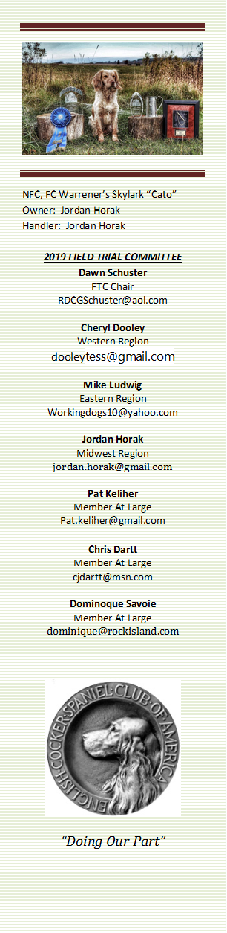
- Call to Order- The meeting was called to order by Deb Strohl at 7:02 PM CST
Present: Deb Strohl, Chris Dartt, Cheryl Dooley, Jordan Horak, Pat Keliher, Mike Ludwig & Dawn Schuster – Absent, Dominique Savoie, Guest: John Dartt
- Approval of Minutes from December 18, 2018 - This was organized by Deb Strohl with the previous FTC Members via email.

- Introduction of New FTC Members – Deb thanked the previous FTC Members and introduced the new Members. She also mentioned that Jeff Janousek has resigned from his At-Large Position and Dominique Savoie will be filling in for the last year of Jeff’s term.

- Election of New FTC Chair – Chris nominated Dawn Schuster as the new FTC Chair. There was discussion around the role of the FTC Chair. Pat seconded the nomination. A vote was taken and the nomination carried.

- Recording Secretary – Chris Dartt made a motion to nominate Cheryl Dooley as Recorder. Pat seconded the motion and the motion carried.

- Selection of Date/Time of Meetings – The new Committee discussed moving the meeting from 7PM CST to 6PM CST and from Tuesdays to Wednesdays.

- Calendar of Events – Deb Strohl provide an up-to-date calendar of Field Trial Events. Chris volunteered to prepare an Excel spread sheet that will show Trials listed by Region, State and Club. Chris will share the information with Bethann Wiley for posting on fieldcockers.com.

- A discussion occurred around the subject of a Utah Club indicating they wanted to hold a sequential Springer/Cocker Trial the same weekend as Lewis & Clark (Roy, MT) the weekend of April 5-7. As Utah has not officially applied for a Trial, it was decided that Cheryl Dooley would contact Western Region Handlers asking how the two locations might affect their entries. Cheryl will also contact Robert Griffin (Lewis & Clark) to get his opinion on the matter.

- New ECSCA Sponsored Trial – John Dartt was present to discuss the possibility of a new Trial to be held April 27 &28. The Trial would be Open/Amateur each day; as well as one puppy stake. John indicated he has lined out a Committee, birds, bird planters, 1- Judge, a Gun Captain and a location (New Glarus Hunt Club). John will fill out the Approval Request Form and submit it to the FTC in the next few days.

- Print Program for NCC – Deb Strohl presented a letter to Margie Wilson of the ECSCA Board asking for approval of an increase in the allowance from $1000 to $1500. This $1500 is to help pay for 35- Prints to be given to Patrons, Judges, Landowner, etc. Margie indicated she will present the letter to the new ECSCA Members at the next meeting.
- Hall of Fame- A discussion occurred around items displayed at the HOF. It was mentioned that HOF Officials yearly remove a National Print to make room for Inductees. The removed print is then auctioned to raise funds. There was discussion around the belief that the HOF was to preserve the Field Cocker History. Members of the FTC will contact various HOF Committee Members for verification on the sale of prints.

- Amateur Judge Voting & Qualified Dog Determination – Cheryl Dooley reported that the Judge Survey Letter has been mailed and a quarter of the Judges have responded to-date. Also, Bethann Wiley has secured Shannon Loritz as the neutral party to count the Final Ballot.

- There was discussion on how to determine qualified dogs for voting and eligibility to run the 2020 NAC. It was determined there will be a 3- Year eligibility period. As such, any dog earning an Amateur Placement in 2016, 2017, or 2018 would be eligible to receive a ballot to vote. Any dog earning an Amateur Placement during the calendar years 2017, 2018, 2019 and early 2020 would be eligible to enter the 2020 Amateur National Championship. Jordan volunteered to maintain a current list of eligible dogs/Handlers similar to the list of Open Qualifiers. Both lists will be posted on fieldcockers.com.

- Amateur National Print Program – A discussion occurred around whether there should be an Amateur National Print program that parallels the NCC Open. It was mentioned that if the ECSCA needs to set an allowance amount, that could be less than the NCC Open amount as there are less Patrons. An amount of $500 was suggested. The topic was then tabled pending the ECSCA decision on the increase allowance for the NCC Open Print Program.

- Revision and Update on ‘how to run an NCC” – A discussion occurred around organizing NCC Guidelines that could be used by NCC Organizers in the future. In particular, budget guidelines will be lined out and address every aspect of an NCC. It was decided a Subcommittee should be formed to take on this task. Mike Ludwig indicated that Murray Tate would be happy to pass on notes he generated during the 2018 NCC planning process. Chris Dartt volunteered to assist with this project. This agenda item will be discussed further during the February FTC meeting.Established Clubs that wish to run Trials under the ECSCA License – This topic was tabled until February.

- Meeting Adjournment – Pat made a motion to adjourn the meeting. The motion was seconded by Mike and was carried. The meeting was adjourned at 9:02 PM.
- Next FTC Meeting – Wednesday, February 20th 6:00PM CST
Respectfully Submitted: Cheryl Dooley

