ECSCA Field Trial Committee Tuesday, February 20, 2019
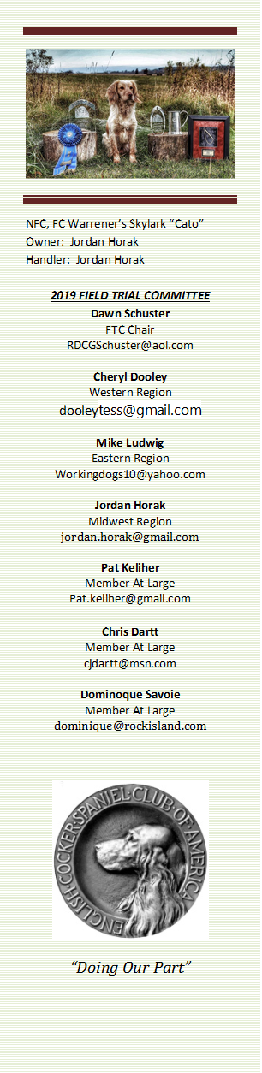
Call to Order- The meeting was called to order by Dawn Schuster at 6:07 PM CST
Present: Chris Dartt, Cheryl Dooley, Jordan Horak, Mike Ludwig, Dominique Savoie & Dawn Schuster - Guests: Dennis Joannides & Ron Bullock
- Approval of Minutes from January 8, 2019 – Jordan Horak made a motion to approve the minutes. Mike Ludwig seconded the motion and the motion carried.
- Approval of Agenda – The agenda was approved with the addition of a discussion around the Mason-Dixon Trial.
- Update on 2019 NCC – Ron Bullock gave a complete update on the planning of the 2019 NCC. Currently he has a Committee consisting of: Ron Bullock, Rumi Schroeder, Lucas Zachery, Allan Elam, Terry Stubbs, Paul McGagh, Vicky Thomas and Cheryl Dooley. Gun Captain – Dave Crews. Bird Planter – Mike Schroeder. Hospitality Chair – Dawn Schuster. Field Marshall – Lisa Pyle. Trophies – Chris Darrt. Bird Supplier – Marty Malloy. It was indicated the Trial will begin on Tuesday, October 29th, with a Training Session being held on Monday. Ron is currently working on the budget and will have that complete by the due date (March 31st). The FTC expressed their willingness to assist Ron with any issues or concerns in the planning process.
- History of the Cocker Hall of Fame – Dennis Joannides was on-hand to give a complete history regarding how the Cocker Hall of Fame was initiated. This discussion included the following key points: A group of Founders of various levels donated funds totaling $65,000 to acquire the area designated for Cockers. Dennis indicated the key reasons behind having a HOF include trying to preserve the History of the English Cocker Spaniel and recognize Individuals and Dogs who have contributed to the Sport. Initially there were not enough items to display so it was decided to frame and hang NCC Champion Prints. Dennis indicated the NCC Prints were donated to the HOF and thus are now property of the HOF. As space is needed for HOF Individuals and Dogs the Prints will be removed and auctioned to raise funds for the HOF. Dennis suggested any further questions should be addressed to Bethann Wiley.
- How to Run an NCC - The last update on the budget template for a NCC was 2013. Chris Darrt updated the template and has passed the information on to Ron Bullock. It was suggested it might be helpful to include data from the three previous NCC budgets. A discussion occurred regarding whether this information could possibly serve as a guide to the current NCC Chair. Dominique agreed to acquire the data from the ECSCA and attach it to the budget template created by Chris.
- ECSCA Sponsored Trial – A discussion occurred around Clubs holding a Field Trial under the ECSCA Parent Club. It was indicated the ECSCA is asking for fiscal responsibility and that the FT Committee needs to have ECSCA Members. Dominique made a motion for the FTC to request a proposed budget along with any application from Clubs wishing to hold a Field Trial under the ECSCA. Chris seconded the motion and the motion carried.
- Print Program for NCC – Dawn Schuster indicated she has not heard from Margie Wilson of the ECSCA Board regarding the FTC request of an increase in the Print Program allowance from $1000 to $1500.
- Voting for National Judges– Cheryl Dooley reported the Preliminary Ballot for the 2020 Amateur Judge voting was sent to Qualified Dogs. The postmark deadline for returning those ballots is March 15th. After that date, the top six vote getters will be determined and Dawn will be notified of the names for the Final Ballot. The Final Ballot will then be mailed and returned to a Neutral Party. Once the Voting for the 2020 Amateur is complete, the voting process for the 2020 NCC will commence.
- Opening Communication between FTC and Trial Community – It was suggested that Regional FTC Reps should attempt to communicate openly with their respective Clubs. Dawn will supply a list of Clubs and email addresses for Contact Individuals. FTC Regional Reps could email FTC minutes to the Clubs and also ask Clubs to keep the FTC informed any issues or concerns thru their Rep. It was suggested that Clubs should also apply for Field Trial approval thru their Regional Reps. A discussion occurred around this topic. No final decision was made regarding this point at this time. However, Reps were encouraged to ask their Clubs to request their Fall Trial dates soon.
- Wisconsin Proposed Law Banning Field Trials – A discussion occurred around a proposed bill in the Wisconsin Legislature to prohibit any competitions involving game. It was suggested the FTC request Pat to draft a letter to the ECSCA Board requesting them to approach the AKC Lobbyists and encourage them to oppose the bill. Cheryl made a motion to have Pat draft such a letter to the ECSCA. Chris seconded the motion and the motion carried.
- North Dakota NCC – Dawn indicated the North Dakota Club met last week and have expressed interest in submitting proposals for the 2020 NCC and the 2022 National Amateur Trials. Dawn will contact them and inform them of what is required to put in a bid to hold those Trials.
- Meeting Adjournment – Chris made a motion to adjourn the meeting. The motion was seconded by Jordan and was carried. The meeting was adjourned at 8:28 PM.
Next FTC Meeting – Wednesday, March 20th 6:00PM CST
Respectfully Submitted: Cheryl Dooley

