ECSCA Field Trial Committee Meeting Minutes
Tuesday October 13, 2020
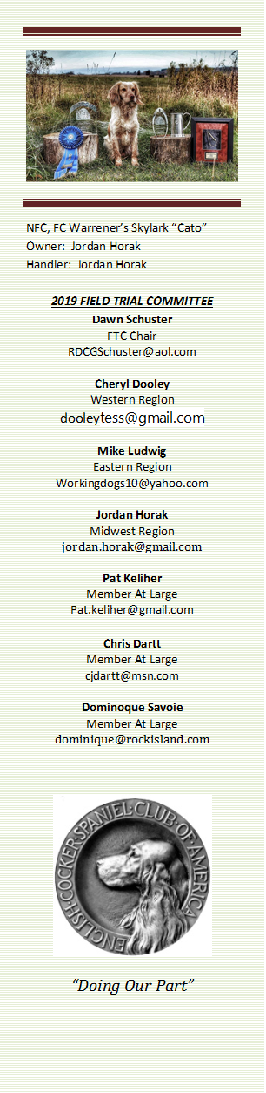
Call to Order: The meeting was called to order by Dawn Schuster at
6:03 PM CST.
FTC Members Present: Dawn Schuster (Chair), Ron Bullock, Chris Dartt, Jordan Horak, Mike Ludwig, Pat Keliher and Cheryl Dooley.

Approval of Agenda: Chris made a motion to approve the Agenda as submitted by Dawn. Pat seconded the motion and the motion passed.

Old Business:

Dog Qualifications for entering the NCC– the FTC had a lengthy discussion regarding a change in Dog Qualifications for future NCCs. Currently the qualification requirement is 1 point within two years of the NCC. Based on the recent Survey Monkey results where 168- individuals answered the questions, it appears the field of Handlers/Owners would like to see a more stringent rule.
The majority of the respondents chose to move to a 1 point within one year of the NCC qualification. The FTC discussed the pros and cons of this change, with pros listed being: 1- a higher quality of dogs entered into the NCC, 2 – Less dogs participating in the NCC (the past few years the number of entries has been between 90-105), and 3- seeing an increase in entries for general Club Field trials held in the spring and fall.
The FTC discussed what would constitute a Calendar Year for a One Year Qualification rule. It was decided the Calendar year would begin at announcements of NCC Placements in the preceding year, follow through the Spring and Fall Trial Seasons and finish at the start of the NCC.
The FTC decided the rule change would begin with the 2022 NCC (location yet to be determined). The 2021 NCC in the East Region will still accept dogs that have placed in 2020 & 2021 (1- point, within two years qualification).
Pat made a motion stating:
Starting with the 2022 NCC, the qualification for dogs entering the NCC will be changed to 1-point within 1- year of the NCC. The calendar year defined as beginning at the announcement of the previous year’s NCC Placements and continuing thru the Spring and Fall Trial seasons up to the beginning of the current year’s NCC. This would allow any dog PLACING in the previous year’s NCC to be automatically qualify to run the next year’s NCC as well as any past National Field Champions. Further, it is requested that the Parent Club consider taking action on this request prior to the 2020 NCC.

Mike seconded the motion. A vote was taken and the FTC unanimously agreed to the new proposal.
Dawn indicated she will alert the ECSCA Parent Board of the FTC recommendation. Once the ECSCA BOD approves the new proposal, it will be announced publicly allowing dog Owners/Handlers to plan for the future.

Judge Qualifications for judging the NCC– Based on the Survey Monkey results on the topic of Judge Qualifications, the FTC discussed a change in qualifications in the future.
The first point discussed was Judges should be Senior Judges, which means having judged a minimum of 12 All-Age Spaniel Field Trials.
Next the FTC addressed the current rule stating of the 12- Trials judged at least 3 must be Cocker Trials at 3 different venues. In an effort to work towards more ‘Cocker People’ judging Cocker Trials, the number was increased from 3 to 6 Cocker Trials.
The FTC, then, addressed the concept of a Judge having Field Championed a Spaniel. It was decided that at a minimum it would be best for Judges to have contributed at least 2- placements toward the Field Championship of a Spaniel.
The next point of discussion was regarding the current criteria of a Judge having handled a spaniel within the last 3-years was discussed at length. There was concerned expressed over not including some very good Judges if we stay with this requirement. Individuals at various points in life may cease trialing for a period of time due to finances, work commitments, children, health, etc…. There was also an opinion that in order to Judge Spaniels a Judge should show passion and familiarity for the Sport by running a Spaniel in trials. The final decision of the FTC was to change the criteria where a Judge needs to handle a spaniel in the last 4- years.
Finally, a new rule was suggested that would require a Judge to be ineligible to Judge a National Open for 3- years after they Judge a NCC. This, likewise, was the majority opinion on the Survey Monkey.
Chris made the following motion regarding National Judge Criteria:

In order to be eligible, a Judge must:
- Have twelve (12) AKC All-Age Spaniel Stake judging assignment points where six (6) of the 12- assignments are AKC Cocker Field Trial All-Age Stakes.
- Have handled a spaniel and contributed at least two placements to the Field Champion Title of a spaniel.
- Have actively handled a spaniel in an AKC All-Age Spaniel field trial in the past four (4) years prior to the election closing date.
- Not have judged a NCC Trial in the past 3- years.
- Sign a contract with the NCC Field Trial Committee that reflects the details of reimbursable expenses which must be in the Guidelines of the ECSCA.
Jordan seconded the motion and the motion unanimously passed.

New Business:

Announcements at 2020 NCC – Dawn announced to the group that with no FTC General meeting at the 2020 NCC – North Dakota a number of FTC members will not be in attendance. As such, Cheryl will be announcing the location of the 2021 NCC as well as the Judges for the 2021 NCC.

Harold Bixby Presentation – Dawn has asked Vicky Thomas to announce the winner of the Bixby award.

Field Trial Evaluations – Question 10 of the Survey Monkey was an open-ended area for Folks to make any comment or suggestions. One comment made was to have an avenue for Handlers to comment on field trials they attend. The areas of comment suggested were: Overall Trail Success/Failure, Judging, Bird Production, Gunning, Marshal, General Accommodations, Likelihood of attending in the future, was there a series in ‘Cocker Cover’. A rough draft of such an evaluation form was created by Cheryl and provided for the FTC to evaluate. The purpose of the form is meant to provide constructive comments (good and bad) to the Field Trial Clubs so they know how Folks are viewing their efforts and can improve on areas of dissatisfaction.
The topic of the Field Trial Evaluation form was tabled for the November FTC meeting.

Spring Calendar – Dawn will be contacting Clubs who normally have a spring trial and encourage them to submit their dates soon.

COVID update – Pat emailed the FTC members a copy of North Dakota COVID statistics recently posted in the New York Times. Cheryl reported the NCC Committee is meeting this evening as well to discuss these data as well as the topic of a banquet. At this time, there will be no Welcome Reception but a Banquet is planned, unless the Committee decides otherwise this evening.
Dawn reported the National Amateur Championship will not have a Banquet. There will be a ‘MEET AND GREET’ where Handlers can say Hello to the Judges and pick up handler bags. There will be no food offered.

Adjournment – Chris made a motion to adjourn the meeting. Jordan seconded the motion and the motion carried. The meeting was adjourned at 8:00 PM CST.

The next FTC Meeting will be held at 6:00 PM (CST) on November 19, 2020.
Respectfully submitted by Cheryl Dooley.

