ECSCA Field Trial Committee Meeting Minutes
Thursday, April 16, 2020
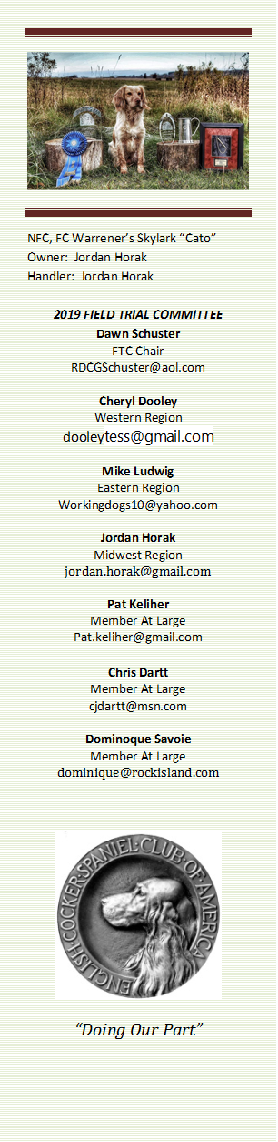
Call to Order - The meeting was called to order by Dawn Schuster at
6:03 PM CST.
FTC Members Present: Dawn Schuster (Chair), Ron Bullock, Chris Dartt, Cheryl Dooley, Jordan Horak, and Mike Ludwig.
Others Present: John Alstad & John Hunke 2020 NCC Co-Chairs
Approval of Minutes from March 19, 2020 –Chris made a motion to approve the minutes. Mike seconded the motion and the motion carried.
Additions to Agenda: Chris suggested the FTC revisit COVID-19 impact on Spring Trials. This will be discussed after the 2020 NCC Update from the North Dakota Committee. Jordan made a motion to accept the Agenda as amended. Ron seconded the motion and the motion carried.
2020 NCC Update from Jon Hunke & John Alstad– The following items were reported on by Jon & John:
Absorbing costs- The NCC Committee is moving forward as planned and will continue to do so as long as the FTC or AKC doesn’t indicate the need to reschedule due to COVID-19. The Committee has been communicating with Karen Spurlin (ECSCA Treasurer) regarding bills that need to be paid.
NCC Committee – All necessary positions have been assigned.
Merchandise- Work is in progress for an on-line catalog.
Grounds Committee – There will be 640 acres of land for use as well as 160 alternative acres.
Bird Supplier– A deposit for $2 per bird has been paid to reserve 1200 birds.
NCC Catalog – Susan Saracino-Diehl has agreed to take care of the catalog.
Patron Program –Deb Strohl has agreed to Chair.
Trophies – Chris Dartt has agreed to Chair.
Purina – Vicky Thomas will contact Purina to request a donation. Chris suggested Vicky be asked to also request the food donations for Placements as well as High point Dog.
Head Marshall – Cheryl Dooley
Bird Planter – Doug Stewart (Canada)
Water – The water site has been approved. There is a backup lake with warm water in Burleigh County in case the weather is cold
Grounds check for hazardous seeds- The Committee is looking for a seed expert to examine the Grounds for ‘mean’ seeds. However, they will have a disclaimer in the Premium for Handlers to beware and run dogs at their own risk.
Lunch Tent- There is only one vendor in the area that rents large tents. A tent has been reserved with that company, however, if the company needs to back out due to the Covid-19 crisis or, there will be no lunch tent.
Date overlap with Canadian National- There was discussion around changing the date of the 2020 NCC as there is an overlap with the Canadian National dates. There was a question around how many Handlers might be interested in running both Trials. The North Dakota Club indicated they have commitments associated with the listed dates and it will be difficult to change. Given the knowledge that the NCC has been the same dates for nearly 10 years, and the Canadian date has changed over the last couple of year, the current date of the NCC will stand.
2020 Spring Trials Recommendations–It was mentioned both Minnesota and North Dakota have trials scheduled for the spring. At this date, it is not clear if either Club will be allowed to proceed with their Trials due to the Covid-19 restrictions. The FTC discussed the situation and decided to encourage both Clubs to adhere to any restrictions put in place by their Governor as well as check with their local DNR for permission to hold a Trial. It was also suggested to take into consideration the mandates in neighboring states that may limit the travel of participants from those states.
Potential 2020 NCC Qualification Change – The FTC discussed the possibility of allowing dogs who placed in 2018 to enter the 2020 NCC. Currently, with the two-year qualification, only dogs earning a placement in 2019 & 2020 would be qualified to enter the NCC. With the Covid-19 pandemic, a number of Spring Trials were cancelled, especially in the Midwest, decreasing the opportunities to qualify. The concern is what effect this might have on 2020 NCC entries. Currently, there are approximately 150- dogs qualified for the 2020 NCC. Adding the 2018 dogs would increase this number by 32-dogs. It was noted that ‘new’/young dogs have not had the usual opportunities to run Trials and qualify for the NCC. There was extensive discussion on any action the FTC could take. It was also noted that Canada is opting to include dogs that qualified in 2019 in addition to those that qualified in 2020. The ultimate conclusion was the situation created by Covid-19 was completely out of the FTC control. However, the FTC will try to encourage Clubs holding Fall Trials to consider adding an additional Open Stake to their fall event. And, encourage Clubs who cancelled Spring Trials to consider planning a fall trial. The FTC will continue to consider the situation as we watch for the country to re-open. Additionally, Jordan will draft a letter to the Pros to determine their thoughts on the issue.
New Business:
NCC 2021 Judge Affirmations – Cheryl reported the Judge survey letter was mailed to 76-potential Judges on April 10, 2020. Responses are due back in late May. At that time, the Preliminary Ballot will be slated and mailed to qualified dogs.
Judge Qualifications – The FTC discussed a concern that NCC Judges should have more knowledge with the Cocker breed. One of the current qualifications required of NCC Judges is to have judged 12- Trials with at least 3 of the 12 being cocker trials at 3-different venues. The FTC discussed whether this should be changed to include more than 3-cocker trials. Another suggestion was that NCC Judges should have either WON a NCC or placed in two NCC trials. Cheryl was asked to determine which Judges would fit that criterion. Cheryl will email that information to the FTC as soon as possible. Another suggestion was to only allow Judges who have championed a Cocker. For now, the discussion was tabled giving FTC Members time to think about alternatives as well as ask Members for their input.
2021 NCC Location – The FTC discussed ways to recruit a Club to host the 2021 NCC. The current rotation of West – East – Midwest needs to be changed as Maine is unable to host the 2021 NCC due to ground maintenance. Maine will bid to host the 2022 NCC. A suggestion was made to seek a Midwest Club to host the 2021 NCC.
Fall Trial Dates – Dawn encouraged FTC Members to contact their respective Clubs and ask them to submit their fall dates soon. A discussion occurred around the need to have Clubs resubmit a request form yearly if they always hold their Trial on the same weekend. It was suggested that if a Club has held a Trial on the same weekend for at least 5- years, they can keep the weekend and do not need to keep submitting a request form unless they need to change the date. It was also noted that any Club that cancels their ‘regular’ Trial in order to host a NCC, will be able to retain their historical weekend.
Adjournment – Jordan made a motion to adjourn the meeting. Mike seconded the motion and the motion carried. The meeting was adjourned at 7:58 PM CST.
The next FTC Meeting will be held at 6:00 PM (CST) on May 21, 2020.
Respectfully submitted by Cheryl Dooley.

