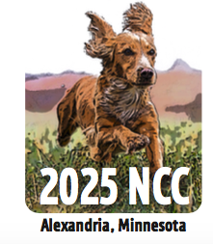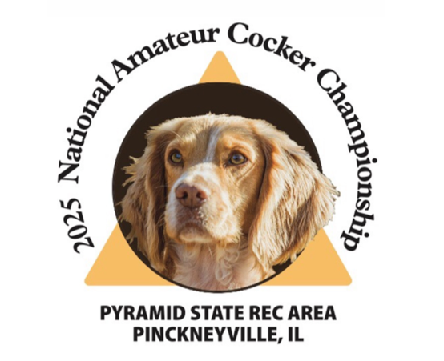

English Cocker Spaniel Club of America

National Open Championships (NCC)
Alexandria, MN October 29 to conclusion

National Amateur Championships (NACC)
Pinkneyville, IL November 17 to conclusion

PLEASE SUPPORT THE 2025 NATIONALS WITH CATALOG ADVERTISING

I hope everyone has had a good Spring Trial season! Now that we have a few months before the Fall season, I’d like to encourage everyone to begin thinking about the Nationals.

One way we can all help fund these two National Trials is through catalog advertising. As always, each championship event will have its own Event catalog.

You can design your own ad, use an ad from previous years, or we can assist with the process. (For assistance with ad creation, contact Sue Myers at smyers@mia.net.)

There is a 10% discount if you advertise in both catalogs. (Full page b/w ad in both catalogs would be $180 instead of $200; $90 for each ad.)

Please see the attached form to order an ad(s). NOTE: If you are running an ad in both catalogs, please write two separate checks made out to ECSCA NCC and ECSCA NACC. (Contact me if you prefer to make payment via Venmo or PayPal.)

Send the form and payment to me at the address below. The deadline for final ad artwork is Sept. 1.

Thank you for helping our fundraising efforts for the 2025 Cocker Nationals!

Kelly Keeler Ramacier
16780 Jeffrey Ave. N
Hugo, MN 55038
kkeelerramacier@gmail.com

