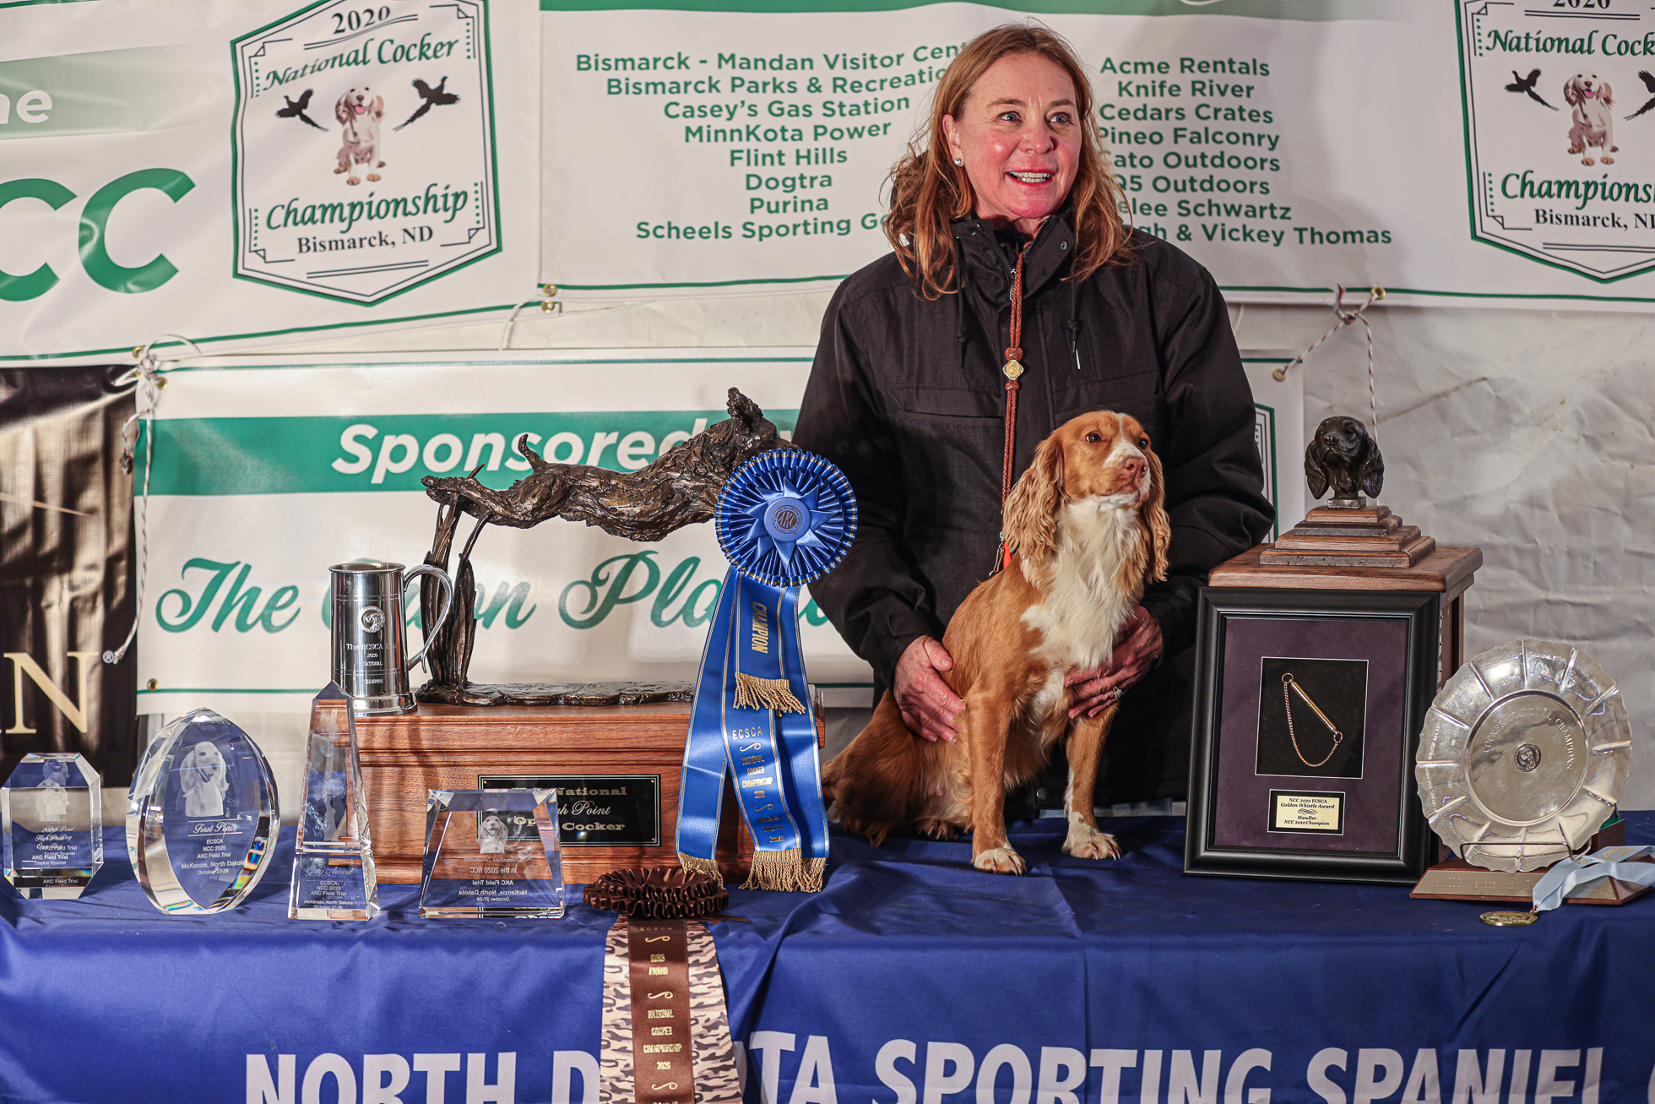
NFC FC CFC Warrener’s Tullinadaly “Tully”
O/H: Vicky Thomas
ECSCA Field Trial Committee
Chair: Dawn Schuster
Rdcgschuster@aol.com
East: Ted Mc Cue
tedjmccue@gmail.com
Central: Susan Sarracino-Deihl
Saracen@rr.wi.com
West: Cheryl Dooley (sec)
dooleytess@yahoo.com
Members at large
Pat Keliher
Pat.keliher@gmail.com
Chris Dartt
cjdartt@msn.com
Ron Bullock
Robull68@yahoo.com
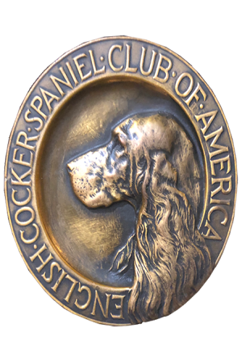
Dear Cocker Enthusiast,

The 2021 NATIONAL COCKER CHAMPIONSHIP will be held this year at the Life Camp (Flint Hills Preserve)will commence on November 3 and run until conclusion.
A great way to become a part of the Championship is to be a PATRON!
The generous support of our patrons over the years has contributed greatly to the success of the event! Please consider being a patron for our 2021 National Championship.
Platinum - $500.00 or more
- Exclusive patron gifts for (2) people.
- Baseball card program (new starting this year)
- Banquet dinner for (2) people
- (2) lunch tickets per day
- National Event catalogs (2)
- Acknowledgement in the 2021 NCC catalog
- 50% discount on advertising in the 2021 NCC catalog
- Best Seats in the House – option to Shag ALL series

Gold - $400.00
- Exclusive patron gift for (1) person
- Baseball card program. ( starting this year)
- Banquet dinner for (1) person.
- (1) lunch ticket per day
- National event catalog (1)
- Acknowledgement in the 2021 NCC catalog
- 25% Discount on advertising in the 2021 NCC catalog
- Best Seat in the house – option to Shag Series 1-4

Silver - $200.00
- Baseball card program (starting this year)
- Banquet dinner Tuesday evening for (1) person
- (1) lunch ticket per day
- National event catalog (1)
- Acknowledgement in the 2021 NCC catalog
- 10% Discount on advertising in the 2021 NCC catalog
- Best Seats in the house – option to Shag series 1-2

Bronze - $100.00
- National event catalog
- Acknowledgement in the 2021 catalog

Please send your check payable to ECSCA/NCC 2021– Deb Strohl
N2286 Shore Drive, Marinette, WI 54143. By October 17, 2021

