Thank you to our generous NACC 2025 sponsers!
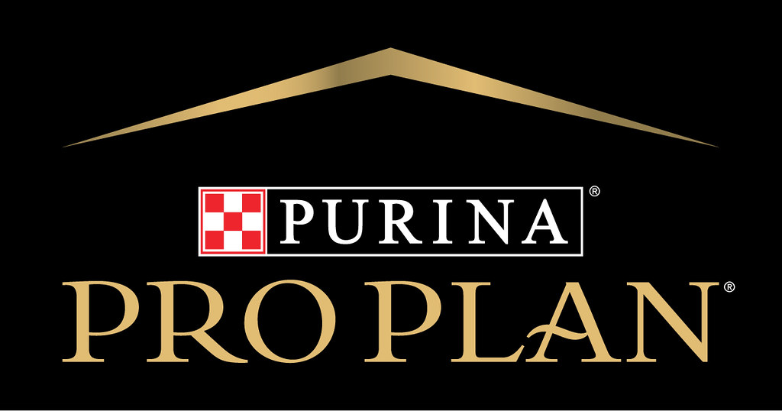
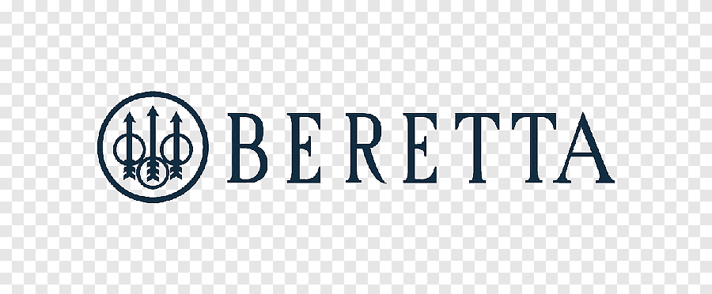

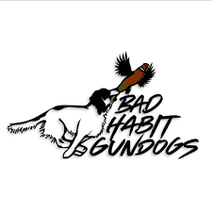

Richard & Laurie Brueckner
Faye & Barry Littlewood
Stonewalker Kennel
Fieldcockers.com
Joe Worsham
Steve Collins
Dr. Rand Doyle

