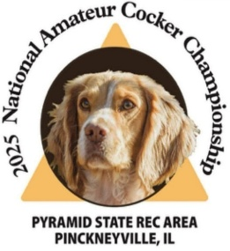
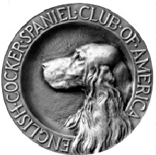
National Amateur Cocker Championship 2025 Banner and Flag Sponsorships
A banner and/or flag sponsorship can be in memory of a person or dog, in the name of a kennel or business,
or in your own name with well wishes.
Banners will be displayed at the start of the series or other area you choose to sponsor.
Series Banner /sponsorships are $300 for each banner. Each banner will be printed with your choice of print and/or photo.
Flag sponsorships are $30 for each flag. Flags will be placed on the series courses. Each flag will be printed with your choice of print.
At the end of the NACC, you will be able to take your banner and/or flags as a keepsake. (Please make arrangements to have your flags picked up if you will not be in attendance)
Please fill in the information below and return it with a check, cash
or money order, no later than October 1, 2025, made out to…
English Cocker Spaniel Club of America. Please note in the memo…NACC 2025
c/o
Dawn Schuster
N2090 Hwy 55
Kaukauna, WI 54130
Name, address, phone number and email of person purchasing the sponsorship. __________________________________________________________________
__________________________________________________________________
exact print you would like on your flag and/or Banner. Please Email a photo if desired for your banner to Rdcgschuster@aol.com __________________________________________________________________
__________________________________________________________________
Total number of Banners ____ X $300
Total number of other sponsorships ____X$150
Total number of Flags _____ X $30
Total $ enclosed for sponsorships ___________
Thank you for your continued support!
Dawn Schuster- Fundraising Committee member, NACC 2025
RDCGSchuster@aol.com

