Rocky Mountain Springer Spaniel Association – Cocker Trial

August 2022
Dear Field Trialers:
The Rocky Mountain Springer Spaniel Association cordially invites you to our annual 2022 fall Cocker Spaniel field trials. This year we are holding two Open Cocker trials, one on Friday September 30, and one on Saturday October 1, 2022. (On the same days we are holding a Springer Spaniel Open trial on Friday and a Springer Amateur on Saturday. The Springer series will alternate with the Cocker series on both days). WE ARE PLANNING ON ENDING THE TRIALS ON SATURDAY OCTOBER 1 HOWEVER, IF NECESSARY, THE TRIAL MAY RUN OVER TO SUNDAY OCTOBER 2.
The fun will start at 7am on Friday September 30 with the first series of the Cocker open followed by the first series of the Springer pen, and both will alternate series until completed. At 7am on Saturday October 1 we will start the first series of the Springer Amateur followed by the first series of the second Cocker Open., and both will alternate series until completed.
The Cocker Puppy Stake will run no sooner than the conclusion of the second series of the Cocker Open on Saturday October 1. Our Puppy judges will be announced before the trial.
Our All-Age judges are Cathy Lewis and Jerry Barrrett.
Hunt Secretary will handle the entries (huntsecretary.com) and entries will close on: September 19, 2022 at 11:59:59pm Eastern Time.
Please remember to be prepared for any kind of weather in Colorado. Some form of blaze orange is required in the field. Due to the dry weather, we ask that you not smoke anywhere on the grounds.
If you have any questions, please feel free to contact the Field Trial Chairman, Kevin Noon 303 907 0122. We hope you will join us for a great field trial.
The trial grounds are located at the Heritage Sporting Club HOME | HERITAGE SPORTING CLUB on Milton Reservoir (Colorado) Watersports Hunting. Please see the map below.
Headquarters:
The Trial Headquarters is the Best Western Plus, at the intersection of I-76 and Hwy 52 in Hudson Co. located approximately 13 miles from the grounds The phone number is 303-536-4401.

PLEASE SEE THE TWO SITE LOCATION MAPS BELOW

The trial grounds are the black polygon north of route 30 and east of 43, (Canvanaugh Rd)
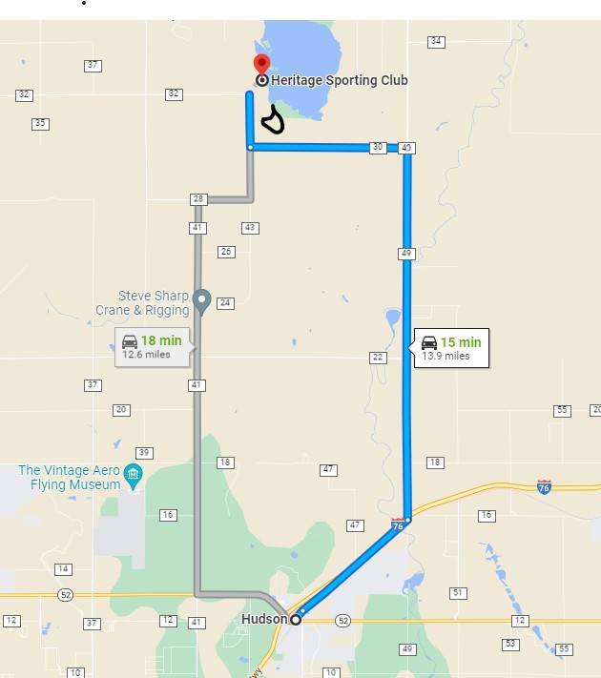

The trial grounds are the black polygon north of route 30 and east of 43, (Canvanaugh Rd)
