Vickie Dahlk
Test Secretary
108 Agnes Circle
Barneveld, WI 53507

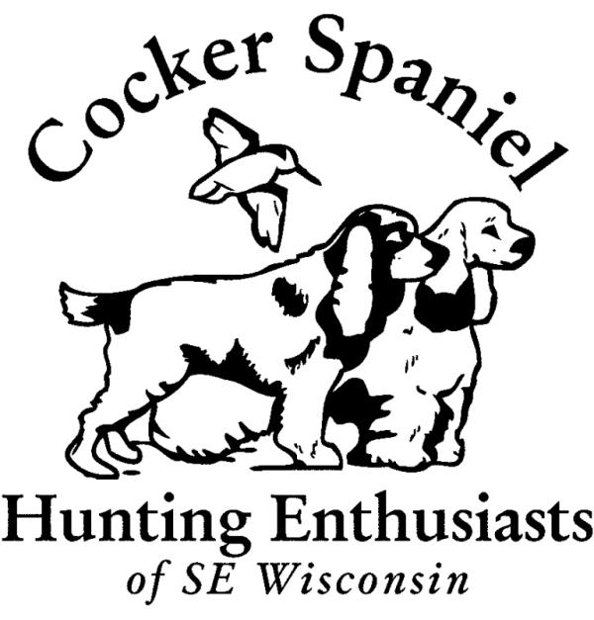
Cocker Spaniel Hunting Enthusiasts
Of Southeastern Wisconsin
Licensed by the American Kennel Club

Saturday, July 30, 2016
AKC Event #: #2016685801
Sunday, July 31, 2016
AKC Event #: # 2016685802

Mazomanie Unit Lower Wisconsin Riverway
Hwy Y
Mazomanie, WI

ENTRY LIMITED: 50 total dogs

This hunt test is open to all AKC breeds permitted to run in AKC Flushing Spaniel hunt tests

PREMIUM LIST

Entries close at 6:00 PM CST, July 13, 2016
After which time entries cannot be accepted, cancelled, altered or substituted except as provided for in Chapter 11, Section 6 of the Dog Show Rules.

Licensed by The American Kennel Club. This test is held under the Rules and Regulations of the American Kennel Club.



ENTRY FEES

Junior, Senior, Master Level …………………… $60.00 Payable to CSHE

MAIL ENTRIES WITH FEES TO:
Vickie Dahlk 108 Agnes Circle, Barneveld, WI 53507
Entry form must be signed.
ENTRIES WILL CLOSE with the Hunt Test Secretary
WEDNESDAY, July 13, 2016 at 6:00 pm CST

The drawing for running order will take place at 108 Agnes Cirlcle, Barneveld, WI
on
Friday, July 15, 2016 at 6:00 6pm CST

LIMITED ENTRY: Entry limited to fifty (50) dogs.
NO PHONE entries accepted.

Chuckar or PHEASANT WILL BE USED AT ALL LEVELS
Pigeons may be used the Junior level
- * * * * * * * * * * * * * * * *
SCHEDULE:
7:00 a.m. Sat, July 30, 2016, Junior, Senior and Master land. Water work to follow land work.
7:00 a.m. Sun, July 31, 2016,Master, Senior and Junior land. Water work will follow land work

JUDGES

Venee Gardner #17862
167 Roe Hampton Lane, Stone Mountain, GA 30087
Frank Hauenschild #5893
23814 S Plum Valley Dr Crete, IL 60417-1780
Jeff Zachow #37170
37934 Valley Road, Oconomowoc, WI 53066
Becky Krueger #58112
1825 Lake View Terrace, Stoughton, WI 53589
Gretchen DeGroot #ZI163
W292 54020A Hillside Rd Waukesha, WI 58189

Saturday, July 30, 2016
Junior/Senior/Master Division A Venee Gardner
Frank Hauenschild

Junior/Senior/Master Division B Jeff Zachow
Becky Krueger

Sunday, July 31, 2016
Master/Senior/Junior Division A Jeff Zachow
Gretchen DeGroot

Master /Senior/Junior Division B Venee Gardner
Frank Hauenschild

Apprentice Judges: Joe Worsham and Jim Karlovec

Location of the hunt test

4 miles North of Mazomanie, WI on Hwy Y, or 8 miles South of Sauk City, WI on Hwy Y, or
25 miles West of Madison, WI

Directions from Madison, WI

Take 12/18 west through Madison. Then take Highway 14 West out of Madison, 17 miles to Mazomanie, turn north on to County Trunk “Y” proceed north through town, then go approximately 4 miles. There will be a brown sign on the west side of the road identifying Lower Wisconsin River Wildlife Area, also there are yellow signs with black lettering identifying the dog training area. Turn west off county trunk ‘Y” on the gravel road that will take you into the dog training area, follow the gravel road to the shelter.

Move-ups

Dogs may be moved up to a higher Test level (in a second event) if a title is acquired after entries have closed in the second Test, subject to the approval of the Hunting Test Committee of the second event, the availability of birds, payment of the difference, if any, in entry fees, and provided also that the dog is moved up at least one-half hour prior to the start of the second Test. Dogs so moved up will be placed at the end of the drawn running order.

Accommodations

Bel Aire Motel (5 miles south of the training grounds)
10291 US Highway 14, Mazomanie, WI 53560
(608) 795-2806
Ganser's Motel – (5 miles north of the training grounds – check on dog policy)
7433 State Road 188
Sauk City, WI 53583
(608) 643-8551
Cedarberry Inn (10 miles north of the training grounds – no dogs allowed in the rooms)
855 Phillips Blvd
Sauk City, WI 53583
(608) 643-6625
Skyview Motel (13 miles north of the training grounds)
S9645 US Highway 12
Prairie Du Sac, WI 53578
(608) 643-4344
There are also several hotels in Middleton (west edge of Madison) which are about 20 minutes from the grounds.

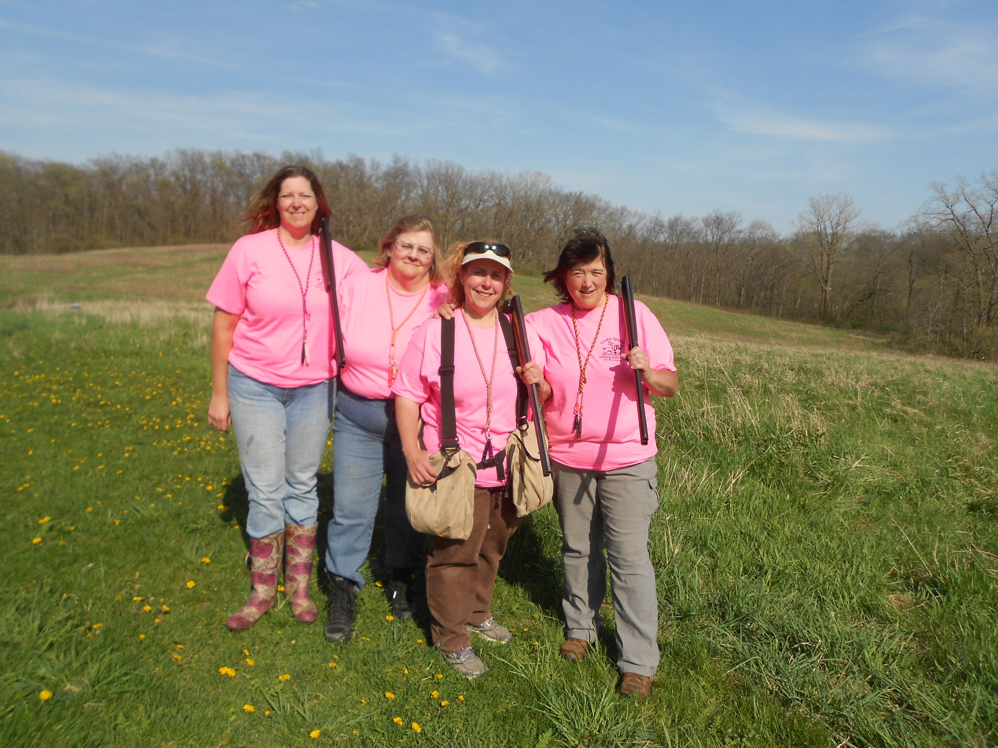

Refunds, Scratches, No Shows

Entry fees paid for a bitch withdrawn because of coming into season or for a dog withdrawn because of an injury or illness, or for a dog which dies, shall be refunded in full by the test giving club. Prior to paying such refund, the club may require an appropriate veterinary certificate. Requests and documentation must be presented prior to the test. There will be no refunds for “no shows”. Entry fees will not be refunded in the event a dog is disqualified, excused by a judge or barred from the test by action of the Hunt Test Committee. No entry fee will be refunded if the test cannot be started or completed by reason of riots, civil disturbance, an act of God, public emergency, or any other cause beyond the control of the Hunt Test Committee.

Food Available At Test Site

Food will be available on site each day provided by Smoken Pig, they will have various sandwiches, hotdogs, brats and hamburgers available for purchase for both Lunch and Breakfast.

EXHIBITORS PLEASE NOTE

- Training, correcting, or disciplining of dogs will not be permitted on the Hunting Test Grounds.
- Please bring adequate water for your dogs and yourself. Be prepared to provide water for your dog while in the field.
- Please remember, all participants and spectators must wear blaze orange into the field. The item must be no smaller than a hat.
- Smoking will not be allowed in the field.
- No entry shall be made and no entry shall be accepted by the Hunt Test Secretary which specifies any condition as to its acceptance.
- Canadian exhibitors must submit entries with checks drawn on U.S. accounts or with international money orders in U.S. funds.
- Returned checks do not constitute a valid entry fee.
- The Club assumes no responsibility for any loss, damage or injury by exhibitors, handlers, or to any of their dogs or property and further assumes no responsibility for injury to children.
- Fees include AKC recording fees

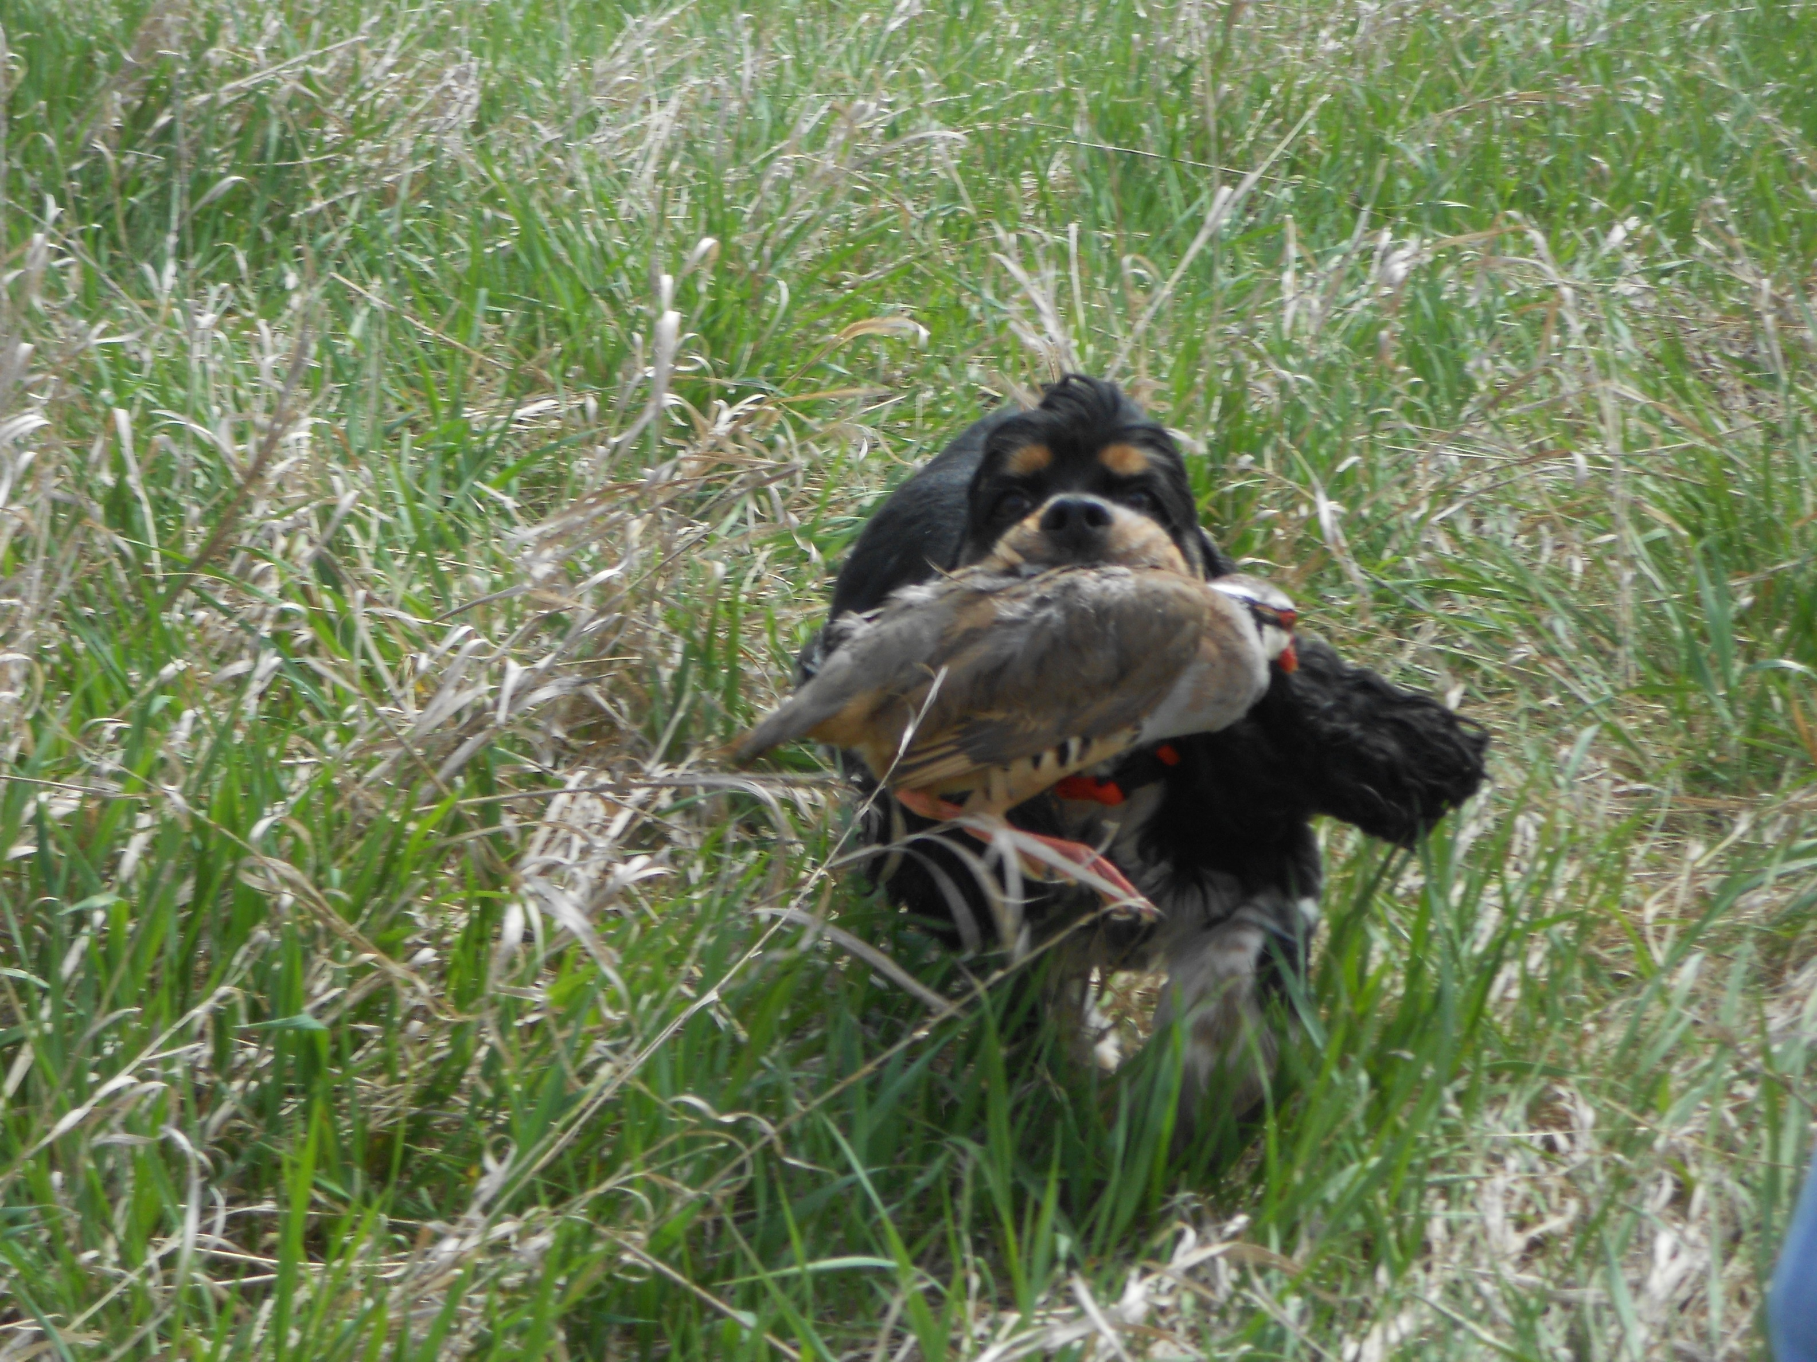

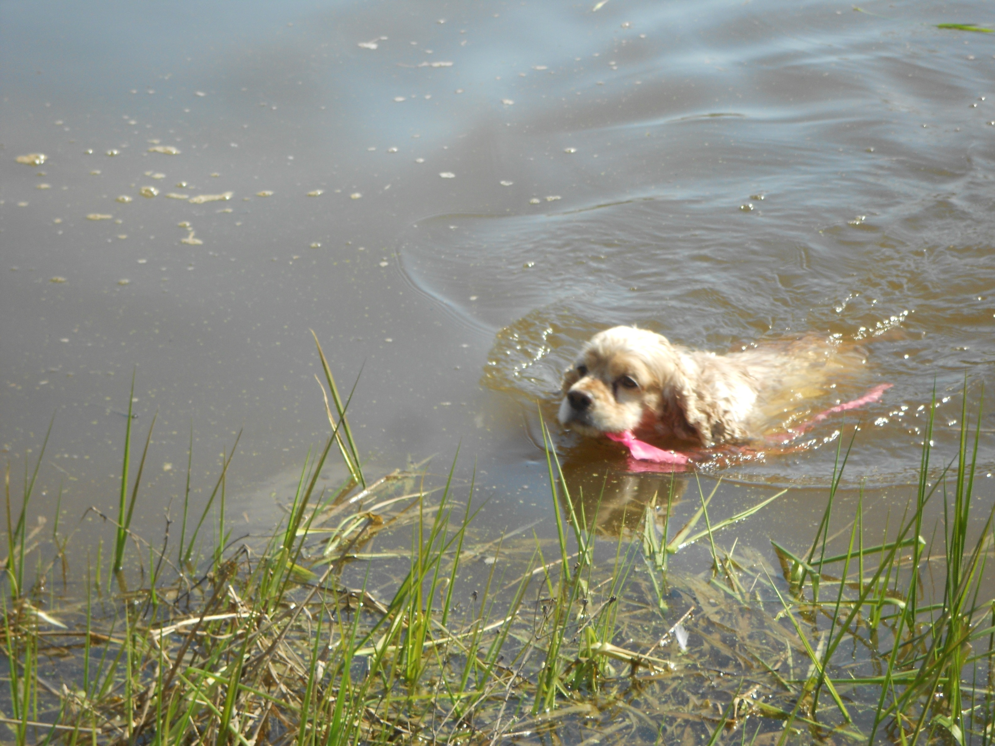

Cocker Spaniel Hunting Enthusiasts
Of Southeastern Wisconsin
www.glacshe.com

Officers
President………………………………………………..………Gretchen Degroot
W292 54020A Hillside Road, Waukesha, WI 58189 degroot@centurytel.net

Vice President ………………………………………..……….Dawn Schuster
N2090 State Hwy 55, Kaukauna, WI 54130 e-mail: RDCGSchuster@aol.com

Treasurer………………………………………………………Vickie Dahlk
108 Agnes Circle, Barneveld, WI 53507. e-mail: vdahlk@charter.net

Secretary ……………………………………………………...Kaye Bennett
1914 N.27th Street, Sheboygan, WI e-mail: kayben2@yahoo.com

Hunt Test Committee

Test Chairman Dawn Schuster
Test Secretary Vickie Dahlk
Committee Member Ron Dahlk
Committee Member Marcia Hagen
Committee Member Roe Froman
Committee Member Kaye Bennett

Veterinarian on Call
Mazomanie Animal Hospital
704 Emily Road, Mazomanie, WI 53560 (888) 675-4296

Prizes

Standard AKC Orange Rosettes will be awarded to all dogs qualifying at this test.

-
OFFICIAL AMERICAN KENNEL CLUB HUNT TEST ENTRY FORM
Note: This Entry Form Must Be Completed in Full
Club: Cocker Spaniel Hunting Enthusiasts of SE WI
Location: Hwy Y, Lower Wis Riverway
Mazomanie, WI
Date: Saturday, July 30, 2016

I SUBMIT $ 60 for entry fees. EVENT # 2016685801

Enter in Stake/Test: Junior Hunter Senior Hunter Master Hunter

NAME OF CALL
DOG (Print) NAME
A.K.C. Reg Or A.K.C. Litter Number
Number (If Dog Not Reg.)
Or ILP No.
Or Foreign Reg. No. And Country of Registry
Breed MALE FEMALE D.O.B.

Sire
Dam
Breeder
Name of Actual Owner (Print)
Owner's Address
City State Zip Code
Name of Owners Agent/Handler (Print)
Phone Email

I (we) agree that the club holding this event has the right to refuse this entry for cause which the club shall deem sufficient. In consideration of the acceptance of this entry and of the holding of this event and of the opportunity to have the dog judged and to win prizes, ribbons, or trophies, I (we) agree to hold the AKC, the event-giving club, their members, directors, governors, officers, agents, superintendents or event secretary and the owner and/or lessor of the premises and any provider of services that are necessary to hold this event and any employees or volunteers of the aforementioned parties, and any AKC approved judge, judging at this event, harmless from any claim for loss or injury which may be alleged to have been caused directly or indirectly to any person or thing by the act of this dog while in or about the event premises or grounds or near any entrance thereto, and I (we) personally assume all responsibility and liability for any such claim; and I (we) further agree to hold the aforementioned parties harmless from any claim for loss, injury or damage to this dog.

Additionally, I (we) hereby assume the sole responsibility for and agree to indemnify, defend and save the aforementioned parties harmless from any and all loss and expense (including legal fees) by reason of the liability imposed by law upon any of the aforementioned parties for damage because of bodily injuries, including death at any time resulting therefrom, sustained by any person or persons, including myself (ourselves), or on account of damage to property, arising out of or in consequence of my (our) participation in this event, however such, injuries, death or property damage may be caused, and whether or not the same may have been caused or may be alleged to have been caused by the negligence of the aforementioned parties or any of their employees, agents, or any other persons. I (we) agree that any cause of action, controversy or claim arising out of or related to the entry, exhibition or attendance at the event between the AKC and myself (ourselves) or as to the construction, interpretation and effect of this Agreement shall be settled by arbitration pursuant to the applicable rules of the American Arbitration Association. However, prior to arbitration all applicable AKC Bylaws, rules, regulations and procedures must first be followed as set forth in the AKC Charter and Bylaws, rules, regulations, published policies and guidelines.

SIGNATURE of Owner or His Agent
Duly Authorized to Make this Entry

OFFICIAL AMERICAN KENNEL CLUB HUNT TEST ENTRY FORM
Note: This Entry Form Must Be Completed in Full
Club: Cocker Spaniel Hunting Enthusiasts of SE WI
Location: Hwy Y, Lower Wis Riverway
Mazomanie, WI
Date: Sunday, July 31, 2016

I SUBMIT $ 60 for entry fees. EVENT #2016685802

Enter in Stake/Test: Junior Hunter Senior Hunter Master Hunter

NAME OF CALL
DOG (Print) NAME
A.K.C. Reg Or A.K.C. Litter Number
Number (If Dog Not Reg.)
Or ILP No.
Or Foreign Reg. No. And Country of Registry
Breed MALE FEMALE D.O.B.
Sire
Dam
Breeder
Name of Actual Owner (Print)
Owner's Address
City State Zip Code
Name of Owners Agent/Handler (Print)
Phone Email

I (we) agree that the club holding this event has the right to refuse this entry for cause which the club shall deem sufficient. In consideration of the acceptance of this entry and of the holding of this event and of the opportunity to have the dog judged and to win prizes, ribbons, or trophies, I (we) agree to hold the AKC, the event-giving club, their members, directors, governors, officers, agents, superintendents or event secretary and the owner and/or lessor of the premises and any provider of services that are necessary to hold this event and any employees or volunteers of the aforementioned parties, and any AKC approved judge, judging at this event, harmless from any claim for loss or injury which may be alleged to have been caused directly or indirectly to any person or thing by the act of this dog while in or about the event premises or grounds or near any entrance thereto, and I (we) personally assume all responsibility and liability for any such claim; and I (we) further agree to hold the aforementioned parties harmless from any claim for loss, injury or damage to this dog.

Additionally, I (we) hereby assume the sole responsibility for and agree to indemnify, defend and save the aforementioned parties harmless from any and all loss and expense (including legal fees) by reason of the liability imposed by law upon any of the aforementioned parties for damage because of bodily injuries, including death at any time resulting therefrom, sustained by any person or persons, including myself (ourselves), or on account of damage to property, arising out of or in consequence of my (our) participation in this event, however such, injuries, death or property damage may be caused, and whether or not the same may have been caused or may be alleged to have been caused by the negligence of the aforementioned parties or any of their employees, agents, or any other persons. I (we) agree that any cause of action, controversy or claim arising out of or related to the entry, exhibition or attendance at the event between the AKC and myself (ourselves) or as to the construction, interpretation and effect of this Agreement shall be settled by arbitration pursuant to the applicable rules of the American Arbitration Association. However, prior to arbitration all applicable AKC Bylaws, rules, regulations and procedures must first be followed as set forth in the AKC Charter and Bylaws, rules, regulations, published policies and guidelines.

SIGNATURE of Owner or His Agent
Duly Authorized to Make this Entry

